User Manual:

System Administrator

| july-20 |

**Document Overview**

**Documentation Goals**

This documentation is intended to provide instruction for ***All System Administration functions****.*

**Table of Contents**

**Overview of Advantzware Specific Keys and Icons** 9

Function Keys 9

Advanced Software Standard Function Keys 10

Program Icons 11

**Backing Up Advantzware** 12

**API Module [NA]** 13

Outbound API [NA1] 13

Outbound Screen 13

Add Outbound – API Lookup 14

Update Outbound 16

Detail Screen 18

Update Detail 19

Triggers Screen 20

Update Trigger 21

ClientXref 22

Add/Update ClientXref – API Information 23

Add/Update ClientXref – Scope 24

Inbound API [NA2] 25

Inbound Screen 25

Update Inbound 27

Detail 28

Outbound API Tester / Console [NA3] 29

Outbound Events 29

Add Outbound Event 30

Inbound API Tester / Console [NA4] 31

Inbound Events 31

Add Inbound Event 32

Inbound API Loader [NA5] 34

Inbound Offline Request Loader 34

API Monitor [NA6] 35

API Data Compare Tool [NA7] 36

**Laptop / Server Link [NL]** 37

Export Estimates [NL1] 37

Import Estimates [NL2] 37

**File Cleanup [NF]** 38

Purge Finished Goods [NF1] 38

Archive / Delete Estimates [NF2] 39

Set FG On-Hand Quantity to Zero [NF3] 40

Set FG On-Order Quantity to Zero [NF4] 41

Purge GL Details / Accounts [NF5] 41

Purge Zero Posted AR [NF6] 42

Purge Orders [NF7] 42

Purge Quotes [NF8] 43

Purge PO’s [NF9] 44

FG Rebuild Bins / Reset Balances [NF)] 45

Purge Jobs [NF!] 47

Purge FG History [NF@] 48

Purge Paid AR Invoices [NF#] 49

Purge Paid AP Invoices [NF$] 50

Load Estimates [NF%] 50

**Y More File Cleanup [NY]** 51

Update Estimate Salesman Commission [NY1] 51

Purge Report File [NY2] 52

Purge Raw Materials [NY3] 53

Update Estimate Labor Rates [NY4] 54

Build Flute / Test Counts [NY5] 55

FG Sell Price / Bin Cost [NY6] 56

Overview 56

Add/Update Finished Good/Bins 58

Update Line 59

Set RM On-Hand to Zero [NY7] 59

RM Rebuild Bins / Reset Balances [NY8] 60

Purge Unship / Post / Closed Releases [NY9] 60

Purge Customers [NY)] 61

Copy Customer Notes [NY!] 61

Fix FG History Cost [NY@] 62

Fix RM History Cost [NY#] 63

Un-Post BOL’s [NY&] 63

Delete Duplicate Web Orders [NY^] 64

Delete All Current IU1 Receipts [NY%] 65

Copy Current Balance to Budgets [NY$] 65

Update Vendor Number [NY*] 66

**User [NU]** 66

Set Company / Location [NU1] 66

Overview 66

Users [NU3] 67

Overview: User Menu Structure 67

User Font and Color Settings 70

Add/Update User – Main Information 71

Add/Update User – User Selection Options 74

Company / Location 75

Add/Update Company 76

Add/Update Location 77

Popup Menu 78

Add/Update Popup Menu 79

Customers 80

Add Customer 80

Ship From 81

Add/Update Ship From 82

Change User Groups [NU5] 83

Add/Update User Groups 86

**Codes [NC]** 87

Email Codes [NC1] 87

Email Codes 87

Add/Update Email Codes 88

Customer Contacts 89

Vendor Contacts 90

Ship Contacts 91

Employee Alerts 92

Sold Contact 93

Title Codes [NC4] 94

Add/Update Title 96

Zip Codes [NC6] 97

Add/Update Zip Code 100

**K-Control Parameters [NK]** 102

System Control Parameters [NK1] 102

Overview 102

Add/Update Control 104

Add/Update Form 108

Help Maintenance [NK2] 110

Add/Update Help 112

Popup Menu Maintenance [NK3] 114

Overview 114

Pop-Up Maintenance Screen 115

Add/Update Pop-Up Maintenance 116

New License Code Entry [NK4] 117

License Overview – Concurrent User License Model 117

License Overview – Registered Client License Model 117

License Overview – Named User License Model 118

Code Entry Screen 118

User Control [NK5] 119

Current Screen 119

Settings Screen 120

Update Settings 121

History Screen 123

Password Screen 124

Update Passwords 125

**Miscellaneous Utilities [NM]** 126

Utilities Screen 126

Add/Update Utility 128

Utility Programs 129

Current Program List – Beginning with (A-B) 129

Current Program List – Beginning with (C) 130

Current Program List – Beginning with (D-E) 132

Current Program List – Beginning with (F) 134

Current Program List – Beginning with (G-N) 138

Current Program List – Beginning with (O-R) 139

Current Program List – Beginning with (S-T) 142

Current Program List – Beginning with (U-Z) 143

**Quick Fixes [NQ]** 146

Patch History [NQ1] 146

Update History 146

Update Customer Number [NQ2] 146

Update FG Item Code [NQ3] 147

Fix A/R Invoice Date [NQ4] 147

Fix Cash Receipt Date [NQ5] 148

Set Salesman Commission [NQ6] 148

Update RM Code [NQ7] 149

Update AP Invoice [NQ8] 150

Create FG Receipts from BOL’s [NQ9] 151

Update AR / OE Invoice Cost & Commission [NQ)] 151

Set Taxable FG Default [NQ!] 152

Fix Invoice Cost [NQ@] 152

Build FG Warehouse / Bin [NQ#] 153

Set FG Item Warehouse / Bin [NQ$] 153

Set FG Blank Warehouse / Bin [NQ%] 154

FG Item Ship Method Update [NQ^] 154

**Z System Reference Files [NZ]** 155

System Reference Files [NZ1] 155

Job Categories [NZ2] 157

Material Types [NZ3] 158

Departments [NZ4] 160

Add/Update Department 162

Preparation Material Types [NZ5] 163

RM / FG Specifications [NZ6] 165

Add/Update Spec 167

Standards Matrix [NZ7] 167

Units of Measure [NZ8] 170

State and Province Abbreviations [NZ9] 172

Add/Update State 174

Holidays [NZ)] 175

Add/Update Holiday 177

Cross References [NZ!] 178

Message Maintenance [NZ@] 180

Update Message 182

**Reports for Admins [NR]** 183

Batch Procedure Maintenance [NR1] 183

Overview 183

Add Batch 185

Batch Running Procedure [NR2] 187

EDI Release Create / BOL Load [NR3] 187

Overview 187

Release Information 188

BOL Information 188

Query Builder [NR8] 189

**System [NS]** 190

Batch Spool Requests [NS1] 190

Overview 190

Batch Spool Request Screen 190

Spool Requests 191

Shutdown Spool Request Monitor [NS2] 191

Configurations [NS3] 192

Update System Configurations 192

Select Tables to Audit [NS4] 194

Audit History [NS5] 195

Audit History 195

Build Security by Menu [NS6] 196

Overview 196

Security Access Screen 197

User Defined Fields Builder [NS7] 198

Program Master [NS8] 206

Add/Update Program 209

Initialize Parameters 211

Email Configuration [NS!] 212

Add/Update Email Configuration 214

Cue Cards [NS$] 216

Cue Card Display Example 216

Date Rules [NS%] 217

Add Rule 218

**Dynamics [ND]** 220

Task Monitor [ND1] 220

Overview 220

Tasks 220

Pending Emails 220

Dynamic Subject Builder [ND2] 221

Subject Screen 221

Add/Update Subject 222

Dynamic Parameter Builder [ND3] 224

Sets 224

Add Set 225

Set Details 226

Add Set Details 227

Parameters 229

Add Parameters 230

Dynamic Subject Sync [ND4] 232

Subject Sync 232

# **Overview of Advantzware Specific Keys and Icons**

## Function Keys

|  |  |
| --- | --- |
| BRWS | The browser, which is a list of records in this file. This is functionally equivalent to the Find option of our standard package. |
| VIEW | View record provides the ability to ADD, CHANGE, DELETE, and UPDATE an individual record. |
| SORT BY | The selections at the bottom of the browser, which will sort the list alphabetic order. |
|  |  |
| Update | Update the current record. |
| Reset | Reset the current record. |
| Add | Add a record. |
| Copy | This will copy the existing record. |
| Delete | Delete the current record displayed on the screen. |
| Cancel | Cancel the information that was entered. |
| Save | Save the record. |
|  |  |
|  | Takes the user to the first current record. |
|  | Moves backward one record. |
|  | Moves forward one record. |
|  | Takes the user to the last current record. |
|  |  |
| F1 | Miscellaneous Fields |
| F3 | Search |
| F3 | List |
| F4 | Notes |
| F6 | Browse |
| F7 | Viewer |
| F12 | Exit |

## Advanced Software Standard Function Keys

|  |  |
| --- | --- |
| Next | Shows the next sequential record. |
| Prev | Shows the previous record. |
| Add | Add a record. |
| Change | Change the current record displayed on the screen. |
| Delete | Delete the current record displayed on the screen. |
| Find | Find a record by searching by description. |
| “1”, “2” | Number 1 or 2 to go the first or second page of this record. |
| Esc | Escape from the current transaction without updating. |
| Q | Quit from the current transaction without updating. |
| F1 | Save |
| F3 | Help information is available on every data field. Simply place the cursor on a field and press F3 to display documentation regarding this particular field. |
| F3 | To insert additional data in a data field without erasing the information currently displayed. |
| F4 | Notes – General |
| F1 | Field Lookup is available on every data field which is maintained in a separate file. Place the cursor on a field and press ***“F1”*** to search for the code by description or to advance a screen of records by pressing the next key. Place the cursor next to the desired record and press enter to transfer the record to the data entry screen. See ***“Page Up”*** / ***“Page Down”*** keys below as an alternative |
| F7 | Delete |
| F8 | Notes – File Specific |
| Enter | Advances the cursor to the next field |
| Page Up | Will skim forward through each record in a data file in sequential order |
| Page Down | Will skim backward through each record in a data file in sequential order |
|  |  |

## Program Icons

|  |  |  |
| --- | --- | --- |
|  | Job Notes |  |
|  | Customer Attachments | Attach files (such as Word/Excel/Images) for this specific customer order. |
|  | Change Move/Set Column Mode |  |
|  | Print Acknowledgement |  |
|  | Export to Excel |  |
|  | Add |  |
|  | Attachments | Attachments for this Estimate. Will transfer to all future repeat orders for this estimate. |
|  | Notes |  |
|  | Spec Notes | Notes for specific finished goods items. |
|  | Utility Application |  |
|  | Help |  |
|  | UDF Viewer |  |
|  | Commissions |  |
|  | Exit |  |
|  |  |  |
|  |  |  |

# **Backing Up Advantzware**

It is highly recommended that all users log out and that you shut the database down before doing a system back-up. Whenever the database is shut down the system automatically deletes all “*.LK” files.

Here are some tips:

1. Our installer will leave a script on your server (usually with an ***“X”*** icon) to shut the database down. Be sure that the users are logged off before the shutdown. Once everyone is logged out hit the “X” icon to shut down the database and then run a back-up. The ***“Keys”*** icon will be the script to restart the database in the morning.
2. Alternatively, you can automate the back-up to start late at night. You could right click the ***“X”*** icon and the ***“Keys”*** icon and cut and paste the shut down and startup script into your backup software.
3. If you run 24 hours per day, and can never shutdown the database, you can do a backup by excluding the “*.LK” files. But the cleanest approach is to do the shutdown, back-up and restart. (You will get the corruption error if you do a back-up while the database engine is still running. The “*.LK” files are the lock files of the Progress database. If you do the back up while the database is up and running, you will not be able to back up these files.)

The database will be on the server C: drive located at C:\ASIGUI\DB

# **API Module [NA]**

## Outbound API [NA1]

### Outbound Screen

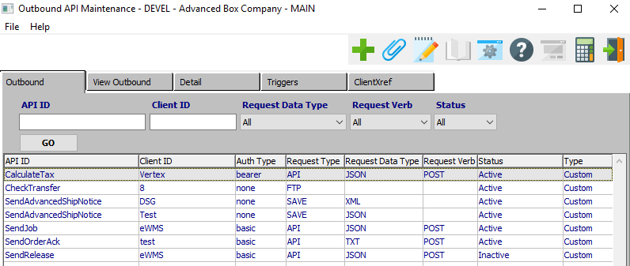

#### ADD

Click the ***“Green + Icon”*** to add a new Outbound API.

#### API ID

Enter an API ID name to search for.

#### Client ID

Enter a Client ID to search for.

#### Request Data Type

The user may choose a Data Type to search for from this drop-down menu. Valid Request Data Types are as follows:

|  |  |  |  |  |
| --- | --- | --- | --- | --- |
| ALL | CSV | JSON | TXT | XML |

#### Request Verb

The user may choose a Request Verb to search for from this drop-down menu. Valid Request Verbs are as follows:

|  |  |  |  |  |
| --- | --- | --- | --- | --- |
| ALL | GET | POST |  |  |

#### Status

The user may choose a API Status to search for from this drop-down menu. Valid Statuses are as follows:

|  |  |  |  |  |
| --- | --- | --- | --- | --- |
| All | Active | Inactive |  |  |

### Add Outbound – API Lookup

Choosing to add a new Outbound API will bring up the “API Outbound Lookup” popup screen. This allows the user to quickly choose an existing API to use as the basis of the new Outbound API parameters.

Once an existing API is chosen, the user may refer to the “Update Outbound” section of this manual.

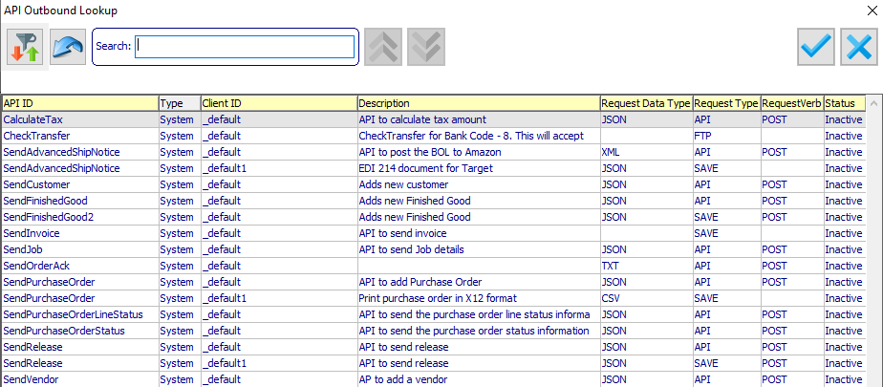

#### TOGGLE COLUMN FILTERS

Clicking the ***“Filter and Arrows Icon”*** button will add search boxes above each of their respective columns. The user can use these search boxes to filter the current list down in order to better search for the specific API that they wish to use.

#### RESET

Click the ***“Blue Arrow Icon”*** button to reset all search parameters.

#### OK

Click the ***“Blue Checkmark Icon”*** button to use the highlighted API to use for the basis of the new Outbound API parameters.

#### CANCEL

Click the ***“Blue X Icon”*** button to cancel searching for an existing API and close the API Outbound Lookup popup screen.

### View Outbound Screen

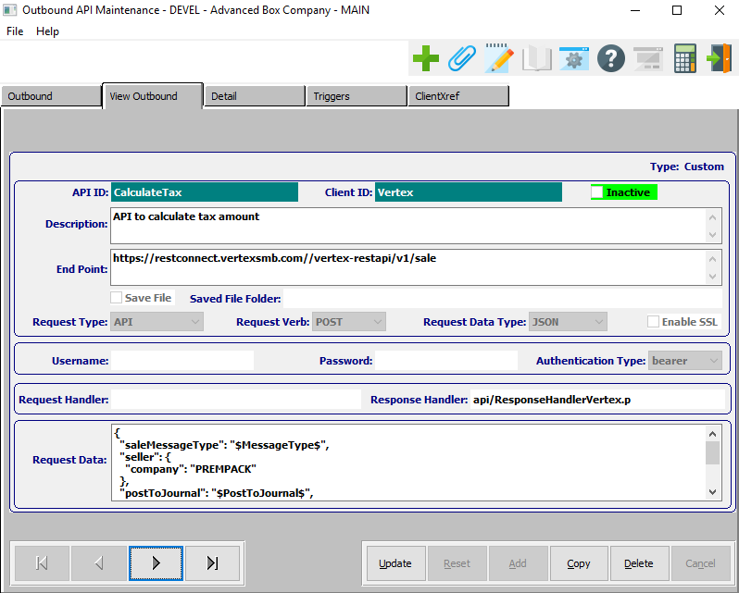

#### UPDATE

To change the currently selected Outbound API, simply click the ***“Update***” button at the bottom of the screen.

#### ADD

Click the ***“Green + Icon”*** to add a new Outbound API.

#### COPY

Click the ***“Copy”*** button to copy information from the currently selected Outbound API.

#### DELETE

To delete the currently selected Outbound API, simply press the ***"D"*** key. Alternatively, click the ***“Delete”*** button at the bottom of the screen.

#### NEXT

Press ***"N"*** (Next) to find next Outbound API to view or modify. Alternatively, press the ***“Right Arrow”*** on the screen.

#### PREVIOUS

Press ***"P"*** (Previous) to find previous Outbound API to view or modify. Alternatively, press the ***“Left Arrow”*** on the screen.

### Update Outbound

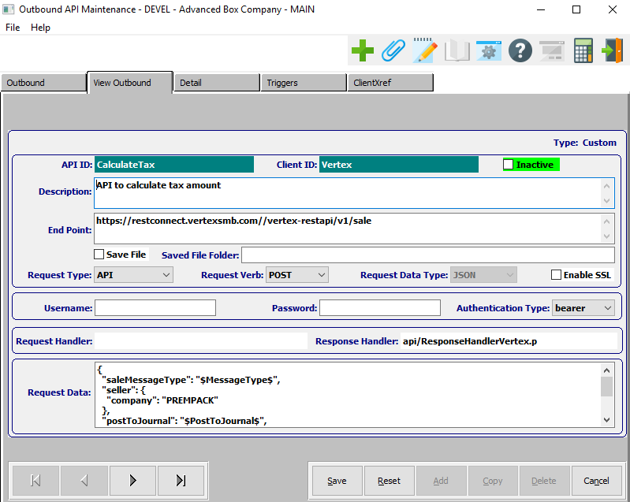

#### SAVE

Click the ***“Save”*** button to save all changes to the current Outbound API.

#### RESET

Click the ***“Reset”*** button to reset all fields to their original state.

#### CANCEL

Click the ***“Cancel”*** button to cancel all changes to the Outbound API without saving.

#### NEXT

Press ***"N"*** (Next) to find next Outbound API to view or modify. Alternatively, press the ***“Right Arrow”*** on the screen.

#### PREVIOUS

Press ***"P"*** (Previous) to find previous Outbound API to view or modify. Alternatively, press the ***“Left Arrow”*** on the screen.

### Update Outbound Field Definitions

#### API ID

The API ID will transfer from the API lookup screen, and cannot be modified by the user.

#### Client ID

When adding a new Outbound API, the user may enter the client ID name in this field. If updating an existing Outbound API, this field cannot be modified.

#### Inactive – Toggle Box

To set this API as inactive, make sure that the Inactive toggle box is checked.

#### Description

The user may enter a description of this API in this field.

#### End Point

Enter the end point of this API in this field.

#### Save File – Toggle Box

To save this API to a file, make sure that the save File toggle box is checked.

#### Saved File Folder

The user may enter a file path to save this API to. Alternatively, press the ***“F1”*** key to choose a file path using the Windows Explorer window.

#### Request Type

The user may choose a Request Type for this API from this drop-down menu. Valid Request Types are as follows:

|  |  |  |  |  |
| --- | --- | --- | --- | --- |
| API | FTP | SAVE |  |  |

#### Request Verb

The user may choose a Request Verb for this API from this drop-down menu. Valid Request Verbs are as follows:

|  |  |  |
| --- | --- | --- |
| GET | POST |  |

#### Request Data Type

The user may choose a Data Type for this API from this drop-down menu. Valid Request Data Types are as follows:

|  |  |  |  |  |
| --- | --- | --- | --- | --- |
| CSV | JSON | TXT | XML | ALL |

#### Enable SSL – Toggle Box

To enable SSL for this Outbound API, make sure that the Enable SSL toggle box is checked.

#### Authentication Type

The user may choose an Authentication Type for this API from this drop-down menu. Valid Authentication Types are as follows:

|  |  |  |  |  |
| --- | --- | --- | --- | --- |
| Basic | Bearer | None |  |  |

### Detail Screen

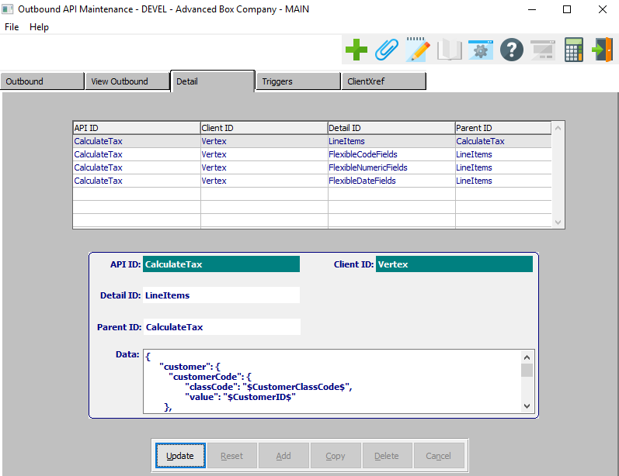

#### UPDATE

To change the currently selected API Request Data, simply click the ***“Update***” button at the bottom of the screen.

### Update Detail

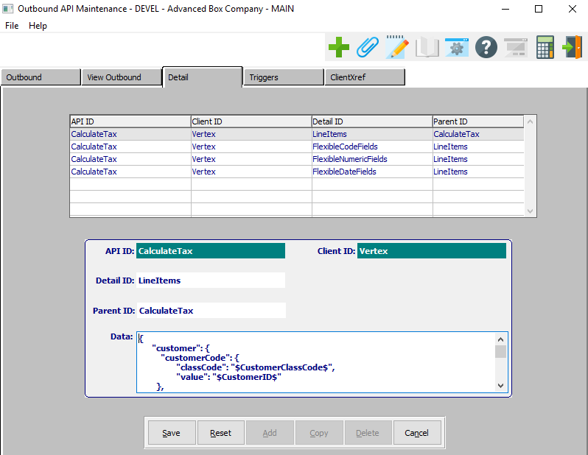

#### SAVE

Click the ***“Save”*** button to save all changes to the current Outbound API.

#### RESET

Click the ***“Reset”*** button to reset all fields to their original state.

#### CANCEL

Click the ***“Cancel”*** button to cancel all changes to the Outbound API without saving.

### Triggers Screen

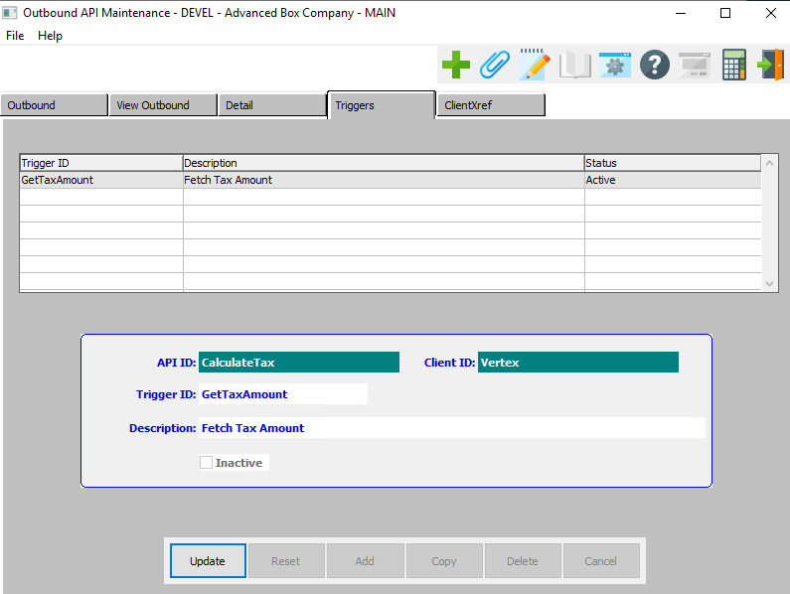

#### UPDATE

To change the currently selected API Trigger ID, simply click the ***“Update***” button at the bottom of the screen.

### Update Trigger

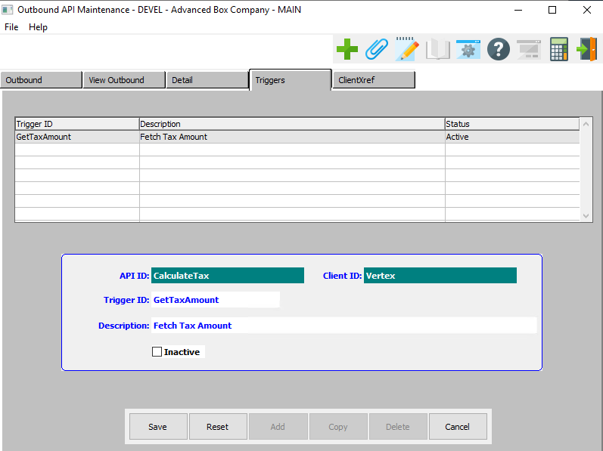

#### SAVE

Click the ***“Save”*** button to save all changes to the current API Trigger.

#### RESET

Click the ***“Reset”*** button to reset all fields to their original state.

#### CANCEL

Click the ***“Cancel”*** button to cancel all changes to the API Trigger without saving.

#### Inactive – Toggle Box

To Set this API as Inactive, make sure that the Inactive toggle box is checked.

### ClientXref

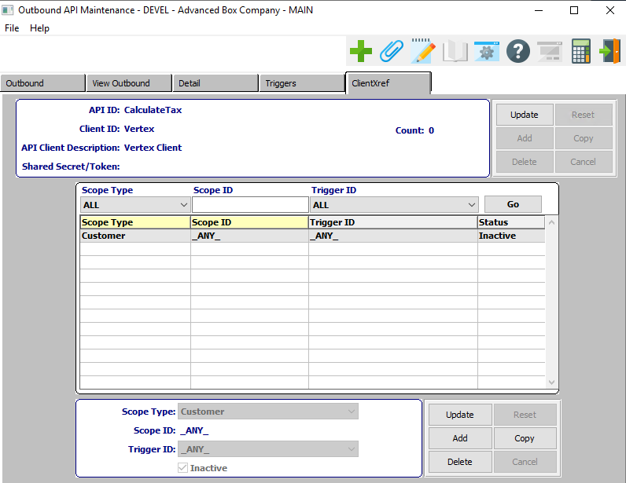

#### UPDATE (Information)

To change the currently selected API Information, simply click the ***“Update***” button at the bottom of the screen.

#### UPDATE (Scope)

To change the currently selected API Scope, simply click the ***“Update***” button at the bottom of the screen.

#### ADD (Scope)

Click the ***“Add”*** button at the bottom of the screen to add a new API Scope.

#### COPY (Scope)

Click the ***“Copy”*** button to copy information from the currently selected API Scope.

#### DELETE (Scope)

To delete the currently selected API Scope, simply press the ***"D"*** key. Alternatively, click the ***“Delete”*** button at the bottom of the screen.

### Add/Update ClientXref – API Information

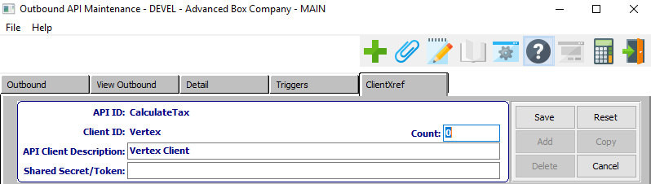

#### SAVE

Click the ***“Save”*** button to save all changes to the current API Information.

#### RESET

Click the ***“Reset”*** button to reset all fields to their original state.

#### CANCEL

Click the ***“Cancel”*** button to cancel all changes to the API Information without saving.

### Add/Update ClientXref – API Information Field Definitions

#### Count

Enter the number of cross references here.

#### API Client Description

Enter a short client description.

#### Shared Secret / Token

Enter the secret token code for this API.

### Add/Update ClientXref – Scope

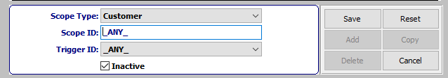

#### SAVE

Click the ***“Save”*** button to save all changes to the current API Scope.

#### RESET

Click the ***“Reset”*** button to reset all fields to their original state.

#### CANCEL

Click the ***“Cancel”*** button to cancel all changes to the API Scope without saving.

### Add/Update ClientXref – Scope Field Definitions

#### Scope Type

The user may choose the scope type for this cross reference from the drop-down list of options

Valid Options are as Follows:

|  |  |  |  |
| --- | --- | --- | --- |
| Any | Customer | Ship To | Vendor |

#### Scope ID

The user may enter their desired name or short description as the scope ID.

Please Note: If the user has chosen the “Any” scope type, the scope ID will default to ‘_ANY_’ and cannot be modified by the user.

#### Trigger ID

The user may choose the Trigger ID for this cross reference from the drop-down list of options.

Valid Options are as Follows:

|  |  |  |  |
| --- | --- | --- | --- |
| Any | Get Tax Amount |  |  |

#### Inactive – Toggle Box

To mark this API Scope as inactive, make sure that the Inactive toggle box is checked.

## Inbound API [NA2]

### Inbound Screen

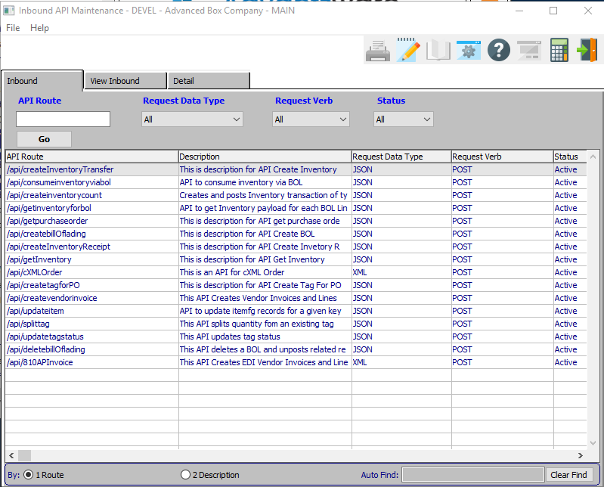

#### API Route

Enter the API route to search for.

#### Request Data Type

The user may choose a Data Type to search for from this drop-down menu. Valid Request Data Types are as follows:

|  |  |  |  |  |
| --- | --- | --- | --- | --- |
| ALL | CSV | JSON | TXT | XML |

#### Request Verb

The user may choose a Request Verb to search for from this drop-down menu. Valid Request Verbs are as follows:

|  |  |  |  |  |
| --- | --- | --- | --- | --- |
| ALL | GET | POST |  |  |

#### Status

The user may choose a API Status to search for from this drop-down menu. Valid Statuses are as follows:

|  |  |  |  |  |
| --- | --- | --- | --- | --- |
| All | Active | Inactive |  |  |

### View Inbound

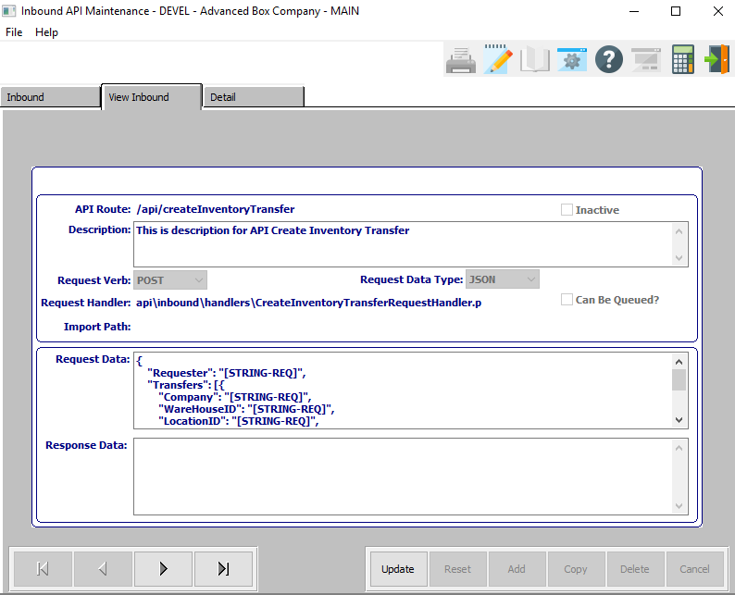

#### UPDATE

To change the currently selected Inbound API, simply click the ***“Update***” button at the bottom of the screen.

#### NEXT

Press ***"N"*** (Next) to find next Inbound API to view or modify. Alternatively, press the ***“Right Arrow”*** on the screen.

#### PREVIOUS

Press ***"P"*** (Previous) to find previous Inbound API to view or modify. Alternatively, press the ***“Left Arrow”*** on the screen.

### Update Inbound

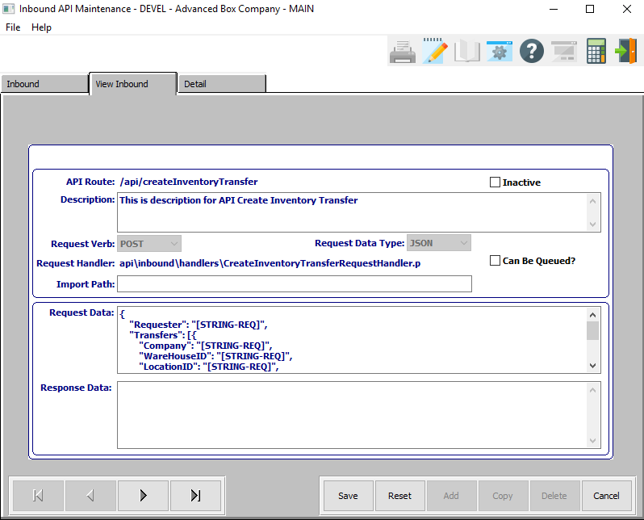

#### SAVE

Click the ***“Save”*** button to save all changes to the current Inbound API.

#### RESET

Click the ***“Reset”*** button to reset all fields to their original state.

#### CANCEL

Click the ***“Cancel”*** button to cancel all changes to the Inbound API without saving.

#### NEXT

Press ***"N"*** (Next) to find next Inbound API to view or modify. Alternatively, press the ***“Right Arrow”*** on the screen.

#### PREVIOUS

Press ***"P"*** (Previous) to find previous Inbound API to view or modify. Alternatively, press the ***“Left Arrow”*** on the screen.

### Update Inbound Field Definitions

#### Inactive – Toggle Box

To set this API as inactive, make sure that the Inactive toggle box is checked.

#### Description

Enter a short description for the Inbound API.

#### Can Be Queued? – Toggle Box

If this Inbound API can be queued with other API’s, make sure that the Can be Queued toggle box is checked.

#### Import Path

Enter the location of the Inbound API to be imported from. Alternatively, press the ***“F1”*** key to use the Windows Explorer window to choose the proper file path.

### Detail

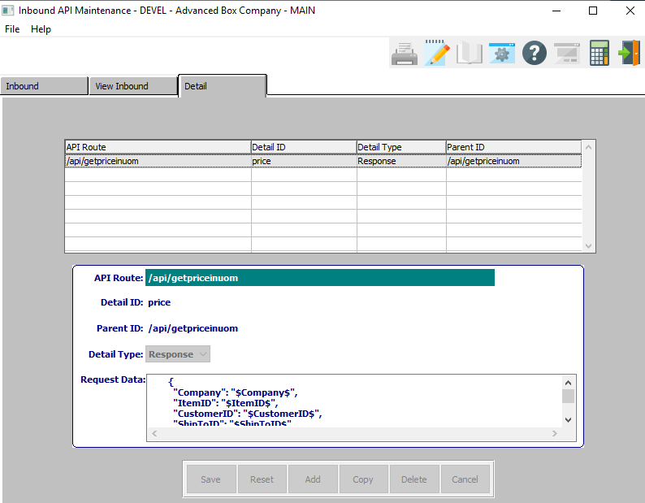

## Outbound API Tester / Console [NA3]

### Outbound Events

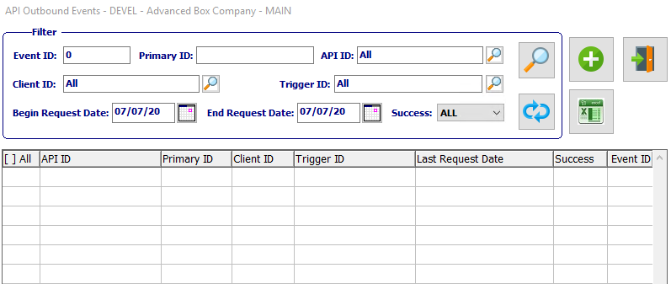

#### FILTER

Click the ***“Magnifying Glass Icon”*** button after entering in any search filters in order to search the system for any outbound events within the user’s search parameters.

#### RETRY EVENT(S)

Click the ***“Blue Refresh Icon”*** button refresh the system to check for any new outbound events.

#### ADD

Click the ***“Green + Icon”*** to add a new outbound event.

#### EXPORT DATA

Click the ***“Excel Spreadsheet Icon”*** button to view all outbound event search results in an excel spreadsheet document.

### Outbound Events Field Definitions

#### Event ID

Enter an event ID to search for.

#### Primary ID

Enter a primary ID to search for.

#### API ID

Enter an API ID to search for.

#### Client ID

Enter a client ID to search for.

#### Trigger ID

Enter a trigger ID to search for.

#### Begin Request Date / End Request Date

Enter the beginning and ending Request Date to search for.

### Add Outbound Event

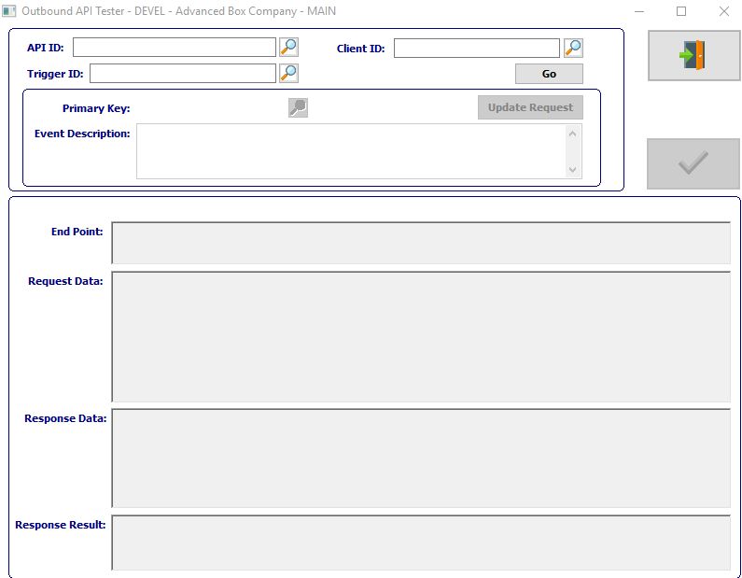

#### EXIT

Click the ***“Exit Door Icon”*** to exit the Outbound API Tester screen.

### Add Outbound Event Field Definitions

#### API ID

Enter an API ID in this field. Alternatively, click the ***“Magnifying Glass Icon***” button to search for an existing API ID.

#### Client ID

Enter a Client ID in this field. Alternatively, click the ***“Magnifying Glass Icon***” button to search for an existing Client ID.

#### Trigger ID

Enter a Trigger ID in this field. Alternatively, click the ***“Magnifying Glass Icon***” button to search for an existing Trigger ID.

## Inbound API Tester / Console [NA4]

### Inbound Events

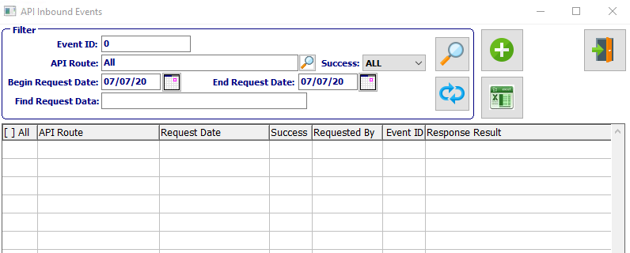

#### FILTER

Click the ***“Magnifying Glass Icon”*** button after entering in any search filters in order to search the system for any inbound events within the user’s search parameters.

#### RETRY EVENT(S)

Click the ***“Blue Refresh Icon”*** button refresh the system to check for any new inbound events.

#### ADD

Click the ***“Green + Icon”*** to add a new inbound event.

#### EXPORT DATA

Click the ***“Excel Spreadsheet Icon”*** button to view all inbound event search results in an excel spreadsheet document.

### Inbound Events Field Definitions

#### Event ID

Enter an Event ID to search for.

#### API Route

Enter the API route to search for.

#### Success

The user may choose a success status to search for from the drop-down list of options.

Valid Options are as Follows:

|  |  |  |
| --- | --- | --- |
| All | Failed | Success |

#### Begin Request Date / End Request Date

Enter the beginning and ending Request Date to search for.

#### Find Request Data

Enter a portion of request data to search for.

### Add Inbound Event

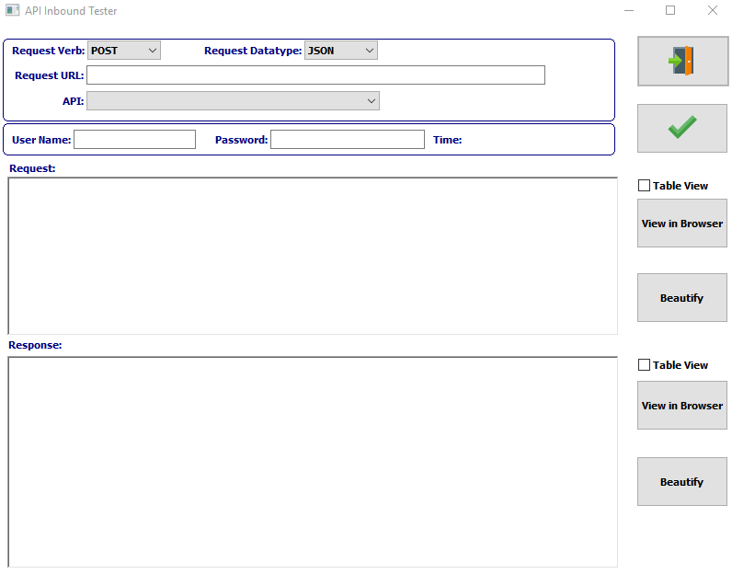

#### EXIT

Click the ***“Exit Door Icon”*** to exit the API Inbound Tester screen.

#### CHECK ICON

Click the ***“Green Check Icon”*** button to approve all changes to the inbound event.

### Add Inbound Event Field Definitions

#### Request Verb

The user may choose a Request Verb to use from this drop-down menu. Valid Request Verbs are as follows:

|  |  |  |
| --- | --- | --- |
| GET | POST |  |

#### Request Data Type

The user may choose a Data Type to use from this drop-down menu. Valid Request Data Types are as follows:

|  |  |  |  |
| --- | --- | --- | --- |
| CSV | JSON | TXT | XML |

#### Request URL

Enter a valid URL for this request.

#### API

The user may choose a valid API option from the drop-down menu.

#### User Name

Enter a username.

#### Password

Enter a user’s password.

#### Table View (Request) – Toggle Box

To view this Request in an excel table, make sure that the Table View toggle box next to the Request section is checked.

#### Table View (Response) – Toggle Box

To view this Response in an excel table, make sure that the Table View toggle box next to the Response section is checked.

## Inbound API Loader [NA5]

### Inbound Offline Request Loader

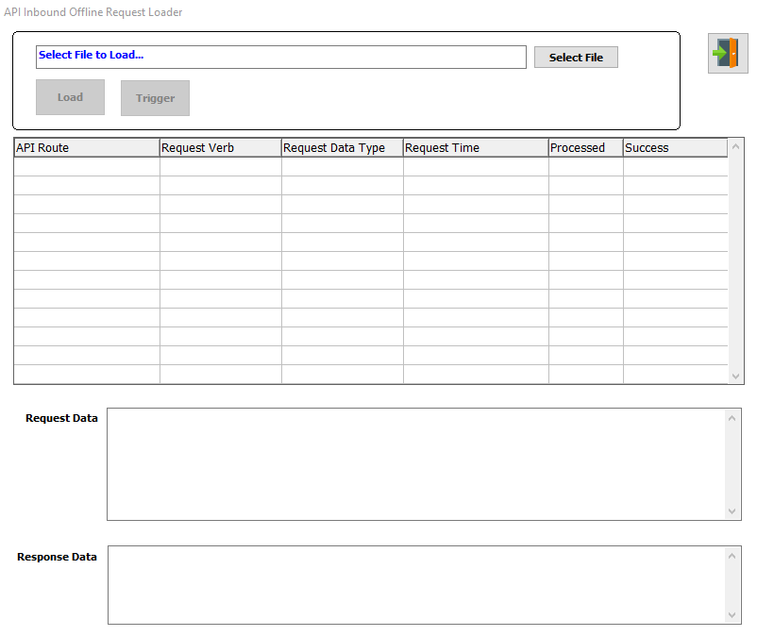

#### EXIT

Click the ***“Exit Door Icon”*** to exit the API Inbound Offline Request Loader popup screen.

#### Select File

Enter the location of the API file to load into the system. Alternatively, press the ***“F1”*** key to use the Windows Explorer window to choose the proper file path.

## API Monitor [NA6]

### Service Resource Monitor

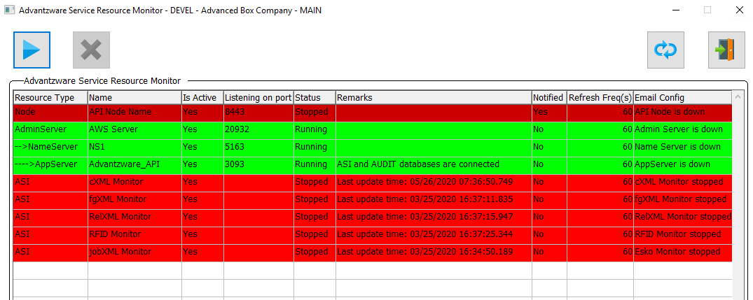

#### RUN

Click the ***“Blue Play Icon***” button to run the currently highlighted/selected Utility Program.

#### REFRESH

Click the ***“Blue Refresh Icon”*** button refresh the system to check for any new API Monitors.

#### EXIT

Click the ***“Exit Door Icon”*** to exit the Service Resource Monitor screen.

## API Data Compare Tool [NA7]

### API Data Comparison

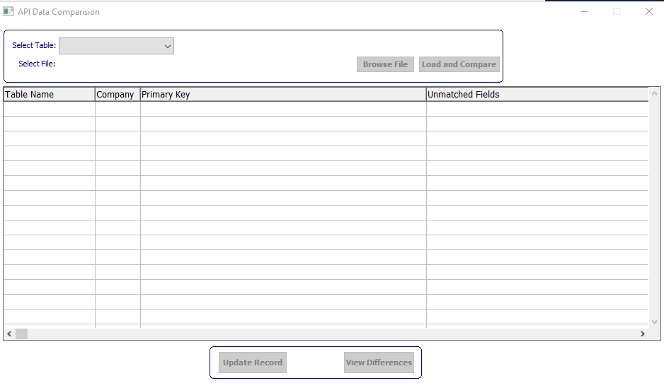

#### Select Table

The user may choose an API table type to search from the drop-down list of options.

Valid Options are as Follows:

|  |  |
| --- | --- |
| API Outbound | API Inbound |
| API Outbound Detail | API Inbound Detail |
| API Outbound Trigger |  |

#### Select File

Once the user has selected the API type that they wish to search for, they may then enter the location of the API Data to be imported from. Alternatively, press the ***“F1”*** key, or click the ***“Browse File”*** button to use the Windows Explorer window to choose the proper file path.

#### LOAD AND COMPARE

Once the user has entered or chosen their desired API file, click the ***“Load and Compare”*** button to load the selected file into the Data Comparison Table.

# **Laptop / Server Link [NL]**

## Export Estimates [NL1]

### Overview

This process is used to export estimates from this database so that they may be imported to a different database with the Import Estimates process.

Please Note: Be sure to run the Import Estimates process on the *other* database, and not this one.

### Selection Parameters

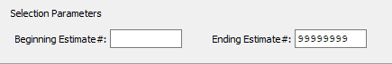

#### Beginning Estimate # / Ending Estimate #

Enter the beginning and ending Estimate Number to Export Estimates for.

## Import Estimates [NL2]

### Overview

This process is used to import estimates to this database that were exported from a different database with the Export Estimates process.

Please Note: Be sure that the Export Estimates process has been run on the other database and not this one.

### Selection Parameters

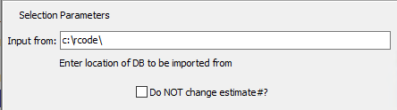

#### Input From

Enter the location of the database to be imported from. Alternatively, press the ***“F1”*** key to use the Windows Explorer window to choose the proper file path.

#### Do NOT Change Estimate #? – Toggle Box

To make sure that the program does not change any estimate numbers within the input form, make sure that the Do Not Change Estimate # toggle box is checked.

# **File Cleanup [NF]**

## Purge Finished Goods [NF1]

Purges single or all Finished Goods Inventory entries and transactions. This screen allows you to clear all Finished Goods History and Finished Goods Item Master Records.

### Selection Parameters

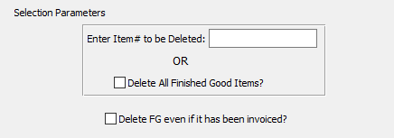

#### Enter Item # to be Deleted

Enter a single item number for deletion from the system.

#### Delete All Finished Good Items? – Toggle Box

To delete all finished good items from the entire system, make sure that the Delete All Finished Good Items toggle box is checked.

#### Delete FG Even if it Has Been Invoiced? – Toggle Box

To delete Finished Goods items from the system even if they have currently been invoiced to a customer, make sure that this toggle box is checked.

## Archive / Delete Estimates [NF2]

### Overview

Archives estimates based on the given ranges, into data files and remove them from the database. This screen provides the options of deleting or archiving (backing up) to a disk. There are various selection ranges to specify what you would like to be done. The system will prompt you to perform a backup. This step ***cannot*** be skipped. A backup must ***always*** be done.

### Selection Parameters

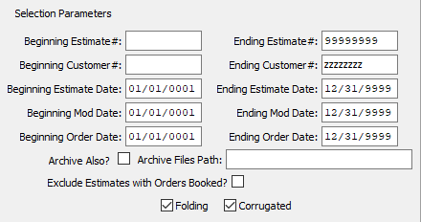

#### Beginning Estimate # / Ending Estimate #

Choose the first and last estimate number for archive or deletion.

#### Beginning Customer # / Ending Customer #

Choose the beginning and ending customer for archive or deletion.

#### Beginning Estimate Date / Ending Estimate Date

Choose the beginning and ending date of the estimate for archive or deletion.

#### Beginning Mod Date / Ending Mod Date

Choose the beginning and ending date of the modification to archive or delete.

#### Beginning Order Date / Ending Order date

Choose the beginning and ending date of the order to archive or delete.

#### Archive Also? – Toggle Box

To archive estimates as well as delete them from the estimate system, make sure that the Archive Also toggle box is checked.

#### Archive Files Path

Enter the location of the Archive to be imported from. Alternatively, press the ***“F1”*** key to use the Windows Explorer window to choose the proper file path.

#### Exclude Estimates with Orders Booked? – Toggle Box

To exclude any estimates that have orders already booked for them, make sure that this toggle box is checked.

## Set FG On-Hand Quantity to Zero [NF3]

Resets the Finished Goods quantity on hand field to zero based on given ranges.

### Selection Parameters

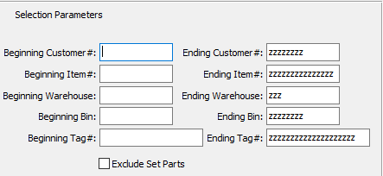

#### Beginning Customer # / Ending Customer #

Enter the beginning and ending Customer Number to set the On-Hand quantity to zero for.

#### Beginning Item # / Ending Item #

Enter the beginning and ending Item Number to set the On-Hand quantity to zero for.

#### Beginning Warehouse / Ending Warehouse

Enter the beginning and ending Warehouse to set the On-Hand quantity to zero for.

#### Beginning Bin / Ending Bin

Enter the beginning and ending Bin to set the On-Hand quantity to zero for.

#### Beginning Tag / Ending Tag

Enter the beginning and ending Tag to set the On-Hand quantity to zero for.

#### Exclude Set Parts – Toggle Box

To exclude set parts when setting the On-Hand quantity to zero, make sure that the Exclude Set Parts toggle box is checked.

## Set FG On-Order Quantity to Zero [NF4]

### Overview

This deletes the Finished Goods Quantities via the Job Costing File and/or Purchase Orders for Finished Goods from the Purchasing Module. This would be run when first implementing Job Costing so that Finished Goods Receipts reduces the quantity on order.

### Selection Parameters

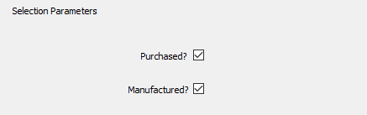

#### Purchased? – Toggle Box

To include purchased goods when setting On-Order quantities to zero, make sure that the Purchased toggle box is checked.

#### Manufactured? – Toggle Box

To include manufactured goods when setting On-Order quantities to zero, make sure that the Manufactured toggle box is checked.

## Purge GL Details / Accounts [NF5]

### Overview

Purges or deletes all general ledger history records from all general ledger account numbers. This is run for a new customer before going live on the software. This can also run for a single general ledger number.

### Selection Parameters

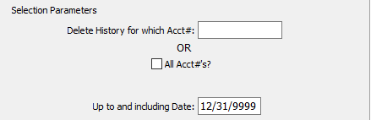

#### Delete History for which Account #

Enter a single account number to purge.

#### All Accounts? – Toggle Box

To purge all accounts in the system, make sure that the All Acct#’s toggle box is checked.

#### Up to and Including Date

Enter a valid date. The report will list all General Ledger Details and Accounts up to and including this date selected.

## Purge Zero Posted AR [NF6]

Purges all paid on account transactions that have been posted with zero. (From the detail aged receivable report). This program will purge all records that are seven years old or older as of the current system date.

### Selection Parameters

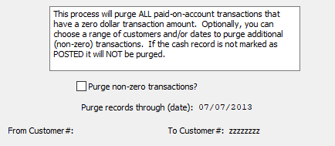

#### Purge Non-Zero Transactions? – Toggle Box

To also purge all non-zero transactions, make sure that this toggle box is checked.

## Purge Orders [NF7]

Purges all orders based on given parameter ranges. The user may purge a single order or choose to delete all orders within a date range.

### Selection Parameters

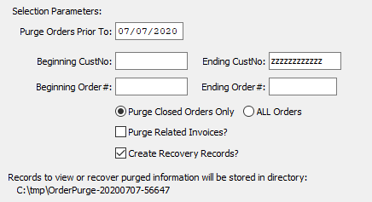

#### Purge Orders Prior To

This date defaults to the system date, but can be modified by the user.

#### Beginning Customer No. / Ending Customer No.

Enter the beginning and ending Customer Number to purge orders for.

#### Beginning Order # / Ending Order #

Enter the beginning and ending Order Number to purge orders for.

#### Orders (Choice)

To choose the preferred Order Type of Closed Orders vs. All Orders, please make sure the desired option choice bubble is toggled.

#### Purge Related Invoices? – Toggle Box

To purge any invoices related to the orders within the selected parameters, make sure that the Purge Related Invoices toggle box is checked.

#### Create Recovery Records? – Toggle Box

To create recovery records for any purged information, make sure that the Create Recovery Records toggle box is checked.

## Purge Quotes [NF8]

Purges all quotes for given parameter ranges.

### Selection Parameters

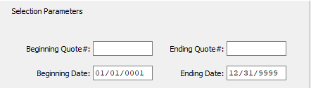

#### Beginning Quote # / Ending Quote #

Enter the beginning and ending Quote Number to purge quotes for.

#### Beginning Date / Ending Date

Enter the beginning and ending Date to purge quotes for.

## Purge PO’s [NF9]

Purges all Purchase Orders for given range.

### Selection Parameters

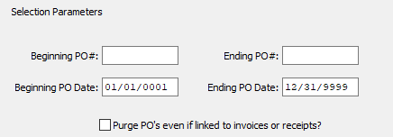

#### Beginning PO # / Ending PO #

Enter the beginning and ending Purchase Order Number to purge purchase orders for.

#### Beginning PO Date / Ending PO Date

Enter the beginning and ending Purchase Order Date to purge purchase orders for.

#### Purge PO’s Even if Linked to Invoices or Receipts? – Toggle Box

To purge purchase orders even if they are currently linked to invoice or receipt records, make sure that this toggle box is checked.

## FG Rebuild Bins / Reset Balances [NF)]

### Overview

This is an excellent report to run at night as the system rebuilds the finished goods balances in chronological order by date of posting of receipts, shipments, physical counts and adjustments. Running this report during the day can affect the overall response time, therefore this is a good utility to run every night in an automated batch process.

ASI recommends not to toggle the ‘Delete Zero Quantity Bins’ as the ***“I”-“F”-“1”*** Bins Tab already eliminates this from displaying.

Please Note: To speed this Utility, an option is also available to recalculate only ***“Active”*** items and the N-R- Util/Utils program called SetFGIA can be run to set finished goods to inactive based on inactivity.

The process will rebuild and recalculate the Finished Goods Bin file. The process will also delete zero and/or negative bins if options are selected.

Please Note: Deleting negative bins is a permanent deletion. The program should be run on a monthly basis or more frequent. This sets the total inventory balances such as quantity on hand for each finished goods item. The system will read all finished transactions for each item starting with the last physical count for that item.

Once the total quantity on hand is calculated for each job, the system will update the bin location file for each warehouse, bin location and tag number for each job. The cumulative quantity of all jobs will be transferred to the finished goods inventory screen, which shows the total unity on hand, on order, allocated and available.

This program will also prompt to delete negative quantity bins. When answered YES, the program will create physical counts of zero for each negative bin when they are deleted. This would be a very fast alternative to manually adding physical counts for each job for each item.

Please Note: Negative bins are created because a shipment is posted for a warehouse and bin location that does not match the finished goods receipt location. Alternatively, a finished goods transfer may be the proper way to correct the imbalance.

Please Note: To ensure proper inventory shipments match the finished goods receipt; the network control should be set to FIFO for first in first out inventory control.

Likewise, jobs and bins that have been fully received and fully shipped may be Purged from the system by selecting the delete zero quantity bins.

### Selection Parameters

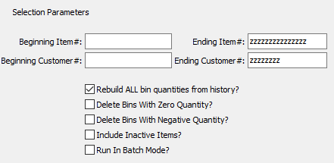

#### Beginning Item # / Ending Item #

Enter the beginning and ending Item Number to rebuild bins and reset balances for.

#### Beginning Customer # / Ending Customer #

Enter the beginning and ending Customer Number to rebuild bins and reset balances for.

#### Rebuild ALL Bin Quantities from History? – Toggle Box

To rebuild all bin quantities from history regardless of selected parameters, make sure that this toggle box is checked.

#### Delete Bins with Zero Quantity? – Toggle Box

To delete any bins within the selected parameters that have a zero-quantity inventory, make sure that this toggle box is checked.

#### Delete Bins with Negative Quantity? – Toggle Box

To delete ant bins within the selected parameters that have a negative quantity inventory, make sure that this toggle box is checked.

#### Include Inactive Items? – Toggle Box

To include any inactive items despite the selected parameters, make sure that the Include Inactive Items toggle box is checked.

#### Run in Batch Mode? – Toggle Box

To run this program in batch mode, make sure that the Run in Batch Mode toggle box is checked.

## Purge Jobs [NF!]

### Overview

Purges all jobs based on given parameter ranges. This program will purge jobs from the system without updating the inventory balances. This process could be used to eliminate old jobs that were never processed on System. It could be used as an alternative to closing jobs.

However, the CLOSEJOB control parameter in the network administration menu will allow closing jobs no matter what the job status if the logical value is ***“Yes”***. If this flag is ***“No”***, then only jobs with a status of ***“W”*** for WIP may be closed. Once material or labor is posted to a job, the status changes to ***“W”*** for WIP.

Other valid job status codes are as follows:

|  |  |  |  |
| --- | --- | --- | --- |
| C | Closed | P | Pending (No Job Standards Created) |
| H | Hold | R | Released |

### Selection Parameters

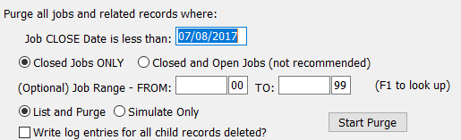

#### Job Close Date is Less Than

The program will purge jobs made on or before the date entered in this field.

#### Job Status (Choice)

To choose the preferred Job Status of Closed vs. All, please make sure the desired option choice bubble is toggled.

Please Note: It is ***Not*** recommended that that the user chooses to purge both closed and open jobs.

#### From Job Range / To Job Range

Enter the beginning and ending Job Range to purge jobs for.

#### Parameter Option (Choice)

To choose the preferred way to run this program of Simulate Only vs. List and Purge, please make sure the desired option choice bubble is toggled.

Selecting the “Simulate” option will not delete any records. Running the program in this way will provide a list of records which would be deleted if the ‘List and Purge’ option were toggled. Running the program in this way allows the user to test which records will deleted to make sure that nothing they deem necessary will be purged within their selected parameters.

#### Write Log Entries for All Child Records Deleted? – Toggle Box

To write log entries for all child records that are deleted within the selected parameters, make sure that this toggle box is checked.

## Purge FG History [NF@]

Purges all Finished Goods history transactions based on given ranges.

### Selection Parameters

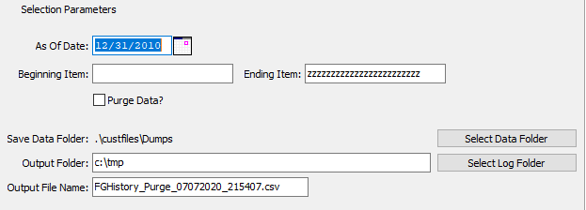

#### As of Date

Enter a valid date. The report will list all Finished Good Histories up to and including this date selected.

#### Beginning Item / Ending Item

Enter the beginning and ending Item Code to purge Finished Good History for.

#### Purge Data? – Toggle Box

To purge the item data within the selected parameters, make sure that the Purge Date toggle box is checked.

#### Output Folder

Enter the location of the folder to output the Finished Good history to. Alternatively, press the ***“F1”*** key to use the Windows Explorer window to choose the proper file path.

#### Output File Name

Enter a name for the output file. This defaults to “FGHistory_Purge_”, followed by the current system date and time. However, this may be modified by the user to reflect any file name that they desire.

## Purge Paid AR Invoices [NF#]

Purges all paid AR invoices for date range selected.

### Selection Parameters

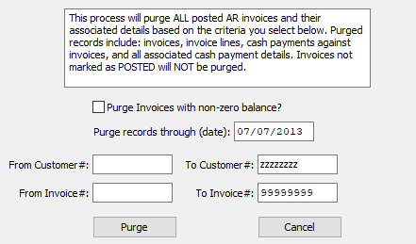

#### Purge Invoices with Non-Zero Balance? – Toggle Box

To purge any invoices within the selected parameters that have a non-zero balance, make sure that this toggle box is checked.

#### Purge Records Through Date

This field defaults to exactly seven years before the system’s current date. However, this may be modified by the user.

#### Beginning Customer # / Ending Customer #

Enter the beginning and ending Customer Number to purge paid Accounts Receivable invoices for.

#### Beginning Invoice # / Ending Invoice #

Enter the beginning and ending Invoice Number to purge paid Accounts Receivable invoices for.

## Purge Paid AP Invoices [NF$]

Purges all paid AR invoices for date range selected.

### Selection Parameters

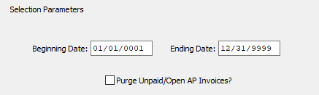

#### Beginning Date / Ending Date

Enter the beginning and ending Date to purge paid Accounts Payable invoices for.

#### Purge Unpaid/Open AP Invoices? – Toggle Box

To purge any unpaid and/or open invoices within the selected parameters, make sure that this toggle box is checked.

## Load Estimates [NF%]

This utility will load estimates that have previous been archived from the NF2 files.

### Selection Parameters

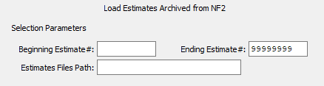

#### Beginning Estimate # / Ending Estimate #

Enter the beginning and ending Estimate Number to load estimates for.

#### Estimates File Path

Enter the location of the Estimate Archive to be imported from. Alternatively, press the ***“F1”*** key to use the Windows Explorer window to choose the proper file path.

# **Y More File Cleanup [NY]**

## Update Estimate Salesman Commission [NY1]

### Overview

Updates each estimate with salesman from customer file based on given ranges. Beginning Estimate # - Enter the estimate number starting point. Archives estimates, based on the given ranges, into data files and removes them from the database.

### Selection Parameters

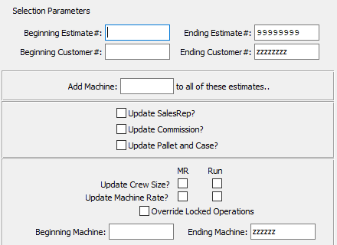

#### Beginning Estimate # / Ending Estimate #

Enter the beginning and ending Estimate Number to update estimate salesman commission for.

#### Beginning Customer # / Ending Customer #

Enter the beginning and ending Customer Number to update estimate salesman commission for.

#### Add Machine

Enter a single machine code to add to all estimates within the selected parameters.

#### Update Sales Rep? – Toggle Box

To update Sales Representative information within the selected parameters, make sure that the Update SalesRep toggle box is checked.

#### Update Commission? – Toggle Box

To update commission percentages within the selected parameters, make sure that the Update Commission toggle box is checked.

#### Update Pallet and Case? – Toggle Box

To update pallet and case information within the selected parameters, make sure that the Update Pallet and Case toggle box is checked.

#### Update Crew Size (MR)? – Toggle Box

To update the crew size for the machine rate within the selected parameters, make sure that this toggle box is checked.

#### Update Crew Size (Run)? – Toggle Box

To update the crew size for the machine run within the selected parameters, make sure that this toggle box is checked.

#### Update Machine Rate (MR)? – Toggle Box

To update the machine rate for the MR within the selected parameters, make sure that this toggle box is checked.

#### Update Machine Run (Run)? – Toggle Box

To update the machine run for the machine rate within the selected parameters, make sure that this toggle box is checked.

#### Override Locked Operations – Toggle Box

To override any operations that are currently locked from information changes, make sure that this toggle box is checked.

#### Beginning Machine / Ending Machine

Enter the beginning and ending machine code to update salesman commission for.

## Purge Report File [NY2]

### Overview

Purges the entire report file. The report file is used for temporary storage of work files, usually for sorting or speed purposes.

## Purge Raw Materials [NY3]

Purges all Raw Material entries and history based on given ranges.

### Selection Parameters

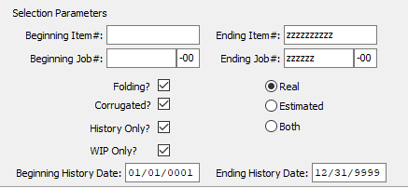

#### Beginning Item # / Ending Item #

Enter the beginning and ending Item Number to purge raw materials for.

#### Beginning Job # / Ending Job #

Enter the beginning and ending Job Number to purge raw materials for.

#### Type (Choice)

To choose the preferred Raw Material Type of Real vs. Estimated (Or Both), please make sure the desired option choice bubble is toggled.

#### Folding? – Toggle Box

To include folding materials in the purge, make sure that the Folding toggle box is checked.

#### Corrugated? – Toggle Box

To include corrugated materials in the purge, make sure that the Corrugated toggle box is checked.

#### History Only? – Toggle Box

To only purge raw material history within the selected parameters, make sure that the History Only toggle box is checked.

#### WIP Only? – Toggle Box

To only purge Works in Process within the selected parameters, make sure that the WIP Only toggle box is checked.

#### Beginning History Date / Ending History Date

Enter the beginning and ending History Date to purge raw materials for.

## Update Estimate Labor Rates [NY4]

### Overview

Updates estimate page 4 operations labor rates with the machine rates based on given ranges. Enter the estimate number starting point. Archives estimates, based on the given ranges, into data files and removes them from the database.

### Selection Parameters

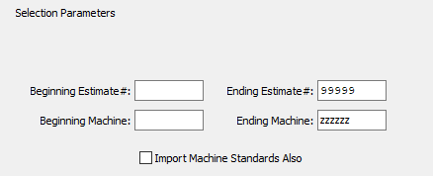

#### Beginning Estimate # / Ending Estimate #

Enter the beginning and ending Estimate Number to Update Estimate Labor Rates for.

#### Beginning Machine / Ending Machine

Enter the beginning and ending Machine to Update Estimate Labor Rates for.

#### Import Machine Standards Also – Toggle Box

To import machine standards when updating labor rates, make sure that this toggle box is checked.

## Build Flute / Test Counts [NY5]

### Selection Parameters

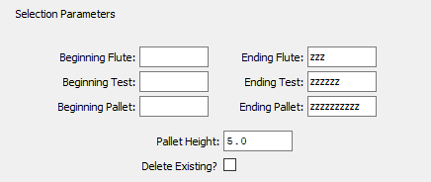

#### Beginning Flute / Ending Flute

Enter the beginning and ending Flute Code to build counts for.

#### Beginning Test / Ending Test

Enter the beginning and ending Test to build counts for.

#### Beginning Pallet / Ending Pallet

Enter the beginning and ending Pallet Code to build counts for.

#### Pallet Height

Enter a new height for all pallets within the selected parameters.

#### Delete Existing? – Toggle Box

To delete all existing information within the selected parameters during the update, make sure that the Delete Existing toggle box is checked.

## FG Sell Price / Bin Cost [NY6]

### Overview

Quick Finished Good items price and bin costs update. This function will allow you to view on the screen, the opening balance for any account, all transactions posted to that account for the current accounting period, and display a current account balance.

The system will display the Description of the Account, the Balance of the Account at the beginning of the month (or the end of last month) and each transaction will be displayed in the lower portion of the screen. You are then able to print all the transactions listed.

### Browse Finished Goods

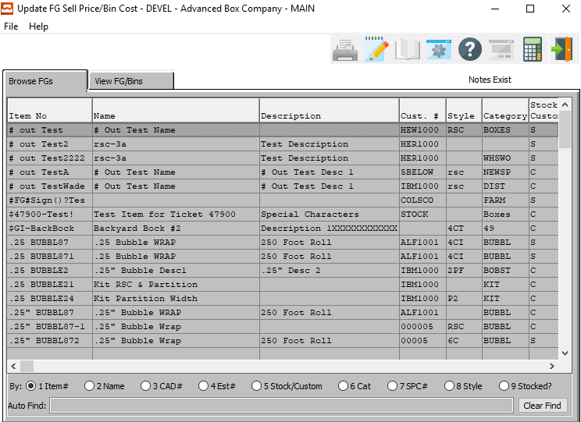

### View Finished Goods/Bins

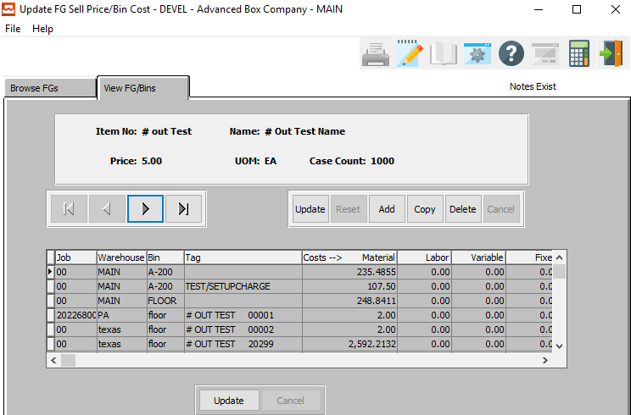

#### UPDATE

To change the currently selected Finished Good/Bin, simply click the ***“Update***” button at the bottom of the screen.

#### ADD

Click the ***“Add”*** button at the bottom of the screen to add a new Finished Good/Bin.

#### COPY

Click the ***“Copy”*** button to copy information from the currently selected Finished Good/Bin.

#### DELETE

To delete the currently selected Finished Good/Bin, simply press the ***"D"*** key. Alternatively, click the ***“Delete”*** button at the bottom of the screen.

#### NEXT

Press ***"N"*** (Next) to find next Finished Good/Bin to view or modify. Alternatively, press the ***“Right Arrow”*** on the screen.

#### PREVIOUS

Press ***"P"*** (Previous) to find previous Finished Good/Bin to view or modify. Alternatively, press the ***“Left Arrow”*** on the screen.

#### UPDATE (Lines)

To change the currently selected Finished Good/Bin Line, simply click the ***“Update***” button at the bottom of the screen.

### Add/Update Finished Good/Bins

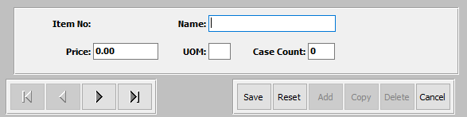

#### SAVE

Click the ***“Save”*** button to save all changes to the current Finished Good/Bin.

#### RESET

Click the ***“Reset”*** button to reset all fields to their original state.

#### CANCEL

Click the ***“Cancel”*** button to cancel all changes to the Finished Good/Bin without saving.

#### NEXT

Press ***"N"*** (Next) to find next Finished Good/Bin to view or modify. Alternatively, press the ***“Right Arrow”*** on the screen.

#### PREVIOUS

Press ***"P"*** (Previous) to find previous Finished Good/Bin to view or modify. Alternatively, press the ***“Left Arrow”*** on the screen.

### Add/Update Finished Good/Bins Field Definitions

#### Name

Enter a name for this Finished Good or Bin.

#### Price

Enter a price for the Finished Good item.

#### UOM

The sell price unit of measure defaults to M for per thousand, however this may be modified. Each unit of measure will yield a different total selling price.

Valid Units of Measure are:

|  |  |
| --- | --- |
| C | Per Hundred |
| CS | Per Case |
| EA | Per Each |
| L | Per Lot |
| M | Per Thousand |

#### Case Count

Enter a case count for this Finished Good or Bin.

### Update Line

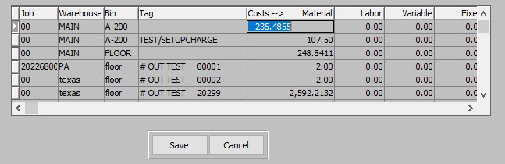

#### SAVE

Click the ***“Save”*** button to save all changes to the current Finished Good/Bin Line.

#### CANCEL

Click the ***“Cancel”*** button to cancel all changes to the Finished Good/Bin Line without saving.

### Update Line Field Definitions

#### Costs 🡪 Material

Enter the cost of material for this item.

#### Labor

Enter the labor cost for this item.

#### Variable

Enter the variable cost for this item.

#### Fixed

Enter the fixed cost for this item.

## Set RM On-Hand to Zero [NY7]

Resets the Raw Materials quantity on hand field to zero based on given range.

### Selection Parameters

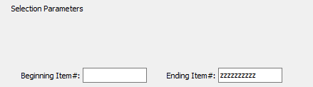

#### Beginning Item # / Ending Item #

Enter the beginning and ending Item Number to set raw material on-hand quantity to zero for.

## RM Rebuild Bins / Reset Balances [NY8]

### Overview

The process will rebuild and recalculate the Raw Materials Bin file based on posted warehouse transactions. The process will also delete zero and/or negative bins if options are selected.

Please Note: Deleting negative bins is a permanent deletion.

### Selection Parameters

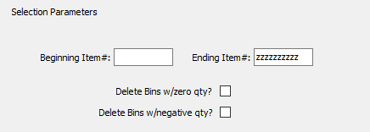

#### Beginning Item # / Ending Item #

Enter the beginning and ending Item Number to rebuild bins and reset balances for.

#### Delete Bins with Zero Qty? – Toggle Box

To delete all bins with a zero-quantity inventory despite the selected parameters, make sure that this toggle box is checked.

#### Delete Bins with Negative Qty? – Toggle Box

To delete all bins with a negative quantity despite the selected parameters, make sure that this toggle box is checked.

## Purge Unship / Post / Closed Releases [NY9]

### Overview

This program will purge the user’s system of any old unshipped, post, and closed releases. In order to run this program, the user must first back up their database for data security.

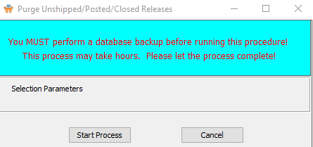

## Purge Customers [NY)]

### Overview

This program will purge the user’s system of any customers within the user-selected parameters. In order to run this program, the user must first back up their database for data security.

### Selection Parameters

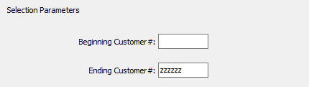

#### Beginning Customer # / Ending Customer #

Enter the beginning and ending Customer Number to purge customers for.

## Copy Customer Notes [NY!]

### Overview

This program will copy any customer notes within the user-selected parameters. In order to run this program, the user must first back up their database for data security.

### Selection Parameters

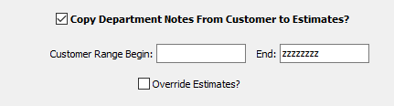

#### Customer Range Begin / Customer Range End

Enter the beginning and ending Customer Numbers to copy customer notes for.

#### Override Estimates? – Toggle Box

To override estimates within the selected parameters, make sure that the Override Estimates toggle box is checked.

## Fix FG History Cost [NY@]

### Overview

This program will fix Finished Good History Costs within the user-selected parameters. In order to run this program, the user must first back up their database for data security.

### Selection Parameters

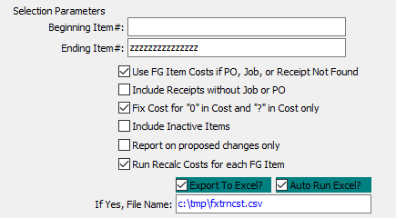

#### Beginning Item # / Ending Item #

Enter the beginning and ending Item Number to fix finished good history cost for.

#### Use FG Item costs if PO, Job, or Receipt Not Found – Toggle Box

To use Finished Good item costs from the system is there are not purchase orders, jobs, or receipts within the selected parameters to pull prices from, make sure that this toggle box is checked.

#### Include Receipts Without Job or PO – Toggle Box

To include receipts within the selected parameters that do not have an attached job or purchase order, make sure that this toggle box is checked.

#### Fix Cost for “0” in Cost and “?” in Cost Only – Toggle Box

To only fix costs whose current data is either unknown or equal to zero, make sure that this toggle box is checked.

#### Include Inactive Items – Toggle Box

To include inactive items that are within the selected parameters, make sure that the Include Inactive Items toggle box is checked.

#### Report on Proposed Changes Only – Toggle Box

To only show proposed changes for items within the selected parameters prior to making any of those changes, make sure that this toggle box is checked.

#### Run Recalc Costs for Each FG Item – Toggle Box

To run the program utility to recalculate any costs in case any changes were made to finished good items within the selected parameters, make sure that this toggle box is checked.

#### Export to Excel? – Toggle Box

To export the printed file to an excel document, make sure that the Export to Excel toggle box is checked.

#### Auto Run Excel? – Toggle Box

To automatically open the new excel document, make sure that the Auto Run Excel toggle box is checked.

#### If Yes, File Name

If exporting the file to Excel, enter the desired file name.

## Fix RM History Cost [NY#]

### Overview

This program will fix Raw Material History Costs within the user-selected parameters. In order to run this program, the user must first back up their database for data security.

### Selection Parameters

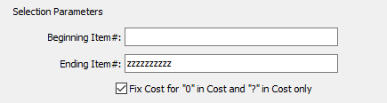

#### Beginning Item # / Ending Item #

Enter the beginning and ending Item Number to fix raw material history costs for.

#### Fix Cost for “0” in Cost and “?” in Cost Only – Toggle Box

To only fix costs whose current data is either unknown or equal to zero, make sure that this toggle box is checked.

## Un-Post BOL’s [NY&]

This program will Un-Post an already posted, user-selected Bill of Lading.

### Selection Parameters

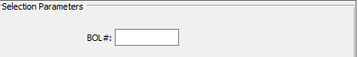

#### BOL #

Enter a valid Bill of Lading number to mark as un-posted.

## Delete Duplicate Web Orders [NY^]

This program will delete any duplicated web orders within the user-selected parameters.

### Selection Parameters

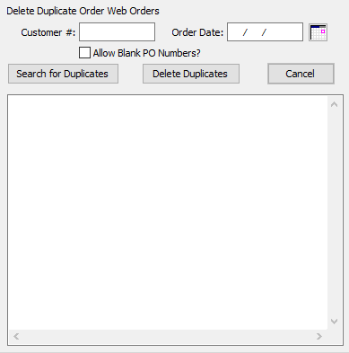

#### SEARCH FOR DUPLICATES

Once all parameters have been set, click the ***“Search for Duplicates”*** button to search the entire system for orders within the set parameters.

#### DELETE DUPLICATES

Once the duplicated documents have been listed, the user may select any files within the list. To select multiple files, use the ***“Control-Click”*** method. Once all desired files have been highlighted, the user may click the ***“Delete Duplicates”*** to delete all the selected files from the system.

#### CANCEL

Click the ***“Cancel”*** button to cancel all changes to the Delete Duplicate Order Web Orders screen without saving.

#### Customer #

Enter a Customer Number to search for duplicated files.

#### Order Date

Enter an order date to search for duplicated files.

#### Allow Blank PO Numbers? – Toggle Box

To allow any blank purchase orders to be included within the duplication search, make sure that this toggle box is checked.

## Delete All Current IU1 Receipts [NY%]

### Overview

This program will delete all current ***“I”-“U”-“1”*** reports within the user-selected parameters. In order to run this program, the user must first back up their database for data security.

### Selection Parameters

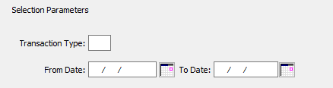

#### Transaction Type

The user may enter a valid transaction type code to delete receipts for. Alternatively, press the ***“F1”*** key to choose a valid transaction code type from a list of valid options.

#### From Date / To Date

Enter the beginning and ending Date to delete all current ***“I”-“U”-“1”*** receipts for.

## Copy Current Balance to Budgets [NY$]

### Overview

This program will copy current years balances to current system budgets within the user-selected parameters. In order to run this program, the user must first back up their database for data security.

### Selection Parameters

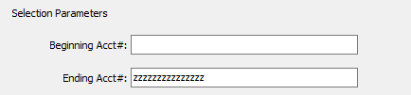

#### Beginning Account # / Ending Account #

Enter the beginning and ending Account Number to copy current balances to budgets for.

## Update Vendor Number [NY*]

### Overview

This program will update an old vendor number to a new vendor number according to the user-selected parameters. In order to run this program, the user must first back up their database for data security.

### Selection Parameters

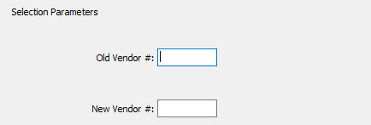

#### Old Vendor #

The user may enter an old vendor number that they wish to update in this field.

#### New Vendor #

The user may enter a new vendor number that they wish to update the old vendor number to in this field.

# **User [NU]**

## Set Company / Location [NU1]

### Overview

This pop-up window allows selection of different company data files.

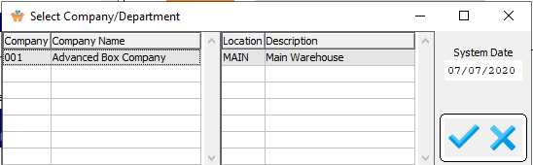

#### OK

Click the ***“Blue Check Mark Icon”*** button to change the currently selected company and location.

#### CANCEL

Click the ***“Blue X Icon”*** button to cancel all changes to the company and location without saving.

## Users [NU3]

### Overview: User Menu Structure

This selection allows the user to customize their drop-down menus. This does not customize the buttons on the main menu. The user will be able to add or remove items from their menu. For example, if a user does not use a particular option, they can remove that option from the menu. They can also move an option to a different menu. For example, if the user would like Zip Codes Loader on the Codes menu instead of the System menu, they can move that option.

To add a Menu item or Program Item to the user’s menu, first highlight the item in the users menu that you would like the new item to go below. Then select a menu item from the top right selection list, or Program Item from the bottom right selection list. Once an item is highlighted, click “Add Menu Item”, or “Add Program Item”. That item will then appear in the users menu structure.

To move an item, highlight the desired selection and use the ***“Page Up” / “Page Down”*** buttons at the bottom of the screen to move the selection to the new place. The dashes in front of each selection represent what menu that selection is on. For example, the word File has no dash in front of it. This means, this selection will appear in the menu bar on the main menu screen. The word Touch Screen is directly under the word file and has one dash in front. This means, Touch Screen is the first option on the File menu.

When you see the word RULE, this places a solid line across the drop-down menu list. When you see the word SKIP, this places a blank line in the drop-down menu list. To change the menu placement, use the ***“<<”*** and ***“>>”*** buttons at the bottom of the screen. These buttons remove or add dashes to the selected item.

To delete an item from the menu, highlight the desired selection and click ***“Remove”***. This will remove that option from the menu.

After the user makes the desired changes, you must click on the ***“Build Menu”*** button. This button is located on the right side of the screen. Once you click the ***“Build Menu”*** button, click on the ***“Save Menu”*** button. This will save your custom menu.

The ***“Default Menu”*** button will change the menu back to the pre-designed menu created by Advanced Software Inc.

The ***“Reset Menu”*** button will change the menu back to whatever it was the last time it was saved. For example, if you already created your custom menus and went into the Menu Structure to make changes. While you are making those changes, decide you no longer wanted the changes, you can click on the ***“Reset”*** button. This will erase any changes you made in this session.

### Browse User

This selection shows all the users. The browser shows the user ID’s and username. The browser also shows if the users usage is tracked, if the user is using defined colors, defined fonts, and control keys. To view a program, you may double click on the selected file or click the ***“View User Tab”***. The icons at the top of the browser provide additional capabilities.

The icon with the fountain pen allows you to view the notes for each user. Each note records the users initials, date, description of the note and a full-page of text for each note. Unlimited notes may be defined for each user. The browse icon will provide immediate access to the browser by user. The icon with the corner of a page folded over allows you to print a list of the users.

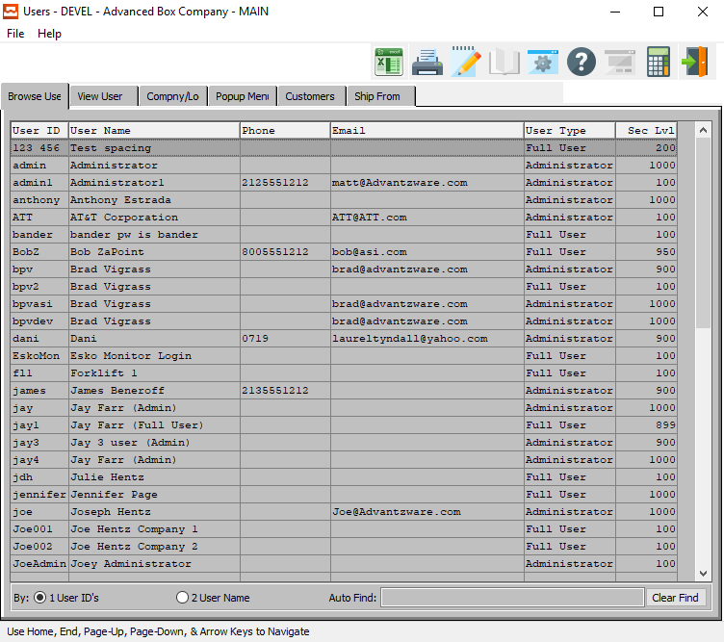

### View User

The View User screen allows you to view the information of each user. You may copy, change, add or delete any user from this screen. Use the ***“Arrow”*** keys at the bottom of the screen to view the next or previous user. The icons at the top of the screen provide additional capabilities.

The browse icon will provide immediate access to the browser by user. The icon with the fountain pen allows you to view any notes for the user selected. The icon with the corner of a page folded over allows you to print a list of the users.

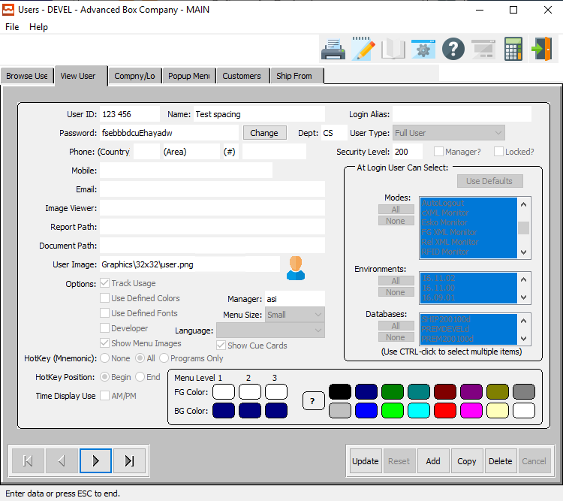

#### UPDATE

To change the currently selected User, simply click the ***“Update***” button at the bottom of the screen.

#### ADD

Click the ***“Add”*** button at the bottom of the screen to add a new User.

#### COPY

Click the ***“Copy”*** button to copy information from the currently selected User.

#### DELETE

To delete the currently selected User, simply press the ***"D"*** key. Alternatively, click the ***“Delete”*** button at the bottom of the screen.

#### NEXT

Press ***"N"*** (Next) to find next User to view or modify. Alternatively, press the ***“Right Arrow”*** on the screen.

#### PREVIOUS

Press ***"P"*** (Previous) to find previous User to view or modify. Alternatively, press the ***“Left Arrow”*** on the screen.

### User Font and Color Settings

This selection allows the user to make custom changes to the font and color settings. The user can change any objects or screen color, or font style. Select an object from the Widget Object box, and then click on the desired foreground and background color. You may also choose a font style from the Available Font selection.

For these changes to take effect, you must check the Use Fonts and Use Colors checkbox and click the save button. If you do not check the Use Fonts checkbox, the fonts will not change. Changes made to the colors and fonts will only change for that user. No other user will be affected.

### Add/Update User – Main Information

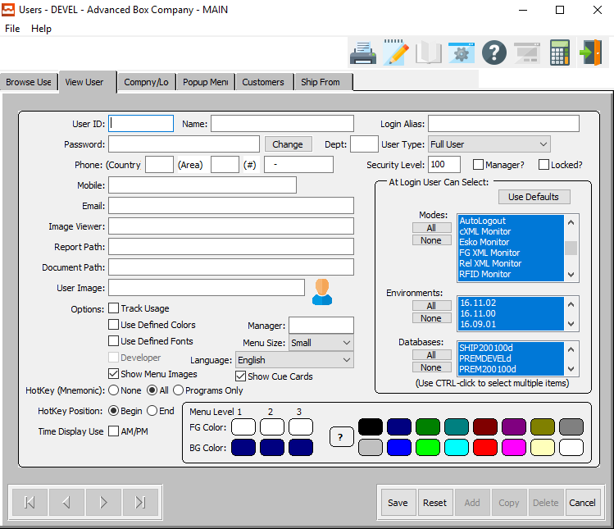

#### SAVE

Click the ***“Save”*** button to save all changes to the current User.

#### RESET

Click the ***“Reset”*** button to reset all fields to their original state.

#### CANCEL

Click the ***“Cancel”*** button to cancel all changes to the User without saving.

### Add/Update User – Main Information Field Definitions

#### User ID

Enter a User ID code.

#### User Name

Enter a name for this user.

#### Login Alias

Enter the login alias for this user.

#### Password

Enter a password for this user.

#### Department

Enter the department code for this user.

#### User Type

Choose the type for this user from the drop-down menu.

#### Phone Number

Enter the phone number of this user.

#### Security Level

Enter a valid security level for this user.

#### Manager – Toggle Box

To indicate that this user is a manager, make sure that the Manager toggle box is checked.

#### Locked? – Toggle Box

To lock this user’s data from further editing, make sure that the Locked toggle box is checked.

#### Mobile

Enter the mobile number for this user.

#### Email

Enter this user’s email address.

#### Image Viewer

Enter the location of the Image Viewer to be imported from. Alternatively, press the ***“F1”*** key to use the Windows Explorer window to choose the proper file path.

#### Report Path

Enter the location of the Report Path for this user. Alternatively, press the ***“F1”*** key to use the Windows Explorer window to choose the proper file path.

#### Document Path

Enter the location of the Document Path for this user. Alternatively, press the ***“F1”*** key to use the Windows Explorer window to choose the proper file path.

#### User Image

Enter the location of the Image for this user. Alternatively, press the ***“F1”*** key to use the Windows Explorer window to choose the proper file path.

#### Options: Track Usage – Toggle Box

To have the system track this user’s usage of the database and software, make sure that the Track Usage toggle box is checked.

#### Options: Use Defined Colors – Toggle Box

To use colors defined here for this user, make sure that the Use Defined Colors toggle box is checked.

#### Options: Use Defined Fonts – Toggle Box

To use fonts defined here for this user, make sure that the Use Defined Fonts toggle box is checked.

#### Options: Developer – Toggle Box

To indicate this user is a developer, make sure that the Developer toggle box is checked.

#### Options: Show Menu Images – Toggle Box

To Show Menu Images for this user, make sure that the Show Menu Images toggle box is checked.

#### Options: Show Cue Cards – Toggle Box

To Show Cue Cards for this user, make sure that the Show Cue Cards toggle box is checked.

#### Manager

Enter the name of this user’s manager here.

#### Menu Size

Choose the default menu size for this user from the drop-down menu.

#### Language

Select this user’s default language from the drop-down list of available languages.

#### Hot Key (Choice)

To choose the preferred Hot Key of Programs Only vs. All (Or None), please make sure the desired option choice bubble is toggled.

#### Hot Key Position (Choice)

To choose the preferred Hot Key position of Beginning vs. Ending, please make sure the desired option choice bubble is toggled.

#### Time Display Use AM/PM – Toggle Box

To display the system’s AM/PM abbreviations when showing this user the time, make sure that this toggle box is checked.

#### Menu Level Colors

Choose the three Foreground and three Background colors for this user here.

### Add/Update User – User Selection Options

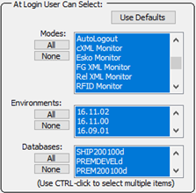

#### USE DEFAULTS

Click the ***“Use Defaults****”* button to automatically use the default Modes, Environments, and Databases that the user may select once they login.

#### ALL

Click the ***“All”*** button for any of the three parameters to automatically highlight the entire list for the desired parameter, thus allowing the user to select all Modes, Environments, or Databases within that list once they login.

#### NONE

Click the ***“None”*** button for any of the three parameters to automatically un-highlight the entire list for the desired parameter, thus disallowing the user to select all Modes, Environments, or Databases within that list once they login.

#### Modes

The user may choose any Modes from within the available modes list that the user can select once they login. The user may use the ***“Control-Click”*** method to choose multiple Modes from the list. Only highlighted Modes will be selectable by the user.

#### Environments

The user may choose any Environments from within the available modes list that the user can select once they login. The user may use the ***“Control-Click”*** method to choose multiple Environments from the list. Only highlighted Environments will be selectable by the user.

#### Databases

The user may choose any Databases from within the available modes list that the user can select once they login. The user may use the ***“Control-Click”*** method to choose multiple Databases from the list. Only highlighted Databases will be selectable by the user.

### Company / Location

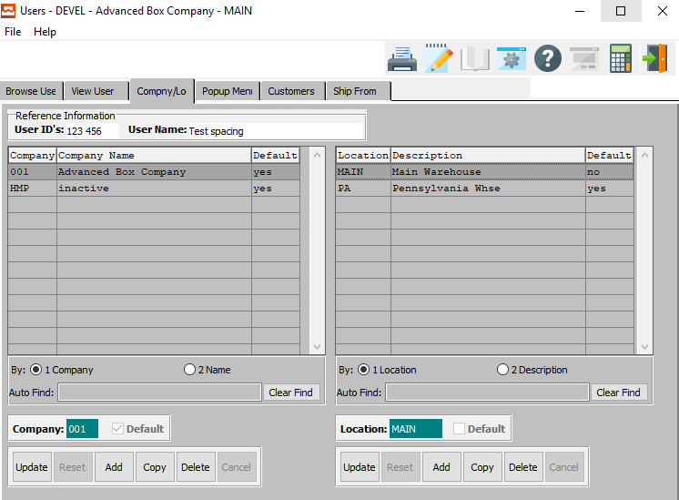

#### UPDATE (Company Information)

To change the currently selected Company, simply click the ***“Update***” button at the bottom of the screen.

#### ADD (Company Information)

Click the ***“Add”*** button at the bottom of the screen to add a new Company.

#### COPY (Company Information)

Click the ***“Copy”*** button to copy information from the currently selected Company.

#### DELETE (Company Information)

To delete the currently selected Company, simply press the ***"D"*** key. Alternatively, click the ***“Delete”*** button at the bottom of the screen.

#### UPDATE (Location Information)

To change the currently selected Location, simply click the ***“Update***” button at the bottom of the screen.

#### ADD (Location Information)

Click the ***“Add”*** button at the bottom of the screen to add a new Location.

#### COPY (Location Information)

Click the ***“Copy”*** button to copy information from the currently selected Location.

#### DELETE (Location Information)

To delete the currently selected Location, simply press the ***"D"*** key. Alternatively, click the ***“Delete”*** button at the bottom of the screen.

### Add/Update Company

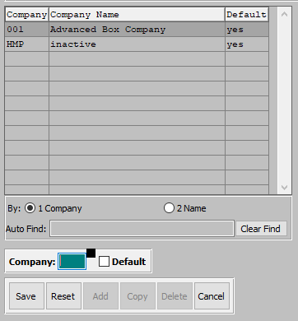

#### SAVE

Click the ***“Save”*** button to save all changes to the current Company.

#### RESET

Click the ***“Reset”*** button to reset all fields to their original state.

#### CANCEL

Click the ***“Cancel”*** button to cancel all changes to the Company without saving.

### Add/Update Company Field Definitions

#### Company

Enter the company code in this field.

#### Default – Toggle Box

To set this as the default company in the system, make sure that the Default toggle box is checked.

### Add/Update Location

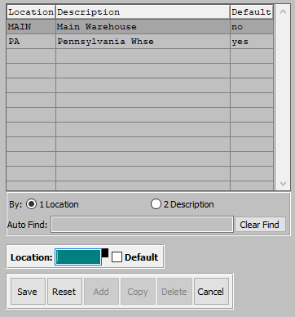

#### SAVE

Click the ***“Save”*** button to save all changes to the current Location.

#### RESET

Click the ***“Reset”*** button to reset all fields to their original state.

#### CANCEL

Click the ***“Cancel”*** button to cancel all changes to the Location without saving.

### Add/Update Location Field Definitions

#### Location

Enter the location in this field.

#### Default – Toggle Box

To set this location as the default location in the system, make sure that the Default toggle box is checked.

### Popup Menu

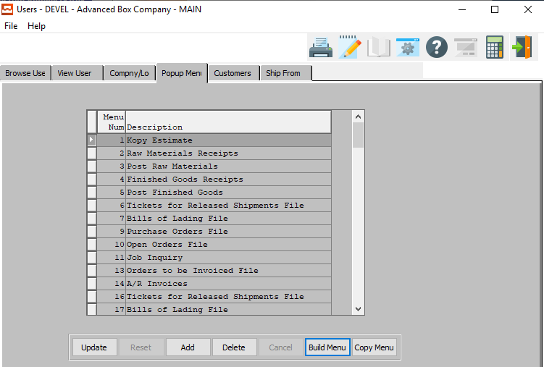

#### UPDATE

To change the currently selected Popup Menu, simply click the ***“Update***” button at the bottom of the screen.

#### ADD

Click the ***“Add”*** button at the bottom of the screen to add a new Popup Menu.

#### DELETE

To delete the currently selected Popup Menu, simply press the ***"D"*** key. Alternatively, click the ***“Delete”*** button at the bottom of the screen.

#### BUILD MENU

Click the ***“Build Menu”*** button to update the list of currently available popup menus.

#### COPY MENU

Click the ***“Copy Menu”*** button to choose a user from which to copy a popup menu from.

### Add/Update Popup Menu

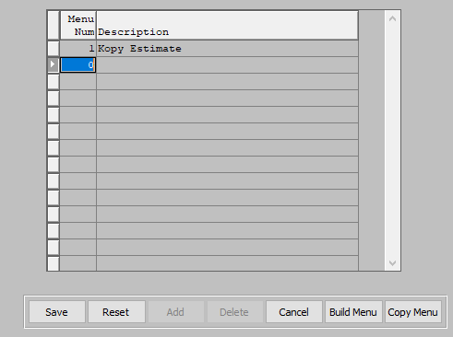

#### SAVE

Click the ***“Save”*** button to save all changes to the current Popup Menu.

#### RESET

Click the ***“Reset”*** button to reset all fields to their original state.

#### CANCEL

Click the ***“Cancel”*** button to cancel all changes to the Popup Menu without saving.

#### BUILD MENU

Click the ***“Build Menu”*** button to update the list of currently available popup menus.

#### COPY MENU

Click the ***“Copy Menu”*** button to choose a user from which to copy a popup menu from.

### Add/Update Popup Menu Field Definitions

#### Menu Number

Enter the menu number for this popup menu.

#### Description

Enter a short description or name for this popup menu.

### Customers

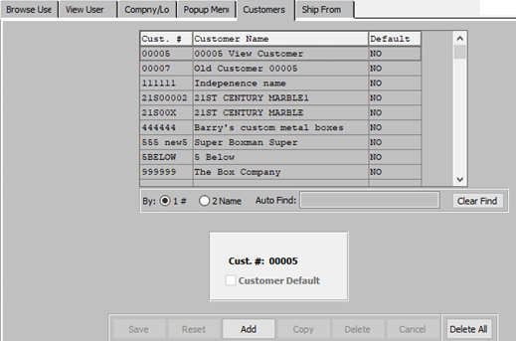

#### ADD

Click the ***“Add”*** button at the bottom of the screen to add a new Customer.

#### DELETE ALL

Click the ***“Delete All”*** button to delete all current customers from this user.

### Add Customer

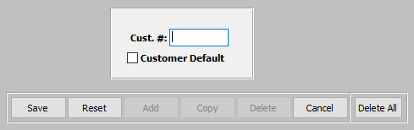

#### SAVE

Click the ***“Save”*** button to save all changes to the current Customer.

#### RESET

Click the ***“Reset”*** button to reset all fields to their original state.

#### CANCEL

Click the ***“Cancel”*** button to cancel all changes to the Customer without saving.

#### DELETE ALL

Click the ***“Delete All”*** button to delete all current customers from this user.

### Add Customer Field Definitions

#### Customer #

Enter a number for this customer.

#### Customer Default – Toggle Box

To mark the customer as the default customer for this user, make sure that the Customer Default toggle box is checked.

### Ship From

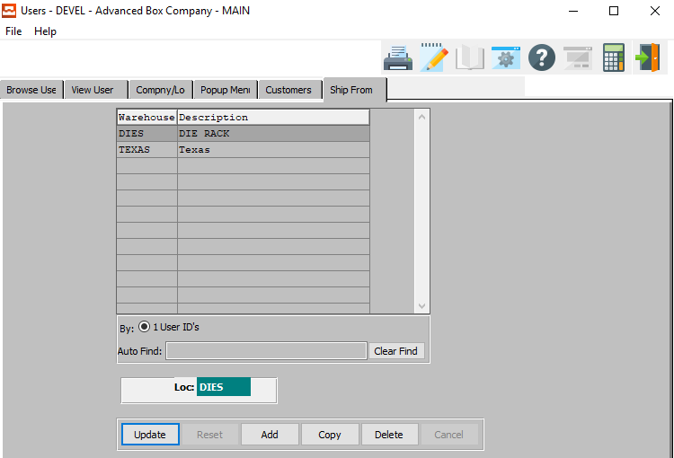

#### UPDATE

To change the currently selected Ship From Location, simply click the ***“Update***” button at the bottom of the screen.

#### ADD

Click the ***“Add”*** button at the bottom of the screen to add a new Ship From Location.

#### COPY

Click the ***“Copy”*** button to copy information from the currently selected Ship From Location.

#### DELETE

To delete the currently selected Ship From Location, simply press the ***"D"*** key. Alternatively, click the ***“Delete”*** button at the bottom of the screen.

### Add/Update Ship From

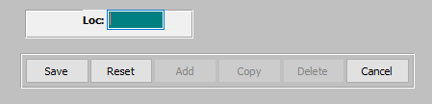

#### SAVE

Click the ***“Save”*** button to save all changes to the current Ship From Location.

#### RESET

Click the ***“Reset”*** button to reset all fields to their original state.

#### CANCEL

Click the ***“Cancel”*** button to cancel all changes to the Ship From Location without saving.

#### Location

Enter the location code for this Ship From Location.

## Change User Groups [NU5]

### Browse User Groups

This selection shows all the user groups. The browser shows the user group, and user ID’s. To view a program, you may double click on the selected file or click the View Program tab. The icons at the top of the browser provide additional capabilities. The icon with the fountain pen allows you to view the notes for each user group.

Each note records the users initials, date, description of the note and a full-page of text for each note. Unlimited notes may be defined for each user group. The browse icon will provide immediate access to the browser by user group. The icon with the corner of a page folded over allows you to print a list of the user groups.

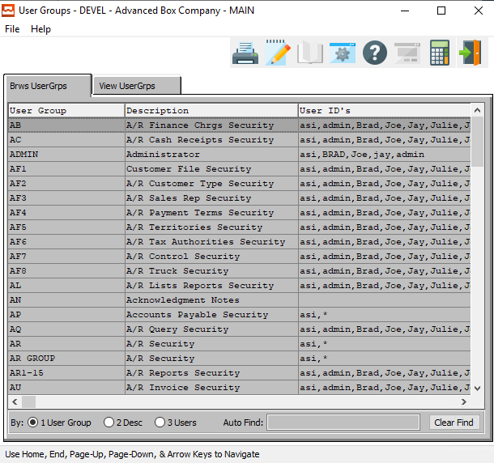

### View User Groups

The view User Groups screen allows you to view the information of each user group. You may copy, change, add or delete any user group from this screen. Use the arrow keys at the bottom of the screen to view the next or previous user group. The icons at the top of the screen provide additional capabilities.

The browse icon will provide immediate access to the browser by user group. The icon with the fountain pen allows you to view any notes for the user group selected. The icon with the corner of a page folded over allows you to print a list of the user groups.

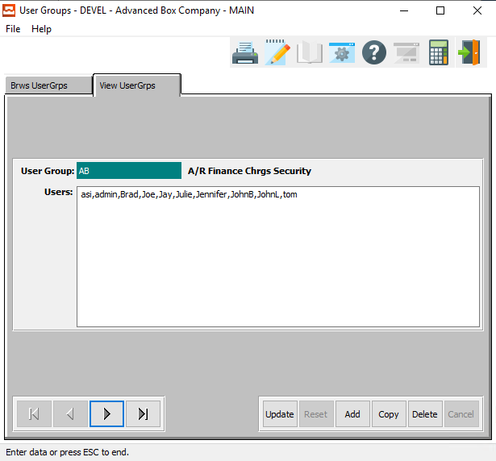

#### UPDATE

To change the currently selected User Group, simply click the ***“Update***” button at the bottom of the screen.

#### ADD

Click the ***“Add”*** button at the bottom of the screen to add a new User Group.

Alternatively, click the ***“Add”*** button at the bottom of the screen.

#### COPY

Click the ***“Copy”*** button to copy information from the currently selected User Group.

#### DELETE

To delete the currently selected User Group, simply press the ***"D"*** key. Alternatively, click the ***“Delete”*** button at the bottom of the screen.

#### NEXT

Press ***"N"*** (Next) to find next User Group to view or modify. Alternatively, press the ***“Right Arrow”*** on the screen.

#### PREVIOUS

Press ***"P"*** (Previous) to find previous User Group to view or modify. Alternatively, press the ***“Left Arrow”*** on the screen.

### Add/Update User Groups

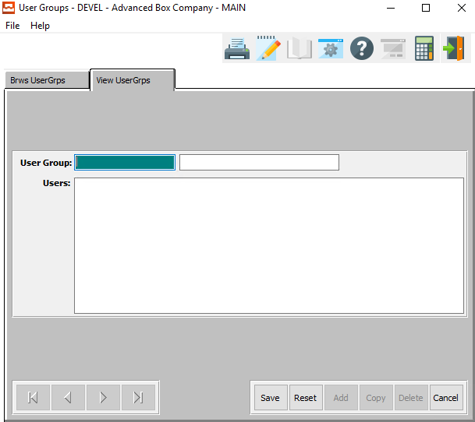

#### SAVE

Click the ***“Save”*** button to save all changes to the current User Group.

#### RESET

Click the ***“Reset”*** button to reset all fields to their original state.

#### CANCEL

Click the ***“Cancel”*** button to cancel all changes to the User Group without saving.

### Add/Update User Groups Field Definitions

#### User Group

Enter the user group name.

#### Description

Enter a description of the User Group Name.

#### Users

Enter the individual usernames for this user group. Each username should be separated by a comma.

# **Codes [NC]**

## Email Codes [NC1]

### Email Codes

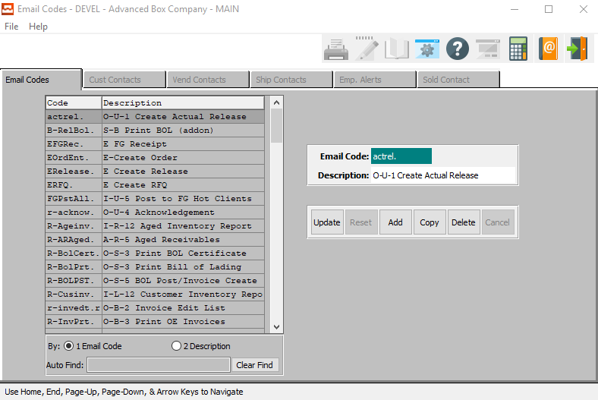

#### UPDATE

To change the currently selected Email Code, simply click the ***“Update***” button at the bottom of the screen.

#### ADD

Click the ***“Add”*** button at the bottom of the screen to add a new Email Code.

#### COPY

Click the ***“Copy”*** button to copy information from the currently selected Email Code.

#### DELETE

To delete the currently selected Email Code, simply press the ***"D"*** key. Alternatively, click the ***“Delete”*** button at the bottom of the screen.

### Add/Update Email Codes

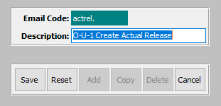

#### SAVE

Click the ***“Save”*** button to save all changes to the current Email Code.

#### RESET

Click the ***“Reset”*** button to reset all fields to their original state.

#### CANCEL

Click the ***“Cancel”*** button to cancel all changes to the Email Code without saving.

#### Description

Enter the description for this email code.

### Customer Contacts

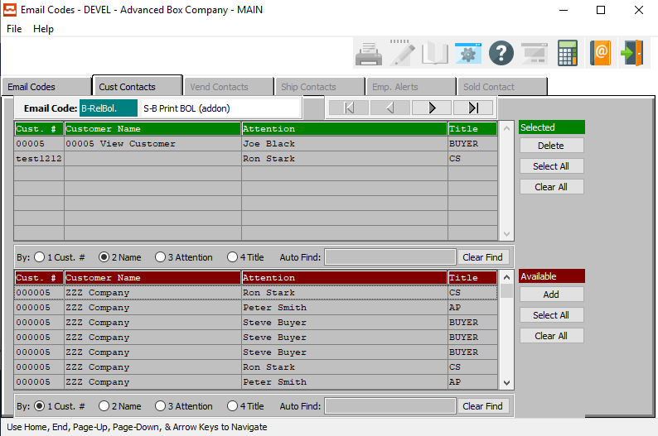

#### DELETE (Selected)

To delete the currently selected Email Code, simply press the ***"D"*** key. Alternatively, click the ***“Delete”*** button at the bottom of the screen.

#### SELECT ALL (Selected)

Click the ***“Select All”*** button in the ‘*Selected’* section to highlight all Customer Contacts that are currently in the *‘Selected’* section. The user may use this for mass deletion of items within this section, as opposed to deleting contacts individually.

#### CLEAR ALL (Selected)

Click the ***“Clear All”*** button in the ‘*Selected’* section to un-highlight all Customer Contacts that are currently in the *‘Selected’* section.

#### ADD (Available)

Click on the selected contact from the ‘*Available’* list to highlight it, then click the ***“Add”*** button to add the selected column to the ‘*Selected’* list.

#### SELECT ALL (Available)

Click the ***“Select All”*** button in the ‘*Available’* section to highlight all Customer Contacts that are currently in the *‘Available’* section. The user may use this for mass deletion of all items within this section, as opposed to deleting contacts individually.

#### CLEAR ALL (Available)

Click the ***“Clear All”*** button in the ‘*Available’* section to un-highlight all Customer Contacts that are currently in the *‘Available’* section.

### Vendor Contacts

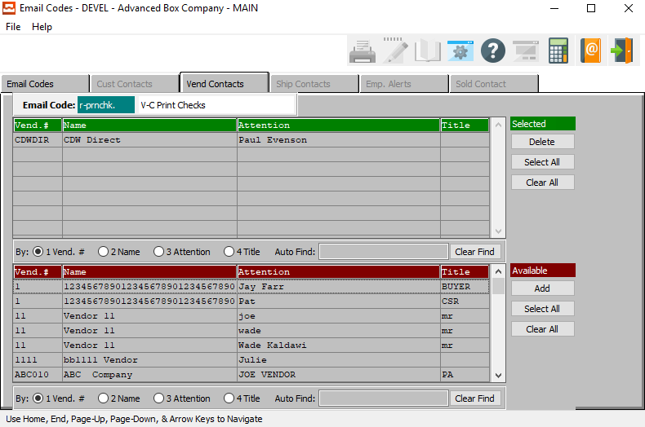

#### DELETE (Selected)

To delete the currently selected Vendor Contact, simply press the ***"D"*** key. Alternatively, click the ***“Delete”*** button at the bottom of the screen.

#### SELECT ALL (Selected)

Click the ***“Select All”*** button in the ‘*Selected’* section to highlight all Vendor Contacts that are currently in the *‘Selected’* section. The user may use this for mass deletion of items within this section, as opposed to deleting contacts individually.

#### CLEAR ALL (Selected)

Click the ***“Clear All”*** button in the ‘*Selected’* section to un-highlight all Vendor Contacts that are currently in the *‘Selected’* section.

#### ADD (Available)

Click on the selected contact from the ‘*Available’* list to highlight it, then click the ***“Add”*** button to add the selected column to the ‘*Selected’* list.

#### SELECT ALL (Available)

Click the ***“Select All”*** button in the ‘*Available’* section to highlight all Vendor Contacts that are currently in the *‘Available’* section. The user may use this for mass deletion of all items within this section, as opposed to deleting contacts individually.

#### CLEAR ALL (Available)

Click the ***“Clear All”*** button in the ‘*Available’* section to un-highlight all Vendor Contacts that are currently in the *‘Available’* section.

### Ship Contacts

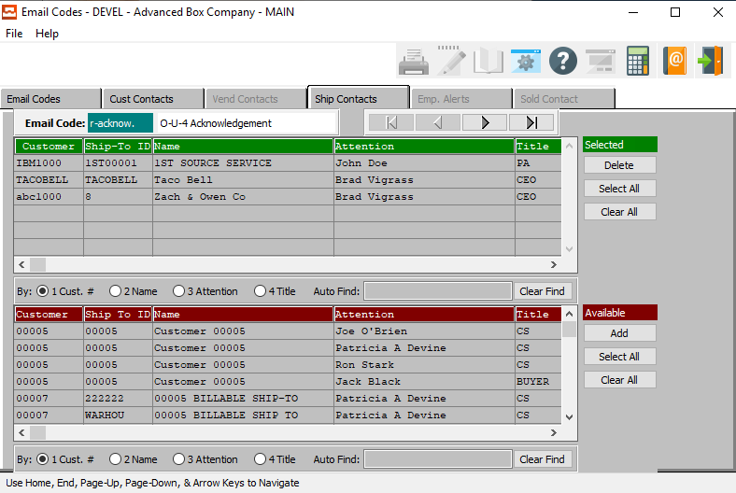

#### DELETE (Selected)

To delete the currently selected Ship Contact, simply press the ***"D"*** key. Alternatively, click the ***“Delete”*** button at the bottom of the screen.

#### SELECT ALL (Selected)

Click the ***“Select All”*** button in the ‘*Selected’* section to highlight all Ship Contacts that are currently in the *‘Selected’* section. The user may use this for mass deletion of items within this section, as opposed to deleting contacts individually.

#### CLEAR ALL (Selected)

Click the ***“Clear All”*** button in the ‘*Selected’* section to un-highlight all Ship Contacts that are currently in the *‘Selected’* section.

#### ADD (Available)

Click on the selected contact from the ‘*Available’* list to highlight it, then click the ***“Add”*** button to add the selected column to the ‘*Selected’* list.

#### SELECT ALL (Available)

Click the ***“Select All”*** button in the ‘*Available’* section to highlight all Ship Contacts that are currently in the *‘Available’* section. The user may use this for mass deletion of all items within this section, as opposed to deleting contacts individually.

#### CLEAR ALL (Available)

Click the ***“Clear All”*** button in the ‘*Available’* section to un-highlight all Ship Contacts that are currently in the *‘Available’* section.

### Employee Alerts

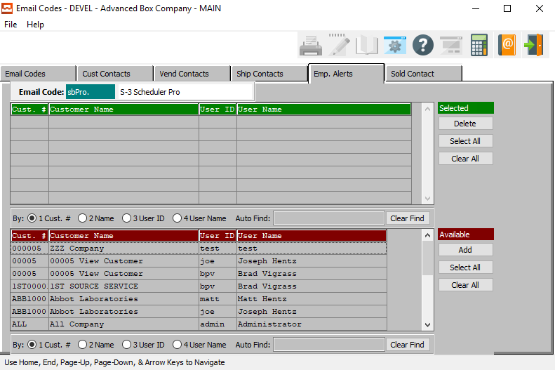

#### DELETE (Selected)

To delete the currently selected Employee Alert, simply press the ***"D"*** key. Alternatively, click the ***“Delete”*** button at the bottom of the screen.

#### SELECT ALL (Selected)

Click the ***“Select All”*** button in the ‘*Selected’* section to highlight all Employee Alerts that are currently in the *‘Selected’* section. The user may use this for mass deletion of items within this section, as opposed to deleting contacts individually.

#### CLEAR ALL (Selected)

Click the ***“Clear All”*** button in the ‘*Selected’* section to un-highlight all Employee Alerts that are currently in the *‘Selected’* section.

#### ADD (Available)

Click on the selected contact from the ‘*Available’* list to highlight it, then click the ***“Add”*** button to add the selected column to the ‘*Selected’* list.

#### SELECT ALL (Available)

Click the ***“Select All”*** button in the ‘*Available’* section to highlight all Employee Alerts that are currently in the *‘Available’* section. The user may use this for mass deletion of all items within this section, as opposed to deleting contacts individually.

#### CLEAR ALL (Available)

Click the ***“Clear All”*** button in the ‘*Available’* section to un-highlight all Employee Alerts that are currently in the *‘Available’* section.

### Sold Contact

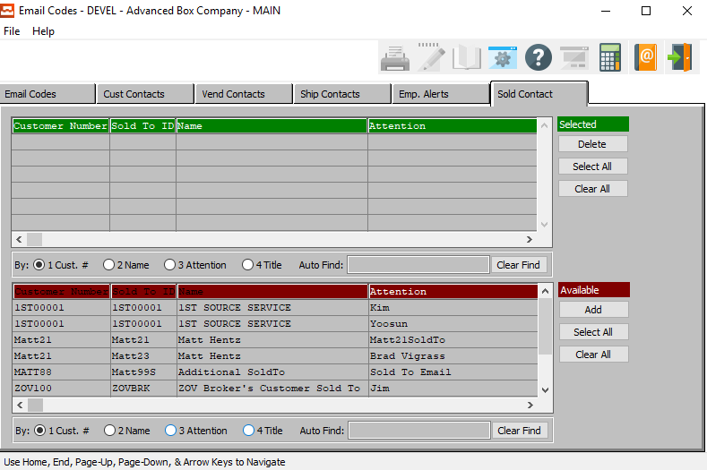

#### DELETE (Selected)

To delete the currently selected Sold Contact, simply press the ***"D"*** key. Alternatively, click the ***“Delete”*** button at the bottom of the screen.

#### SELECT ALL (Selected)

Click the ***“Select All”*** button in the ‘*Selected’* section to highlight all Sold Contacts that are currently in the *‘Selected’* section. The user may use this for mass deletion of items within this section, as opposed to deleting contacts individually.

#### CLEAR ALL (Selected)

Click the ***“Clear All”*** button in the ‘*Selected’* section to un-highlight all Customer Contacts that are currently in the *‘Selected’* section.

#### ADD (Available)

Click on the selected contact from the ‘*Available’* list to highlight it, then click the ***“Add”*** button to add the selected column to the ‘*Selected’* list.

#### SELECT ALL (Available)

Click the ***“Select All”*** button in the ‘*Available’* section to highlight all Sold Contacts that are currently in the *‘Available’* section. The user may use this for mass deletion of all items within this section, as opposed to deleting contacts individually.

#### CLEAR ALL (Available)

Click the ***“Clear All”*** button in the ‘*Available’* section to un-highlight all Sold Contacts that are currently in the *‘Available’* section.

## Title Codes [NC4]

### Browse Titles

This selection shows all valid job title codes listed in the system. The browser shows the title and description. You may sort to browser list by Title Code or by Description by clicking on the desired sort option at the bottom of the screen. To view a title, you may double click on the selected job title or click the View Title tab. The icons at the top of the browser provide additional capabilities. The icon with the fountain pen allows you to view the notes for each title.

Each note records the users initials, date, description of the note and a full-page of text for each note. Unlimited notes may be defined for each title. The browse icon will provide immediate access to the browser by title. The icon with the corner of a page folded over allows you to print a list of the job titles.

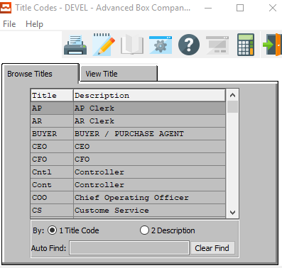

### View Title

The view Title screen allows you to view the information of each job title. You may copy, change, add or delete any information from this screen. Use the arrow keys at the bottom of the screen to view the next or previous title. The icons at the top of the screen provide additional capabilities.

The browse icon will provide immediate access to the browser by title. The icon with the fountain pen allows you to view any notes for the title record selected. The icon with the corner of a page folded over allows you to print a list of the job title codes and descriptions.

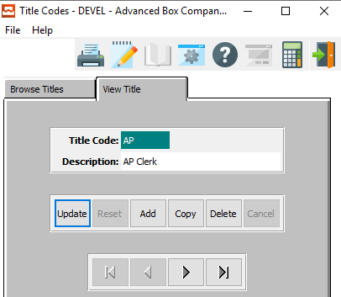

#### UPDATE

To change the currently selected Title Code, simply click the ***“Update***” button at the bottom of the screen.

#### ADD

Click the ***“Add”*** button at the bottom of the screen to add a new Title Code.

#### COPY

Click the ***“Copy”*** button to copy information from the currently selected Title Code.

#### DELETE

To delete the currently selected Title Code, simply press the ***"D"*** key. Alternatively, click the ***“Delete”*** button at the bottom of the screen.

#### NEXT

Press ***"N"*** (Next) to find next Title Code to view or modify. Alternatively, press the ***“Right Arrow”*** on the screen.

#### PREVIOUS

Press ***"P"*** (Previous) to find previous Title Code to view or modify. Alternatively, press the ***“Left Arrow”*** on the screen.

### Add/Update Title

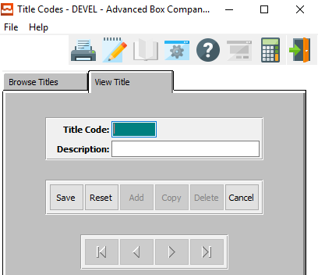

#### SAVE

Click the ***“Save”*** button to save all changes to the current Title Code.

#### RESET

Click the ***“Reset”*** button to reset all fields to their original state.

#### CANCEL

Click the ***“Cancel”*** button to cancel all changes to the Title Code without saving.

### Add/Update Title Field Definitions

#### Title Code

Enter a user-defined code for this title.

#### Description

Enter a short description for this title code.

## Zip Codes [NC6]

### Browse Zip Codes

This selection shows all valid zip codes listed in the system. The browser shows the zip code, preference type, preference number, city, state, area code, and daylight savings. You may sort to browser list by Zip/Postal Code or by City by clicking on the desired sort option at the bottom of the screen.

To view a zip code, you may double click on the selected zip code or click the View Zip Code tab. The icons at the top of the browser provide additional capabilities. The icon with the fountain pen allows you to view the notes for each zip code.

Each note records the users initials, date, description of the note and a full-page of text for each note. Unlimited notes may be defined for each zip code. The browse icon will provide immediate access to the browser by zip code. The icon with the corner of a page folded over allows you to print a list of the zip codes.

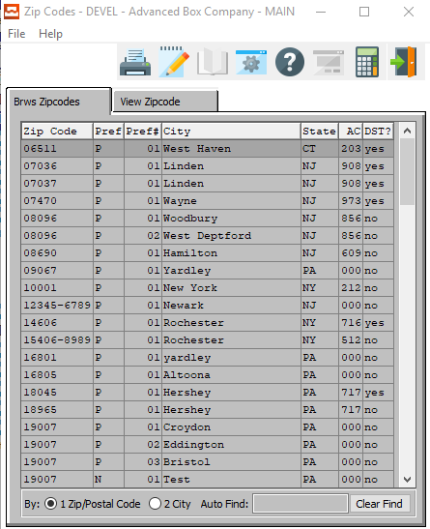

### View Zip Code

The view Zip Code screen allows you to view the information of each zip code. You may copy, change, add or delete any information from this screen. Use the ***“Arrow”*** keys at the bottom of the screen to view the next or previous zip code. The icons at the top of the screen provide additional capabilities.

The browse icon will provide immediate access to the browser by zip code. The icon with the fountain pen allows you to view any notes for the record selected. The icon with the corner of a page folded over allows you to print a list of the zip codes.

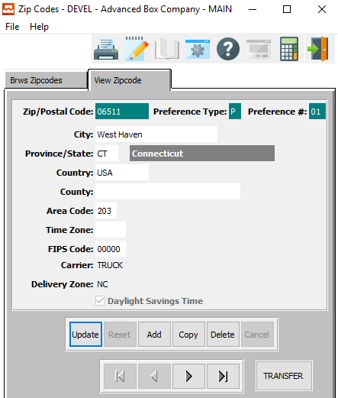

#### UPDATE

To change the currently selected Zip Code, simply click the ***“Update***” button at the bottom of the screen.

#### ADD

Click the ***“Add”*** button at the bottom of the screen to add a new Zip Code.

#### COPY

Click the ***“Copy”*** button to copy information from the currently selected Zip Code.

#### DELETE

To delete the currently selected Zip Code, simply press the ***"D"*** key. Alternatively, click the ***“Delete”*** button at the bottom of the screen.

#### NEXT

Press ***"N"*** (Next) to find next Zip Code to view or modify. Alternatively, press the ***“Right Arrow”*** on the screen.

#### PREVIOUS

Press ***"P"*** (Previous) to find previous Zip Code to view or modify. Alternatively, press the ***“Left Arrow”*** on the screen.

#### TRANSFER

Click the ***“Transfer”*** button to transfer the currently selected delivery zone by zip code from one customer file to another.

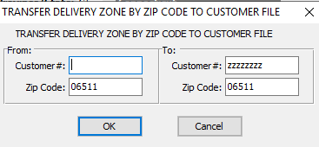

### Add/Update Zip Code

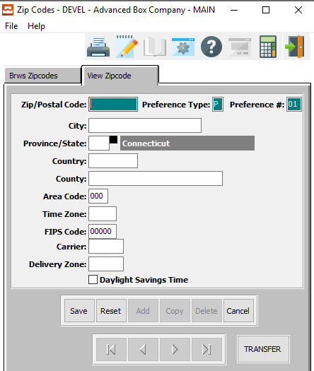

#### SAVE

Click the ***“Save”*** button to save all changes to the current Zip Code.

#### RESET

Click the ***“Reset”*** button to reset all fields to their original state.

#### CANCEL

Click the ***“Cancel”*** button to cancel all changes to the Zip Code without saving.

#### TRANSFER

Click the ***“Transfer”*** button to transfer the currently selected delivery zone by zip code from one customer file to another.



### Add/Update Zip Code Field Definitions

#### Zip/Postal Code

Enter the new zip or postal code in this field.

#### Preference Type

Enter the preference type for this zip code.

#### Preference #

Enter the preference number for this code.

#### City

Enter the city for the zip code.

#### Province/State

Enter the province or state for this zip code.

#### Country

Enter the country for this zip code.

#### County

Enter the county for this zip code.

#### Area Code

Enter the Area Code for this zip code.

#### Time Zone

Enter the time zone for this zip code.

#### FIPS Code

Enter the FIPS code for this zip code.

#### Carrier

Enter the default carrier for this zip code.

#### Delivery Zone

Enter the delivery zone code for this zip code.

#### Daylight Savings Time – Toggle Box

To mark this zip code as adhering to the rules of daylight savings time, make sure that the Daylight Savings Time toggle box is checked.

# **K-Control Parameters [NK]**

## System Control Parameters [NK1]

### Overview

The system control parameters make is possible to develop one standard software package to all clients while allowing each individual customer to utilize the package with different methodologies. The description of the control parameter may be modified so that each company may describe the function in their own words.

Please Note: To view detailed information on individual system-standard parameters, please review the ***“N”-“K”-“1”*** Parameter Manual.

### Browse Control

This selection shows all parameter files in the system. The browser shows the file name. To view a file, you may double click on the selected file or click the View Parameter File tab. The icons at the top of the browser provide additional capabilities. The icon with the fountain pen allows you to view the notes for each file.

Each note records the users initials, date, description of the note and a full-page of text for each note. Unlimited notes may be defined for each file. The browse icon will provide immediate access to the browser by file name. The icon with the corner of a page folded over allows you to print a list of the parameter files.

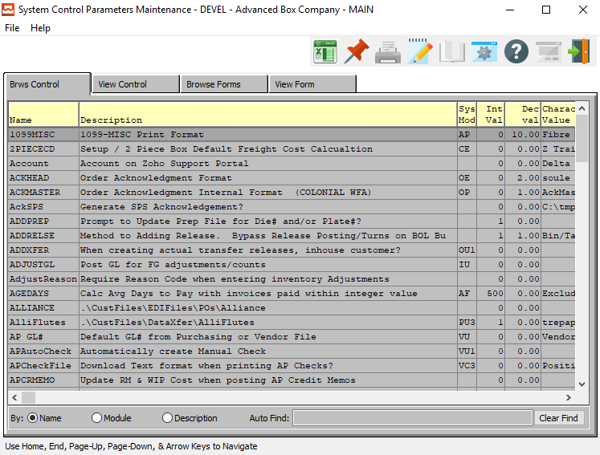

### View Control

The view Parameter File screen allows you to view the information of each file. You may copy, change, add or delete any file from this screen. Use the arrow keys at the bottom of the screen to view the next or previous parameter file. The icons at the top of the screen provide additional capabilities.

The browse icon will provide immediate access to the browser by file name. The icon with the fountain pen allows you to view any notes for the record selected. The icon with the corner of a page folded over allows you to print a list of the parameter files.

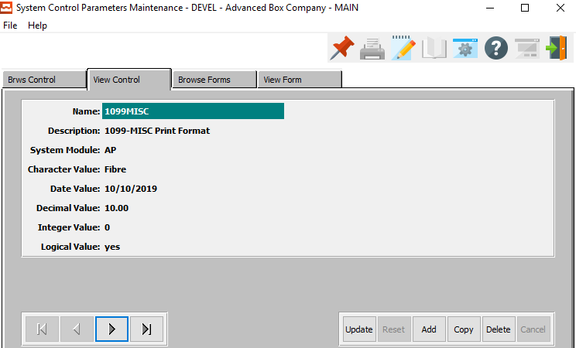

#### UPDATE

To change the currently selected Control, simply click the ***“Update***” button at the bottom of the screen.

#### ADD

Click the ***“Add”*** button at the bottom of the screen to add a new Control.

#### COPY

Click the ***“Copy”*** button to copy information from the currently selected Control.

#### DELETE

To delete the currently selected Control, simply press the ***"D"*** key. Alternatively, click the ***“Delete”*** button at the bottom of the screen.

#### NEXT

Press ***"N"*** (Next) to find next Control to view or modify. Alternatively, press the ***“Right Arrow”*** on the screen.

#### PREVIOUS

Press ***"P"*** (Previous) to find previous Control to view or modify. Alternatively, press the ***“Left Arrow”*** on the screen.

### Add/Update Control

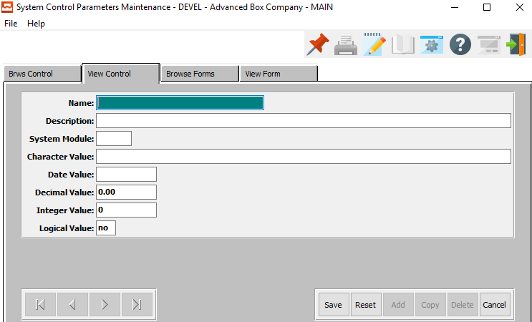

#### SAVE

Click the ***“Save”*** button to save all changes to the current Control.

#### RESET

Click the ***“Reset”*** button to reset all fields to their original state.

#### CANCEL

Click the ***“Cancel”*** button to cancel all changes to the Control without saving.

### Add/Update Control Field Definitions

#### Name

The name is programmed by Advanced Software, Inc and cannot be changed. Each program name acts as a switch or toggle to turn on a feature of the software so that the standard industry packaged software becomes customized for each installation.

#### Description

The description describes the nature of the enhancement as well as a help message for the use of the software feature. This may be changed to better explain the function.

#### Character Value

The character value is used by Advanced Software, Inc to define names of forms, bin locations or default specific calculations as well as various print options. The character values are utilized to define the names of all forms including acknowledgments, quotations, release tickets, bills of lading and invoices. To select the options available for this field, the page up or page down key will scroll through the options available for each program.

Please Note: The Bill of Lading Form defined in this field will print for all customers that are not defined in the View Form Tab.

Please Note: Bill of Ladings that are signed by the customers must be scanned via a program such as Adobe Photoshop. When saving the file, the file name must be the BOL number with the extension of “.jpg” and the file must be saved in the folder designated in the character value of the N-K-1 BolSign control parameter.

The signed bill of lading can be reprinted via the BOL ICON displayed in the Order Inquiry via the Invoice folder screen.

#### Date Value

This field is used to define a default date. This field provides a default date to printing release tickets up to this date as defined in the RELPRINT feature. If no date is defined, then the user is forced to manually enter a date during release printing so that only releases or deliveries are only printed a day at a time.

#### Decimal Value

This field could be used as a default number including decimals. For example, the SETPRINT option allows a matching markup percentage to be defined as the default for estimate calculations for Corrware Set estimates.

#### Integer Value

This field could be used as a default whole number without a decimal value. For example, the number of invoice copies to print may be defined with the INVCOPYS feature.

#### Logical Value

This field as a “***Yes”*** or ***“No”*** response to turn the modification on or off. This is used to print or not print the label headings on the forms.

### Browse Forms

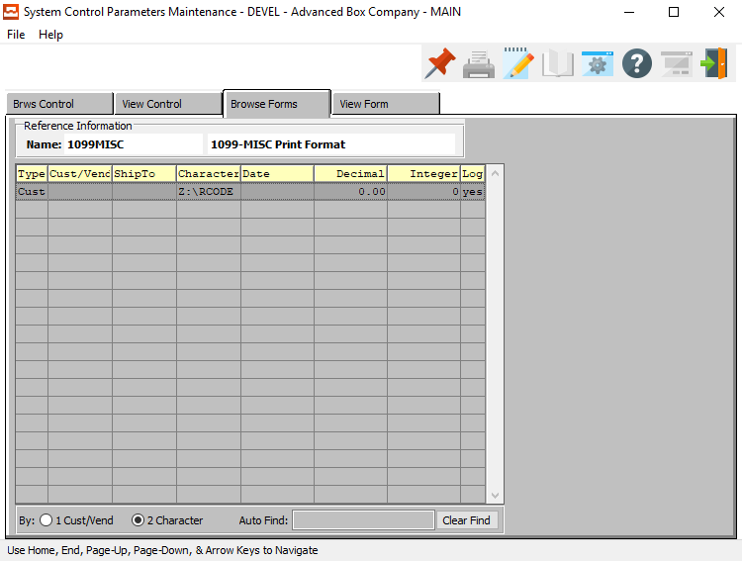

### View Form

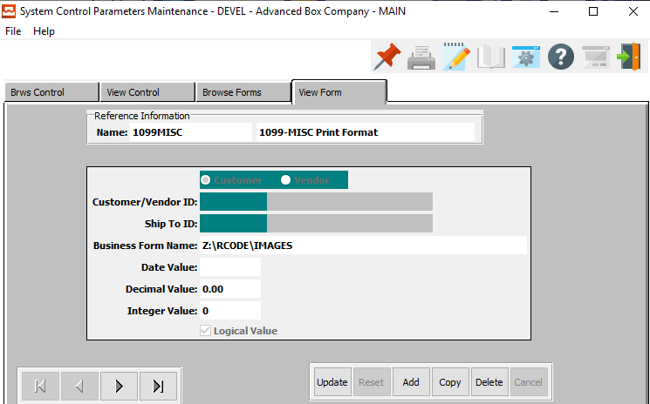

#### UPDATE

To change the currently selected Form, simply click the ***“Update***” button at the bottom of the screen.

#### ADD

Click the ***“Add”*** button at the bottom of the screen to add a new Form.

#### COPY

Click the ***“Copy”*** button to copy information from the currently selected Form.

#### DELETE

To delete the currently selected Form, simply press the ***"D"*** key. Alternatively, click the ***“Delete”*** button at the bottom of the screen.

#### NEXT

Press ***"N"*** (Next) to find next Form to view or modify. Alternatively, press the ***“Right Arrow”*** on the screen.

#### PREVIOUS

Press ***"P"*** (Previous) to find previous Form to view or modify. Alternatively, press the ***“Left Arrow”*** on the screen.

### Add/Update Form

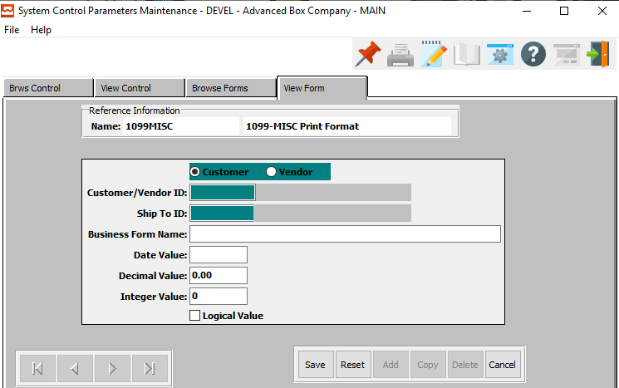

#### SAVE

Click the ***“Save”*** button to save all changes to the current Form.

#### RESET

Click the ***“Reset”*** button to reset all fields to their original state.

#### CANCEL

Click the ***“Cancel”*** button to cancel all changes to the Form without saving.

### Add/Update Form Field Definitions

#### Customer/Vendor (Choice)

To choose the preferred Form choice of Customer vs. Vendor, please make sure the desired option choice bubble is toggled.

#### Customer / Vendor ID

Enter the customer or vendor ID code for this form.

#### Ship-To ID

Enter the Ship-To ID for this form.

#### Business Form Name

Enter a specific Business Form Name for this customer or vendor. All other customers and vendors will print the Bill of Lading form defined in the View Control Character Value.

#### Date Value

This field is used to define a default date. This field provides a default date to printing release tickets up to this date as defined in the RELPRINT feature. If no date is defined, then the user is forced to manually enter a date during release printing so that only releases or deliveries are only printed a day at a time.

#### Decimal Value

This field could be used as a default number including decimals. For example, the SETPRINT option allows a matching markup percentage to be defined as the default for estimate calculations for Corrware Set estimates.

#### Integer Value

This field could be used as a default whole number without a decimal value. For example, the number of invoice copies to print may be defined with the INVCOPYS feature.

#### Logical Value – Toggle Box

This field as a “***Yes”*** or ***“No”*** response to turn the modification on or off. This is used to print or not print the label headings on the forms. To indicate a yes, make sure that the Logical Value toggle box is checked.

## Help Maintenance [NK2]

### Browse Help

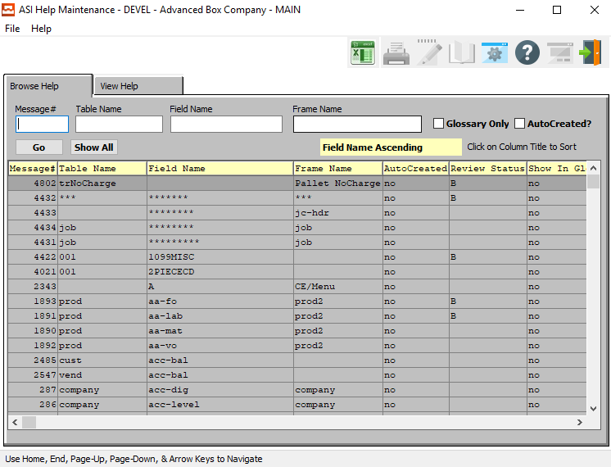

#### Message #

Enter a message number to search for.

#### Table Name

Enter a table name to search for.

#### Field Name

Enter a field name to search for.

#### Frame Name

Enter a frame name to search for.

#### Glossary Only – Toggle Box

To only search for help items from a glossary, make sure that the Glossary Only toggle box is checked.

#### Auto Created? – Toggle Box

To only search for help items that are marked as Auto Created, make sure that the AutoCreated toggle box is checked.

### View Help

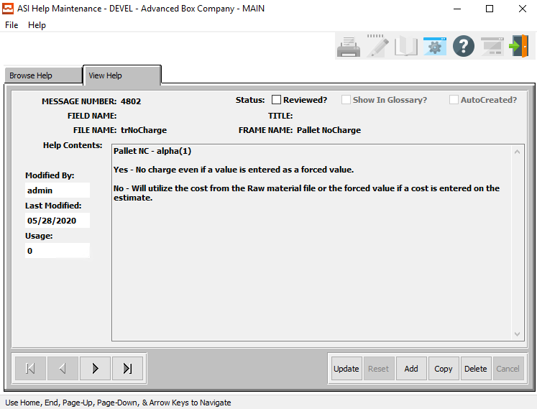

#### UPDATE

To change the currently selected Help Item, simply click the ***“Update***” button at the bottom of the screen.

#### ADD

Click the ***“Add”*** button at the bottom of the screen to add a new Help Item.

#### COPY

Click the ***“Copy”*** button to copy information from the currently selected Help Item.

#### DELETE

To delete the currently selected Help Item, simply press the ***"D"*** key. Alternatively, click the ***“Delete”*** button at the bottom of the screen.

#### NEXT

Press ***"N"*** (Next) to find next Help Item to view or modify. Alternatively, press the ***“Right Arrow”*** on the screen.

#### PREVIOUS

Press ***"P"*** (Previous) to find previous Help Item to view or modify. Alternatively, press the ***“Left Arrow”*** on the screen.

### Add/Update Help

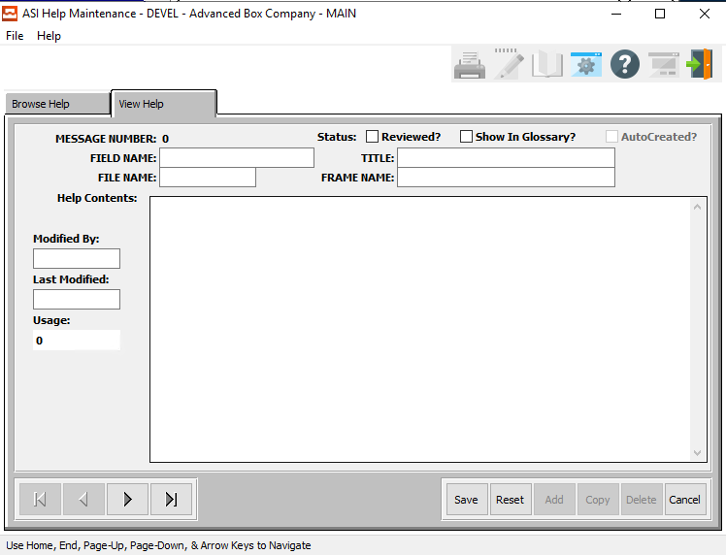

#### SAVE

Click the ***“Save”*** button to save all changes to the current Help Item.

#### RESET

Click the ***“Reset”*** button to reset all fields to their original state.

#### CANCEL

Click the ***“Cancel”*** button to cancel all changes to the Help Item without saving.

#### NEXT

Press ***"N"*** (Next) to find next Help Item to view or modify. Alternatively, press the ***“Right Arrow”*** on the screen.

#### PREVIOUS

Press ***"P"*** (Previous) to find previous Help Item to view or modify. Alternatively, press the ***“Left Arrow”*** on the screen.

### Add/Update Help Field Definitions

#### Review? – Toggle Box

To mark this form as needing review, make sure that the Review toggle box is checked.

#### Show in Glossary? – Toggle Box

To show this form in the glossary, make sure that the Show in Glossary toggle box is checked.

#### Field Name

Enter a field name for this Help information.

#### Title

Enter a title for this Help information.

#### File Name

Enter a file name for this Help information.

#### Frame Name

Enter a frame name for this Help information.

#### Help Contents

Enter all the desired help contents for this Help Information.

#### Modified By

Enter the username of the last user to modify this help section.

#### Last Modified

Enter the date on which this help section was last modified.

## Popup Menu Maintenance [NK3]

### Overview

The Popup Maintenance is the master file that ultimately allows each user to define their POPUP icon to show the files, reports, inquires and utilities that they most often use. Once defined, the user can access their favorites from any screen in Advantzware.

This provides the ability to customize to the ***“F6”*** Popup Menu which may be used throughout the software. Any file may be added to the Popup window with this maintenance program. To add a file to the menu, you must know the program name. To find the program name, simply press the ***“F3”*** Help Key from the file that you wish to display, write down the exact name and then add to the ***“F6”*** Menu Popup.

Each user can define their own Popup Maintenance via the Network Users administration.

The systems administrator or each user with security can define what menu options and what order. It is best to delete all user menu options, then imports the ***“N”-“K”-“1”*** master menu. Once defined, the icon for computer multitasking displays the menu options.

Each user can define their own Popup Maintenance via the Network. The advantage is that the user can stay focused on the screen where they are working. For example, the user can Add order, create PO, print the PO, create release, print and post release, create load tags, view and post finished goods receipts, print the bill of lading and create the invoice all from order entry.

### Pop-Up Maintenance Screen

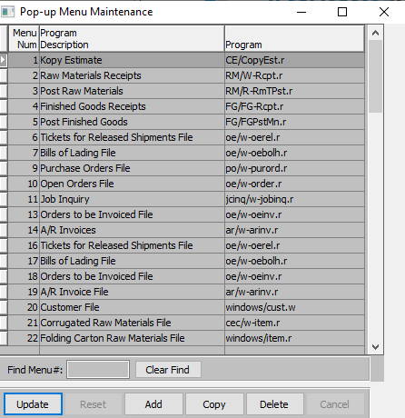

#### UPDATE

To change the currently selected Popup Menu, simply click the ***“Update***” button at the bottom of the screen.

#### ADD

Click the ***“Add”*** button at the bottom of the screen to add a new Popup Menu.

#### COPY

Click the ***“Copy”*** button to copy information from the currently selected Popup Menu.

#### DELETE

To delete the currently selected Popup Menu, simply press the ***"D"*** key. Alternatively, click the ***“Delete”*** button at the bottom of the screen.

### Add/Update Pop-Up Maintenance

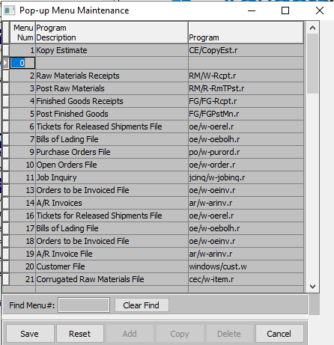

#### SAVE

Click the ***“Save”*** button to save all changes to the current Popup Menu.

#### RESET

Click the ***“Reset”*** button to reset all fields to their original state.

#### CANCEL

Click the ***“Cancel”*** button to cancel all changes to the Popup Menu without saving.

### Add/Update Pop-Up Maintenance Field Definitions

#### Menu Number

Enter the Menu option number. It is recommended to put the order files near the top to access them quicker.

#### Program Description

Enter the description that you want to display on the ***“F6”*** Menu for this file.

#### Program

Enter the program name including the directory for the file.

## New License Code Entry [NK4]

### License Overview – Concurrent User License Model

#### User Definition and Types

With the Concurrent User model, a User can be:

1. A Client Device – Client Devices include, but are not limited to, workstations, personal computers, PDA devices, cellular phones and laptops that are operated by a human.
2. A Non-Human Operated Device – Non-Human Operated Devices include, but are not limited to, temperature devices, production line bar code scanners and tracking devices.
3. A Server Process – A Server Process is any process that is not initiated by a Client Device or Non-Human Operated Device. Server Processes include, but are not limited to, automated controls, background jobs or automated processes.

Licensees must be able to identify and count each User and are not permitted to estimate the Concurrent User license count based on the number of connections needed to serve the Users.

#### Counting Methodology

The Concurrent User license count must be the greater of:

1. The peak number of Client Devices and Non-Human Operated Devices that simultaneously use an Open Edge client product or simultaneously use an application that can access an Open Edge server product.
2. The peak number of Server Processes that can simultaneously use an Open Edge server product.

### License Overview – Registered Client License Model

#### User Definition and Types

With the Registered Client model, a User can be:

1. A Client Device – Client Devices include, but are not limited to, workstations, personal computers, PDA devices, cellular phones and laptops that are operated by a human.
2. A Non-Human Operated Device – Non-Human Operated Devices include, but are not limited to, temperature devices, production line bar code scanners and tracking devices.
3. A Server Process – A Server Process is any process that is not initiated by a Client Device or Non-Human Operated Device. Server Processes include, but are not limited to, automated controls, background jobs or automated processes.

Licensees must be able to identify and count each User and are not permitted to estimate the Concurrent User license count based on the number of connections needed to serve the Users.

#### Counting Methodology

The Registered Client license count must be equal to the total number of Client Devices, Non-Human Operated Devices and Server Processes that can use an Open Edge client product or use an application that can access an Open Edge server product.

### License Overview – Named User License Model

#### User Definition and Types

1. A Human
2. A Non-Human Operated Device – Non-Human Operated Devices include, but are not limited to, temperature devices, production line bar code scanners and tracking devices.
3. A Server Process – A Server Process is any process that is not initiated by a Client Device or Non-Human Operated Device. Server Processes include, but are not limited to, automated controls, background jobs or automated processes.

Licensees must be able to identify and count each User and are not permitted to estimate the Named User license count based on the number of connections needed to serve the Users.

#### Counting Methodology

The Named User license count must be equal to the total number of humans, Non-Human Operated Devices and Server Processes that can use an Open Edge client product or use an application that can access an Open Edge server product.

### Code Entry Screen

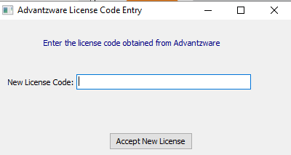

#### ACCEPT NEW LICENSE

Click the ***“Accept New License”*** button after entering the new license code in order to active the newly acquired license.

#### New License Code

Enter the new license code obtained from Advantzware.

## User Control [NK5]

### Current Screen

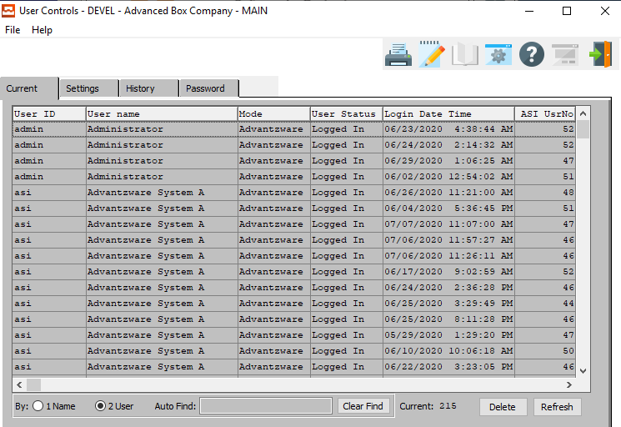

#### DELETE

To delete the currently selected User Control, simply press the ***"D"*** key. Alternatively, click the ***“Delete”*** button at the bottom of the screen.

#### REFRESH

Click the ***“Refresh*** button to refresh the current controls browser screen.

### Settings Screen

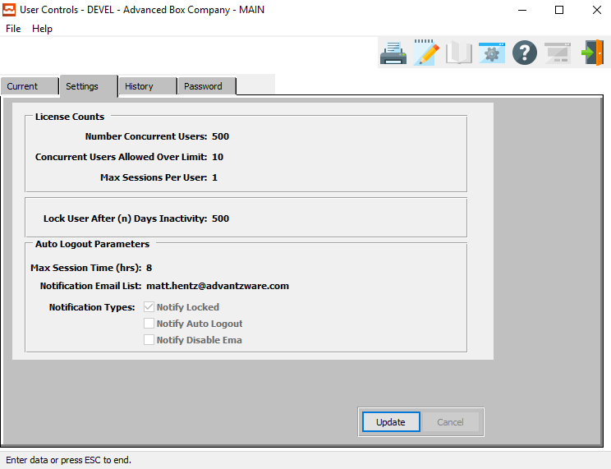

#### UPDATE

To change the currently selected User Control Settings, simply click the ***“Update***” button at the bottom of the screen.

### Update Settings

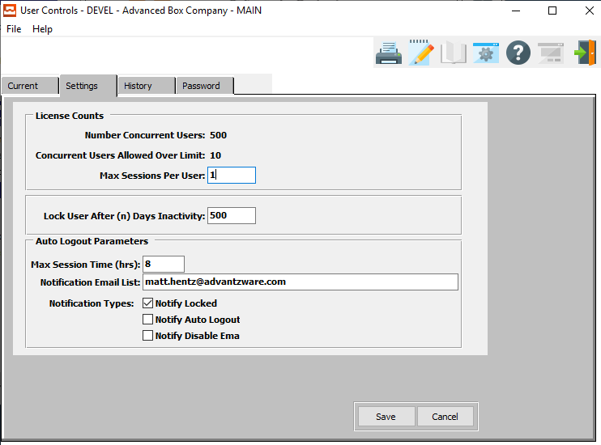

#### SAVE

Click the ***“Save”*** button to save all changes to the current User Control Settings.

#### CANCEL

Click the ***“Cancel”*** button to cancel all changes to the User Control Settings without saving.

### Update Settings Field Definitions

#### Max Sessions Per User

Enter the number of the maximum sessions that one user can run at the same time.

#### Lock Users After (n) Days Inactivity

Enter a number of days after which to lock a user out for inactivity.

#### Max Session Time (Hours)

Enter a maximum number of hours that a user can be logged into a section before inactivity will log them out.

#### Notification Email List

Enter a list of emails to send notifications to about this user’s flagged activity.

#### Notify Locked – Toggle Box

To send an email to all those on the notification email list if this user has been locked due to inactivity, make sure that the Notify Locked toggle box is checked.

#### Notify Auto Logout – Toggle Box

To send an email to all those on the notification email list if this user has been logged out due to inactivity, make sure that the Notify Auto Logout toggle box is checked.

#### Notify Disable Time – Toggle Box

To send an email to all those on the notification email list if this user is nearing their disable time, make sure that this toggle box is checked.

### History Screen

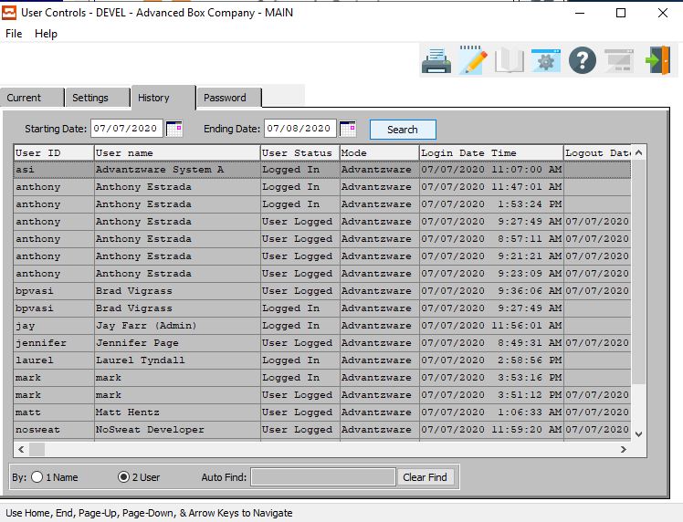

#### Starting Date / Ending Date

Enter the beginning and ending History Date to search for.

### Password Screen

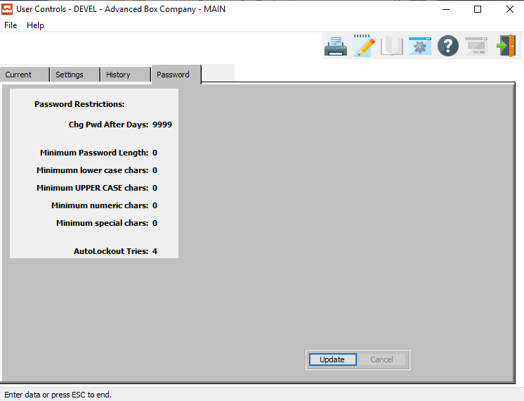

#### UPDATE

To change the currently selected password control system, simply click the ***“Update***” button at the bottom of the screen.

### Update Passwords

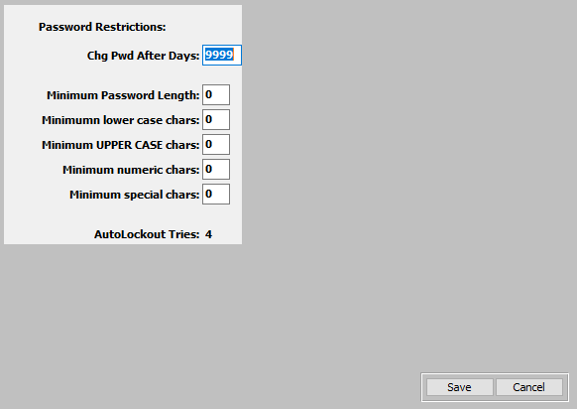

#### SAVE

Click the ***“Save”*** button to save all changes to the current password control system.

#### CANCEL

Click the ***“Cancel”*** button to cancel all changes to the password control system without saving.

### Update Passwords Field Definitions

#### Change Password After Days

Enter the number of days that may go by before a user is forced to update their current password.

#### Minimum Password Length

Enter the minimum number of characters that a user’s password must be.

#### Minimum Lower-Case Characters

Enter the minimum number of lower-case characters that a user’s password must contain.

#### Minimum Upper-Case Characters

Enter the minimum number of upper-case characters that a user’s password must contain.

#### Minimum Numeric Characters

Enter the minimum number of numeric characters that a user’s password must contain.

#### Minimum Special Characters

Enter the minimum number of special characters that a user’s password must contain.

# **Miscellaneous Utilities [NM]**

## Utilities Screen

### Browse Utilities

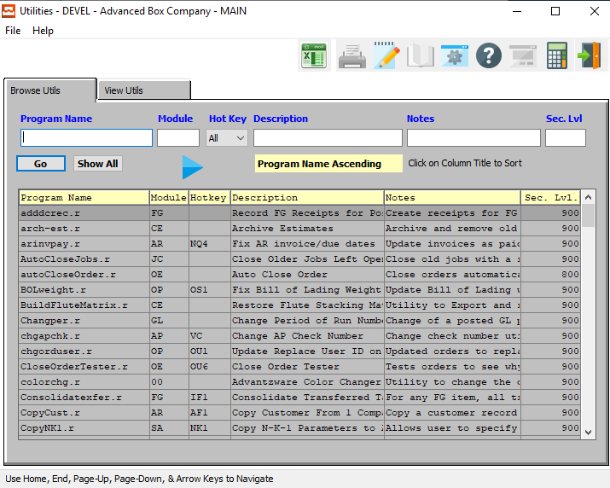

#### RUN UTILITY

Click the ***“Blue Play Icon***” button to run the currently highlighted/selected Utility Program.

### Browse Utilities Field Definitions

#### Program Name

Enter a program name to search for.

#### Module

Enter a module code to search for.

#### Hot Key

Choose a hot key to search for from the drop-down menu.

#### Description

Enter a program description to search for.

#### Notes

Enter any notes to search for.

#### Sec. Level

Enter a security level to search for.

### View Utilities

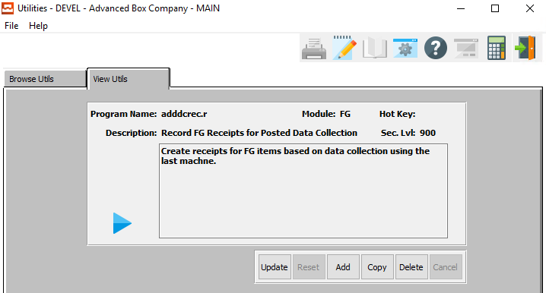

#### UPDATE

To change the currently selected Utility Program Description, simply click the ***“Update***” button at the bottom of the screen.

#### ADD

Click the ***“Add”*** button at the bottom of the screen to add a new Utility Program Description.

#### COPY

Click the ***“Copy”*** button to copy information from the currently selected Utility Program Description.

#### DELETE

To delete the currently selected Utility Program Description, simply press the ***"D"*** key. Alternatively, click the ***“Delete”*** button at the bottom of the screen.

#### RUN UTILITY

Click the ***“Blue Play Icon***” button to run the currently highlighted/selected Utility Program.

### Add/Update Utility

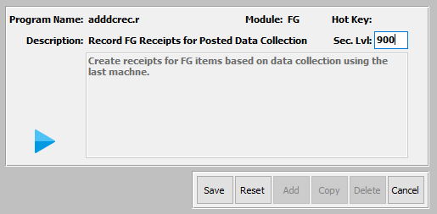

#### SAVE

Click the ***“Save”*** button to save all changes to the current Utility Program Description.

#### RESET

Click the ***“Reset”*** button to reset all fields to their original state.

#### CANCEL

Click the ***“Cancel”*** button to cancel all changes to the Utility Program Description without saving.

#### RUN UTILITY

Click the ***“Blue Play Icon***” button to run the currently highlighted/selected Utility Program.

#### Sec. Level

Enter a security level for the currently selected program. Only those users with a minimum of the entered security level will be able to run the utility.

## Utility Programs

### Current Program List – Beginning with (A-B)

#### ADDDCREC – Record FG Receipts for Posted Data Collection

Utility to search data collection for quantity produced on the last machine in the job file, then creates a finished goods receipt for the unit count in the finished goods bin file with the cases per pallet from the bin file. This data may be available on a job previously created before the current job.

#### ARINVPAY – Fix AR Invoice/Due Dates

Jobs will close automatically based on the N-K CLOSEJOB character value option. Jobs that are not closed, but are past the due date should be closed automatically. This new utility will be called AUTO CLOSE JOBS. The user will have option to enter a job number range and DAYS PAST DUE. If the user enters 5, then all jobs OPEN with the DUE DATE in the Job file past 5 days will automatically close.

Also, Reopen Jobs will require a password as defined in the N-K-1 JOBPASSWORD. Logical Value = YES will prompt for a password that is defined in the character value field.

#### AUTOCLOSEJOBS – Utility to Close Older Jobs Left Open

This utility will close any open jobs older than a user-selected date.

#### BOLPOST – Un-post Bill of Lading Posted but Not Invoiced

The utility will un-post a posted Bill of Lading. When an order has a release with a status of ***"Z"***, but the bill of lading cannot be found or then this utility will allow the original BOL to be un-posted so that the release can be processed.

#### BOLWEIGHT – Utility to Correct Bill of Lading Weight per Line

Utility to update weight on posted or un-posted bill of ladings. These will multiple bill of lading quantity for each quantity /100 times finished good weight/100. The total of all lines should update the Total BOL weight.

### Current Program List – Beginning with (C)

#### CHANGPER – Change Period of Run Number

This utility program will change the period of a user-selected run number.

#### CHECKRUN – Check the Run# Amounts vs. Posted Amounts

New utility to check the run# amounts against what actually got posted to GL by date range. If it doesn’t match, then display the amounts.

#### CHGAPCHK – Change AP Check Number

This utility program will change a user-selected Accounts Payable check number.

#### CHGORDUSER – Utility to Update Replace User ID on All Orders

This utility program will update and replace a user-selected User ID on all orders connected to an old user ID.

#### CHK-MOD2 – Security for N-K POEXPORT

This utility program will allow a user to set security parameters for the N-K-POEXPORT system.

#### CONSOLIDATEXFER – Consolidate Transferred Rags

This utility program will consolidate user-selected transferred rags.

#### COPYCUST – Copy Customer from One Company to Another Company

This utility is to copy customer master file from one company to the next company within the existing database. i.e. from company 001 to company 002. Provide a dropdown list of customers that may be selected to copy.

#### COPYNK1 – Copy N-K-1 Parameters to Another Company

This utility program will copy all user-selected N-K-1 parameters to another user-selected company.

#### COPYRM – Copy Raw Material from Company A to Company B

This utility will allow the user to copy a raw material’s information from one company’s raw materials list to another, without having to enter all of the information manually.

This will display item code that is in process of copying. When Finished, System will Display: All Records Copied.

Please Note: This must copy corrugated item to Corrugated based on item file.

#### COPYRMTAGCOST – Copy RM Tag Receipt Cost to Tag Issues, Transfers, Cycle

This utility program will copy a user-selected raw material tag receipt cost to other user-selected tag issues and cycles.

#### COPYSCORES – From Box Design to Spec Folder W & L

This utility is to copy box design scores on estimate Box design folder to SPEC folder Width and length panels.

#### COPYSTYLE – Copy Style from Company A to Company B

This utility will allow the user to copy complete style information from one company’s Style list to another, without having to enter all of the information manually.

This will display item code that is in process of copying. When Finished, System will Display: All Records Copied.

Please Note: Choosing ***“Yes”*** will also copy the FLUTE FILE and FLUTE MATRIX.

#### CORKRAFT – Utility to Build XRef Table for Corrukraft

This utility program will allow a user to build a cross reference table for Corrukraft.

#### CRTFGLOC – Set Up Finished Goods by Location

This utility program will set up user-selected Finished Goods by a user-selected location.

#### CRTFGREC – FG Receipts from BOL Shipments (Task# 3280303)

Create FG Receipts from Posted BOLs Task # 03280303- This utility will post a FG receipt for all Bill of Ladings that they have posted and are missing a finished good receipt record. This utility could be run again and again without duplicating the records.

This utility will also transfer the cost from the FG bin record on the bill of lading to the invoice history file. Therefore, if I review job 879 which only has a bill of lading shipment, this will create a Finished Good receipt matching that BOL. Same job number, unit counts, partial unit. Cost, etc.

#### CRTFGSHP – Utility to Build FG Receipts from BOL Shipments

When the order control file is set to Update Inventory when Posting? INV

This utility fixes the bug related to order entry control flag set the update inventory = INV. This will create a FG shipment for each Bill of Ladings that they have posted and are missing a finished good shipment record which did not update the bin file. This utility could be run again and again without duplicating the records.

This utility will also transfer the cost from the FG bin record on the bill of lading to the invoice history file.

#### CRTINV – Add Invoice from BOL Lines

This utility program will add invoices from user-selected bill of lading lines.

#### CUSTRECK – Utility to change Blank Record Key for Customer Notes

This utility program will allow a user to change any blank records keys from user-selected customer notes.

#### CVTSMTX – Update Salesman DB to Version 4.10

This utility program will update a user-selected salesman database to a new system version without manually having to do so.

### Current Program List – Beginning with (D-E)

#### D-CUSTFG – Re-sequence Finished Goods Item Code by Customer

Worksheet to Renumber FG Items by Customer - Create a worksheet browser that can be updated or deleted. The browser will show all the FG numbers that you would like to change the customer number within the FG from the old to the new #.

You will be able to do all the items, or delete the ones from the browser that you do not want to change at this time. This will work similar to a find and replace utility. You will be able to specify the characters within the number to change from old to new. This must validate that the number it is being changed to new item that does not already exist; if it does it will go to the next higher number in the sequence.

#### D-UNDORD – Undo Deleted Orders

When orders are deleted, the status is changed. Only when the order is purged will the order be purged from the system. Add Utility to undelete the deleted order.

#### DEF-REL-STATE – Update Release Status Field

This utility program will update a user-selected release status field.

#### DEF-RM-ITEM – Update Raw Material Inventory Fields

Define Raw Materials Inventory Fields - This utility will universally set Items to specific field such as Auto Allocate, Stocked, Consumption UOM and more.

#### DEFE-I-V – Set Board Vendor Sheet Limits to 999

To set all RM cost matrix to 999 - This changes all raw material maximum sheet width and maximum sheet length to 999. If the dimensions are zero, then the vendor names will not appear when calculating an estimate.

This utility will set all the maximum width and maximum length in the board cost matrix for each vendor defined. This will overwrite any dimensions that may be assigned.

When calculating an estimate, the estimator may select a specific vendor, or the estimator may allow the program to select the vendor with the best price for each estimated quantity. Both options will only show vendors that have the material cost matrix defined for the material on the job. Also, the vendor’s machine must be able to manufacture the sheet size as defined on this cost matrix. If the dimensions are all zero, then that vendor will not be used during the cost calculation.

#### DELETEOF4PRICES – Purge Obsolete Price Matrixes from OF3

This utility program will purge any obsolete prices matrixes from the OF3 system.

#### DELAPCHK – Purge AP Checks

Utility to purge individual or range of Accounts Payable checks. Only need to type in check# instead of vendor and check#. Enter the bank code for the checking account. This code can be found in the General Ledger bank file under (***“G”-“F”-“4”***) Enter the beginning and ending check number to purge.

Check the toggle box to delete associated payment records. You must check this box to delete all the check records from all check register reports and inquiry screens.

#### DELNOTES – Finished Goods Spec Notes Delete Utility (Drop Down)

This utility program will allow a user to delete user-selected Finished Good specification notes.

#### DELORDLN – Delete Duplicate Line Item with Qty 0

This utility program will allow the user to delete any duplicated line item with the quantity of zero within user-selected parameters.

#### DFITMTAX – Utility to Use the New Taxable Field

Utility to use the new taxable field. This was using a ref table field. This must be run after receiving this patch.

#### DPBOXIMG – Utility to Dump Box Images

This will download the box image from the database in which the program is run. This will allow the user to download to any folder and disk drive a necessary.

(Util/LDBoximg.r) This will load the box images from any disk drive and folder that is entered on the program.

#### DPINKS – Dump Inks from Advantzware System

Dump Inks to File - Utility to dump inks from Advantzware to a file. Once dumped, the inks may be loaded into a client’s database via the Load utility.

New utility to dump corrugate inks. Also new utility to load inks. I will dump the corrugated inks from our test database and load onto various clients. I will also load onto the corrugated and folding ship databases. This should be similar utility as the dump style and load style utility called DPSTYLE.r and LDSTYLE.r.

Ideally, we could dump either Folding material or corrugated materials or both.

#### DPSTYLE – Dump Styles to Style.Dat File

Data load program to import the latest corrugated box style file from the test database.

This will load the Box Design Number, Formula Folder and all the Score Allowances for each Corrugated Flutes.

#### DPUTILS – Util/DPUtils.r and Util/LDUtils.r

Dump utility will dump the utilities listed under Util/Utils from one database to a . DAT file.

Load utility will load into a database from a .Dat file.

#### DUMPDATA – Dump Customer, Finished Goods, Order and Invoice History

Dump Master Files to Excel - Dump customer master, finished goods item master, order header and line item details and invoice history files into Excel format. The program will display a list of files that may be dumped into excel. The files must be selected from the list and moved to the right column to confirm the download.

Each file may be downloaded separately and saved as any file name that is typed by the user. Clients should dump the data once to dump data and test interface. Once an interface is written and 100% tested, then the dump can be run again to download current data.

#### DUMPMODI – Dump Module Records

This utility program will dump any user-selected module records from the system.

### Current Program List – Beginning with (F)

#### FGCAPS – Capitalize all Finished Goods Item Codes

UTIL/FGCAPS.r Task # 12210402 - Utility will capitalize all letters in the FG item code.

#### FGTAGSMM – New Utility to Show FG item Not Equal to Tag number

The tag number is SS is created with the FG item code plus additional sequential number. This utility will show any tag number if the first 15 characters do not match.

#### FG-TAXED – To Change Tax Code for All FG Items

Put Utility Program on ***“N”-“Q”-“!”*** Called Default Tax Code for FG Items. Default to ***“Yes”***. When then enter this, then all items in the system will have taxable field set to ***“Yes”***.

#### FG-PURGE – Until Program will Delete Actual Releases

Until program will delete Actual Releases in the ***“O”-“T”-“1”*** file and Actual Bill of Ladings in the ***“O”-“S”-“1”*** file. After the users purge the FG history for a specific FG item, then they should be able to purge the finished goods item via the ***“N”-“F”-“1”*** Purge Finished

#### FIX-SHEETS-PO – Fix Cost of Rolls Sheet via Outside Vendor

This utility program will fix a user-selected cost of rolls sheet via user-selected outside vendors.

#### FIXSES-UNIT – Set Unit per Pallet

This utility program will set user-selected units per pallets.

#### FIXCEITM – Estimate FG Item Code Update (Task# 6030511)

New Utility to Change the Ink Code on Estimates by Estimate Range & Customer Range. From Old Ink Code to NEW INK CODE. Provide status messages what estimate is being updated as utility is running.

#### FIXFGHIS – Clear Vend PO# from FG Receipts if Job # present

This utility program will clear user-selected vendor purchase orders from finished good receipts if a user-selected job number is present on the order.

#### FIXFGUOM – Fix Finished Goods Cost UOM (Task# 03250304)

This utility program will allow users to fix a user-selected finished good cost unit of measure.

#### FIXGLHISTORY – Fix GL History Posting Run Amounts

This utility program will allow users to fix user-selected general ledger posting run amounts.

#### FIXJ-NO – Job-HDR Already Exists with Internal Job Number Bug

This utility program will allow a user to quickly fix a ‘job already exists’ system bug.

#### FIXMACHP – Build Machine Attachment Partition Records

This utility program will allow a user to quickly build partition records for a user-selected machine attachment.

#### FIXORDERS – Delete Order Line Items with Blank Item

This utility program will delete order lines with blank items within user-selected parameters.

#### FIXRECKEY – Purge Blank Record Keys that Create Lockups

This utility program will purge blank record keys that may create system lockups from within user-selected parameters.

#### FIXRELSTATE – Correct Release Status Mismatch

This utility program will correct any system release status mismatches from within user-selected parameters.

#### FIXRELSTATUS – Updates the Orders Release Status Field

This utility program will update user-selected order release statuses.

#### FIXRMREC – To Allow Adding AP Invoices for PO

Older character clients that have posted data to the raw material receipts prior to upgrading to the new GUI software must run this utility to update the raw material receipts records. Until this utility is run, they may not be able to add AP Invoices.

#### FIXSETHIST – Fix Set History for Ship Only Releases

Fix Set History Showing Negative Quantitates on ***“I”-“R”-“2”*** - These appear to be all set master numbers (end with 00) but the amounts seem co-incite with the previously reported issue of unassembled sets that are shipped by component that used to create a ***"S"*** entry in FG history now creating two ***"T"*** entries in FG history (one positive and one negative)

#### FIXSETS – Utility to Fix Set Button Item Code and Part#

Utility to Fix Set Button Item and Part Codes - Utility must transfer the SET MAINTENANCE folder to the estimate SET BUTTON including the FG item code, Customer Part#, Item Name, Description and Product Category from the Set FG item code. ASSEMBLED / UNASSEMBLED Flag from the Set FG item file and the ***“W”***, ***“L”***, ***“D”*** from the FG item TOTALS screen.

Utility to update the set header information. Single item estimates with quantity per set = 2 are not being updated. Add this logic to the utility.

#### FIXSNAME – Update Salesman Name on Order Entry

This utility program will allow a user to update a salesman’s name on a user-selected order entry.

#### FIXSNOTE – Fix Spec Notes for Finished Goods Items

This utility program will allow a user to fix specification notes on user-selected finished good items.

#### FIXTRANSDATE – Fix Finished Goods Transaction Date

This utility program will allow a user to fix transaction dates on user-selected finished good items.

#### FIXTSTME – Fix for Total Time of Touch Screen Machine Transactions

This utility program will allow a user to fix the total time of a user-selected touch screen machine transaction.

#### FFIXUSERID – Update all FG History User Id with "?" to "ASI"

This utility program will update all Finished Good history user ID’s that have become undefined to the default ‘ASI’.

#### FIXUSERS – Fix Users and User Records

This utility program will allow users to fix user-selected users and user records quickly.

#### FIXWIP – Utility to Fix Posted Work in Process

This utility program will allow users to fix a user-selected posted work in process item.

#### FX0FGTRN – Fix FG Transfers with Wrong Quantity

Fix Transferred Tags with Zero Quantity - Finished Goods Tag file shows correct Bin and Qty, but Transfers did not update the proper bin. The utility will fix the data.

#### FXACCT2 – Update Current Year Buckets

This utility program will allow user to update current year buckets throughout the system.

#### FXACCTG3 – Update Current & Last Year buckets

This utility program will update current and last year buckets throughout the system.

#### FXACTLYO – Update Last Year Opening Balance

This utility program will update the last year opening balance by updating it to user-selected information.

#### FXBOLPOST – Restore Bill of Lading to Non-Posted Status

This utility program will allow a user to restore a user-selected bill of lading to its initial non-posted status.

#### FXESTQTY – Restore Estimate Not Displaying

This utility program will allow a user to restore an estimate that is currently not displaying within the estimation browser.

#### FXGLTPER – Utility to Fix GLTrans Period Date

Utility to fix GLTRANS records. Will scan all General Ledger transaction records to check the period against the posting date. If the period does not match the posting date, it will correct it.

#### FXINVBOL – Update BOL# When Combined on a Single Invoice

Utility to correct invoice and Bill of Lading data. Specifically, this should be used when multiple bill of ladings for the same purchase order create a single invoice, and the bill of lading number on the invoice query all show the same BOL#.

#### FXITEMV – Fix Corrugated Vend Cost Record Key for Adder Markups

This utility program will all a user to fix a user-selected corrugated vendor cost key for user-selected adder markups.

#### FXMNOTE – Restore Job’s Machine Notes

This utility program will allow a user to restore a user-selected job’s previous machine notes.

#### FXOERETL – Returns Should Reduce the Ship Quantity

This utility program will allow a user to reduce the ship quantity of an item after any returns have taken place.

#### FXOESHIP – Update Order Browsers Ship Quantity

This utility program will allow a user to update user-selected order browser ship quantities.

#### FXOPENED – Fix Open Orders, Jobs and Purchase Orders Status

Fixes Orders, Jobs and PO's Open / Closed Status - This utility updates the open or closed status for all jobs, orders and purchase orders.

#### FXORDCST – Fix Order Cost/Margin

This utility program will allow a user to fix the cost or margin of a user-selected order.

#### FXORINVO – Update Order Line Item's Invoiced Qty

This utility program will allow a user to update a user-selected item invoice quantity for a user-selected order.

#### FXPMTXED – Fix Price Matrix Effective Date

This utility program will allow a user to fix an effective date for a user-selected price matrix.

#### FXPURUOM – Purchase UOM Set to EA for all FG & RM Items

This utility program will allow a user to change a purchase unit of measure for all finished good and raw material items.

#### FXRECKEY – Fix Customer File Record Keys to Fix Notes Without Dates

Utility that replaces blank dates and notes that have no record key. Without a date, the notes are not shown unless the user clicks the group or department radio button. In addition, a note without a record key will appear on multiple customer codes. This fixes notes by customer or by contacts under the phone icon.

Likewise fixes problem when Customer Contact Phone info will not stay in the correct customer file. After adding the info and it dumps it back to a different account. This new Utility fixes notes throughout the system that are BLANK and assigns a record key.

#### FXSHPQTY – Updates Orders Ship Quantity

This utility fixed a bug when closing line items of an order. The quantity allocated was not properly updated. This will fix the Quantity "Allocated to Orders" for all old closed orders.

#### FXSLSMAN – Utility to Update Estimate Commission, Order, and Invoice Lines

Run N-Y-1 and update salesmen & commissions only, then run N-R-util/fxslsman.r. Do not select update Pallet/Case as this will override the pallet and bundle that may have been manually updated during estimating.

This utility fixes the commission report that is missing commission dollars. This is a result of the order line is missing the commission percentage which is imported from the estimate commission percentage. Many older estimates do not have the commission percentage defined for the salesman.

Need utility to update every estimate with the commission percentage from the salesman matrix based on the product category. Next, the estimate commission percentage must transfer to the orders line item as well as the invoice line item. Once this data is corrected, the commission report could be rerun and should show the correct commission dollars.

#### FXTRNCS2 – Updates RM History Cost from Purchase Order

This utility program will update raw material history cost from a user-selected purchase order.

### Current Program List – Beginning with (G-N)

#### GLINVDIF – Report Shows Difference in Invoice Amount vs. Posted Amount

This utility program will look through the entire system and show the user any invoices that have a different amount from their posted amounts.

#### LDBOXIMG – Utility to Load Box Images

Util/DPboximg.r this will download the box image from the database in which the program is run. This will allow the user to download to any folder and disk drive a necessary.

Util/LDBoximg.r this will load the box images from any disk drive and folder that is entered on the program.

#### LDINKS – Load Inks from Inks.Dat File

Load and Dump Inks - Utility to dump inks from Advantzware to a file. Once dumped, the inks may be loaded into a client’s database via the Load utility.

#### LDSTYLE – Load Styles from Style.Dat File

This utility program will dump styles from Advantzware to a file. Once dumped, the styles may be loaded into a client’s database via the Load Utility.

#### ITEMREC – To fix Raw Goods Icon Error No FG Item Exists

This utility will correct the raw material error that seems to search for FG item Spec Code.

#### LOADMOD1 – Load Module Records

This utility program will dump module records from Advantzware to a file. Once dumped, the records may be loaded into a client’s database via the Load Utility.

#### LOADPREP – Load Prep / Die File from Estimate Spec Information

Load Prep Codes - UTIL/LoadPrep.r Utility to create PREP codes via Estimates Utility will search each item for each estimate and transfer the Die# and Plate# to the prep file including the estimate #, style, die# or Plate #, customer code, box length, width, depth, etc.

The last date modified on the estimate or the last ordered date from the order number on the estimate, whichever is more current will become the DATE LAST USED in the Prep file.  
Make Material Type D default description = Cutting Die

* Make Material Type P default description = Printing Plate
* Default Cost Type to MIS
* Default UOM to EA
* Default the 2nd Owner to the customer code as 0% ownership
* Die Width and Die Length should import.

#### LOADTAG – Load Tag Update Job Number on FG transactions

This utility program will update job numbers on load tags for user-selected Finished Good transactions.

#### MODULE – Menus for Add-ons per Module

This utility program will all the user to define menus for add-on modules.

#### MKFGINKS – Ink Colors Copied from Last Estimate to FG Item Colors

Util/mkfginks.r Task # 08040506 - Utility to copy ink colors from the last estimate created for each ink type and download the inks into the finished goods COLOR folder. This will copy each unique ink type.

#### MOVEEST – Move Estimate Files

This utility program will move user-selected estimate files to a new user-defined location.

#### MEWIR12 – IR12 New Version

This utility program will update any ***“I”-“R”-“@”*** files to their newest system versions quickly.

### Current Program List – Beginning with (O-R)

#### OEPOSTGL – Post OE Invoices to G/L

This utility program will post user-selected order entry invoices to the General Ledger system.

#### OHSHIPED – Show FG Tag Numbers Shipped and Also On-Hand Qty

Show Shipped Tags with Quantity on Hand – Task # 098150515 Add Utility to show all FG items / Tag # that have an On-Hand balance, but also have a quantity that has been shipped. There should no items in the category except for bugs via sharpshooter. Since Century does not ship partial pallets, the inventory on hand should have no shipment.

Since Most Tags are shipped complete, items with an On-Hand Balance need to be adjusted. The parameter called OESHIP will allow shipping components of unassembled sets separately from the finished goods set item.

 To activate, change the ***“N”-“K”-“1”*** OESHIP logical value to YES. When creating a set estimate, the SET Button must check the unassembled field.   When adding an order for this estimate, the set item as well as all the components will transfer to the order entry screen.   The sets quantity on the order will be multiplied by the quantity per set for each component to show the components order and release quantity. Set parts will be released just as any other item is normally released and shipped.

 Each item may be released and shipped separately with the exact quantity that was produced.   Over runs and under runs can now be shipped for each component.   When the last component is shipped to complete the set, the SET Finished Goods Items will be automatically transferred to the invoice for the Set quantity that may be invoiced.

The bill of lading post program will determine the component with the smallest quantity shipped per the QTY/SET ratio to determine how many sets should be invoiced. Every bill of lading posted for all components will create an invoice with a Zero Invoice Qty as well as the ship quantity.

#### PALLETISSUES – Update the Number of Pallets

This utility program will update the user-selected number of pallets.

#### PORECCST – Utility to Fix Invalid Raw Material Costs (Task 12270406)

This utility program will allow the user to fix any invalid raw material costs within the system.

#### PRODCODE – Update the Items Production Code as New / Repeat

Define FG Prod Cod as New or Repeat - This Utility will update all FG items Production Code as New or Repeat based on if the item has 1 order or more orders for each item. If one order exists, the item will be labels as NEW, whereas if multiple orders exist, then the production code will be defined as REPEAT.

The logical Value will turn on the logic for newly created item. When creating new finished goods items via Order Entry, Estimating, Job File or Finished Goods, the inventory class will default to NEW. When an item is added on a second order, then the FG item's Class field will be renamed as REPEAT. Please note, an item may be on different estimates / jobs, hence the system must verify if another job exists for this item.

#### PURGEACTMCHBLANKNO – Purge Blank Number on Sheet Fed Transactions

This utility program will purge any blank numbers on user-selected sheet fed transactions.

#### PURGELO – Purge Invalid List Objects

This utility program will purge any invalid list objects within a user-selected set of parameters.

#### PURGEMU2 – Delete Un-Posted Raw Material Issues by Date Range

This utility program will delete all un-posted raw materials within a user-defined date range.

#### PURGEORDERS – Purge Orders Without Customer and Without F.G. items

To Purge Aborted Orders without Items - This utility will purge those orders. Shown on ***“O”-“Q”-“1”*** that has no customer and no item. If the user deletes the orders, then they must post the orders to purge them. This utility will erase completely from the system.

#### PURGEORPHANSETPARTS – Remove Unposted Components Not Linked to Set

This utility program will remove any unposted set components from the system that are not currently linked to a set.

#### PURGETAGS – Purge SS Load Tags

This utility program will purge user-selected sharpshooter load tags.

#### PURGNOTE – Purge Finished Goods Spec Notes Range

This utility program will purge Finished Good specification notes within a user-selected range.

#### R-IMPACT – GL Account Import Utility

This utility program will import General Ledger accounts from a user-selected file.

#### R-ORDPST – Order Post/Purge Deleted

This utility program will purge deleted posted orders from the system.

#### RCTDPURG – Utility to Purge Un-posted Cycle Counts

This utility program will purge any unposted cycle counts from the system.

#### REOPENYR – Reopen Year After Closing

This utility program will reopen a user-selected year that has previously been closed.

#### REPLACECAD – Replace CAD# and File# in Prep Code

This utility program will replace a user-defined CAD number and file number in a user-selected preparation code.

#### REPLACESTYLE – Replace Style & Recalc for Customer

This utility program will replace a style for a user-selected customer, and then recalculate that customer’s costs.

#### RMBIN – Auto Create R/M Bins

This utility program will allow a user to automatically create Raw Material bins.

#### RMTAGSOH – Show Issued Tags with Negative or On Hand Balance

Show tags Issued by Negative On-Hand - Tags may be issued from wrong bin location. Tags issued should not have negative on hand, hence should be cycled counted to 0. This utility shows the items with zero on hand.

#### RUNESTCOST – Recalculate Every Estimate in the System by Estimate Range

New utility to recalculate every estimate in the system by estimate range. This will calculate the estimate based on the flags called recalculate machine standards and warehouse charges as the last time the estimate was calculated. The estimate calculation will utilize the new commission logic and handling charge logic, etc. Once the cost is calculated, the program will import the quoted sell price for each quantity and readjust the profit margins.

Once the cost and sell price have been adjusted, the costs will be moved to the bin file for each order / job that utilizes that FG item / estimate. Once the bin costs have been updated, the finished goods standard cost must be recalculated, and the order cost would be updated.

Finally, the cost must be transferred to the invoice history file for all invoices posted.

### Current Program List – Beginning with (S-T)

#### SETEBORD – Estimate Order Number Update Utility

This utility program will update a user-selected estimate order number.

#### SETEBSCORES – Utility to Increase Panels from 20 to 30

This utility program will increase user-selected panels.

#### SETESTINK – RM Ink Name & Description Xfer to All Estimates

Util/SetEstInk.r Task # 10100504 - New Utility to move the ink description in the raw materials file to all estimates with that ink code. Please note, any manually changed ink descriptions will be overwritten by this utility. Provide Option to select Estimate Ink or Real Ink and Ink code Range from INK to INK. Also toggle box option for INK or VARNISH.

#### SETFGIA – Set Inactive Items to Inactive Status

This utility program will search the entire system for items that are currently inactive, and make sure that they are marked as such.

#### SETIAMGE – Sets FG Item Image to NK1 GRAPHIC and FG Item #.jpg

This utility program will allow a user to set a user-selected finished good item image to a pre-defined N-K-1 graphic item.

#### SETINK – Ink Setting for Yield, Press, Ink Type and Press Type

This utility program will allow a user to set up an ink setting within the system to use.

#### SETJOBMAT – Fix Real Job Materials

This utility program will allow the user to fix materials for user-selected real jobs.

#### SETJOBSTART – Set Job Start and Close Dates

This utility program will allow a user to set stop and start dates for any user-selected jobs.

#### SETPOSCORES – Utility to Move Estimate Scores to Purchase Order

This utility program will move a user-selected estimate scores to a specific purchase order.

#### SETPRUOM – Purchase FG & RM Purchase UOM via Last Purchase Order

This utility program will allow the user to define purchased finished good and raw material units of measure from a previous purchase order.

#### SETRELSHP – Set Planned & Ship Quantity field in Release Folder

This utility program will allow a user to define planned and ship quantities in the release folder.

#### SHOW-NEG-JOBS – Find Negative Job Quantity on Job Routing

This utility program will search the system for any negative job quantities within job routings.

### Current Program List – Beginning with (U-Z)

#### UNPOSTREL – Un-Post Releases Where the Release Post Fails

This utility program will un-post any releases that have failed when attempting to post.

#### UPD-BOX – Box Design Disk Drive Letter Update

New utility to change the drive letter in the box design file that points to the image file. Currently the ship database drive is an R:\RCODE\ASIIMAGE\filename.bmp. Since the customers may have many disk drives, this will change the letter from R: to F: or C: or N: or K:, etc. The program will prompt the user for the new drive letter, then change the letter.

#### UPDAPCHK – Update Un-posted AP Checks

This utility program will allow a user to update an accounts payable check that has already been marked as posted.

#### UPDAPPAY – Update Posted Checks

This program should allow user to change the check date of an AP posted check.

#### UPDARCAL – Update line item of OP/AR invoice

The utility allows a user to change a line item of a user-selected order processing or accounts receivable invoice.

Create a utility to update ar-cashl. call it updarcashl.r / Program should find ar-cashl using fields, company, cust-no, check-no, and line / Should list out fields for updating: inv-date, amt-disc, amt-due, amt-paid, on-account.

#### UPDARINV – Update AR invoice fields

Enter customer# and invoice#. Then pop up all fields of the invoice with titles so I can update any one of them. Write utility to update invoice fields. Write utility to: enter customer number and invoice number. Then pop up all fields of the invoice with titles so I can update any one of them.

#### UPDATEESTNO – Update Estimate Number

This utility program will allow a user to update a specific estimate number.

#### UPDATEFGCOUNTS – Update Finished Good Counts

This utility program will allow a user to update specific finished goods counts.

#### UPDATEIMAGEPATH – Updates the Path of Box Images the Estimate Range given

Change the path of designs in old Estimates - Util\updateimagepath.r

Run this utility to update the path of the cad image or die image in all estimates. This will give the user the ability to move the cad images from one location to another without having to update each estimate individually.

From estimate number to estimate number / Cad image or die image / Old Path - New Path - Should default from the ***“N”-“K”-“1”*** die file or cad file, but give the user the ability to override.

#### UPDBINPO – Update Vendor PO# on I-F-1 Bin-Jobs Tab

This utility program will allow a user to update a user-selected vendor purchase order number on an Inventory bin.

#### UPD-BOX –Change Drive Letter in Box Design File

New utility to change the drive letter in the box design file that points to the image file. Currently the ship database drive is an R:\RCODE\ASIIMAGE\filename.bmp. Since the customers may have many disk drives, this will change the letter from R: to F: or C: or N: or K:, etc. The program will prompt the user for the new drive letter, then change the letter.

#### UPDCUST – Update Customer Fields

This utility program will allow a user to update user-selected customer fields quickly.

#### UPDESTINK – Update Estimate Inks via Raw Goods

This utility program will allow a user to update estimate ink information via user-selected raw goods.

#### UPDFGSHP – Ship Method Default by Case or Pallet

This utility program will allow the user to select a default shipping method of case or pallet in order to make future processing quicker.

#### UPDFGUNT – Update FG Qty/Case and Units/Pallet

This utility program will allow a user to update user-selected finished good quantity by case and unit by pallet numbers.

#### UPDFLUTE – To Replace Flute Code Throughout System

This utility program will allow the user to replace a user-specified flute code throughout the database system.

#### UPDGLTR – Add Invoice Number to Criteria

Need to add the invoice number for the search criteria for util/updgltr.r. Sometimes there are more than one invoice# paid for a customer.

#### UPDHISTUNITQTY – Update History Unit Quantity

This utility program will allow the user to update the quantity history of a user-selected unit.

#### UPDOVUN – Under run/Overrun Transfer to Line Item via Header

Utility to Update Line Item Overrun / Under run % - New 4.10 database fields called Overrun% and Under run% on the Line item. The ***“Add”*** button will now transfer the percentage to the line item screen from the overrun / under run from the order entry view folder, which is transferred from the customer file when the estimate# is blank. This new overrun / under run would then like this to print on both folding and corrugated factory tickets. This utility will update all old orders.

#### UPDPRMTX – New Utility to Update All the Stock Matrix Prices

New utility to update all the stock matrix prices. Make BACKUP before running. Delete all matrixes defined for customer equal to blank.

Prompt for Customer Code to change all matrixes with that customer code to a blank customer code. Change all customer files price level to 1. Change all customers Auto Re-price to No.

#### UPDRMTRN – Correct Zero Check Amounts/No Vendor Number

This utility is to delete all checks with zero amounts and no vendor numbers.

#### UPDVEND# – Update/Change Vendor Number

Click ***“Run”*** button and the next screen will come up. On the Update Vendor Number screen type in the Old Vendor# that you want to change and then fill in the New Vendor#. Then start the Process.

#### UPMSTEST – Folding Estimates as Master Tandem Estimates

This utility program will allow a user to define specific folding estimates as default master tandem elements in order to make processing quicker.

#### W-ARHEAD – Restore Invoice Purged via N-F-13

This utility program will allow a user to restore a previously purged invoice by searching through system backups for the old file.

#### W-HRMS-X – HRMS Cross Reference File

This utility program will allow a user to quickly update a specific cross reference file.

#### W-UPDSMN – Update Salesman on Estimate

This utility program will allow the user to update a salesman’s information on a user-selected estimate.

#### W-PRDNOT – Case Label Colors / Notes

Order Information will be downloaded to print case labels. The format is dictated by ***“N”-“K”-“1”*** Case tag. This utility allows the user to enter predefined packing notes for the case label such as specific colors. When selecting a Case Label to print via ***“O”-“U”-“)”***, this will display the Packing Code with a label "COLOR" on the Create Case Label Screen.

The ***“F1”*** key will show the valid packing created via this utility. For example, this will show the COLOR (Packing Note) to show a specific list of colors such as RED, BLUE, GREEN, GOLD, and PINK, which represents the ribbons on the printer that is printing the labels. The actual field that is updated is on the estimate file is on the Inks/Pack Folder called "Packing Notes" which will be downloaded to the text file. Specific notes may exist for each packing case.

#### WARINVRESTORE – Code for Each Finished Good Item on the Job.

Updating in the PACK NOTE field on the estimate will update the FG item file and updating the FG item file will update the estimate number defined on the FG item file.

#### ZEROPARTS – Set Qty on Hand to Zero for Overrun Parts of Set

This utility program will allow a user to set the current quantity on-hand of user-selected set parts to zero.

# **Quick Fixes [NQ]**

## Patch History [NQ1]

### Update History

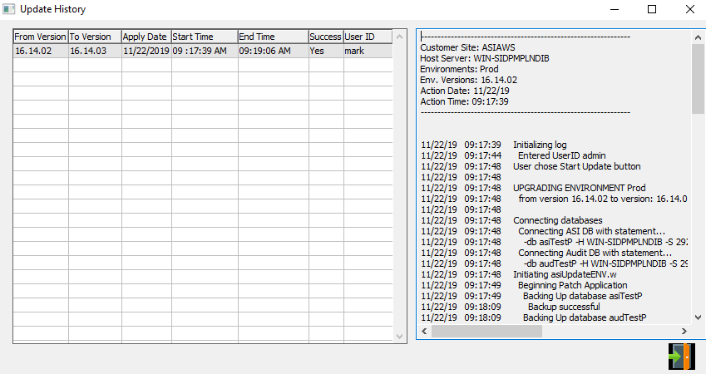

#### EXIT

Click the ***“Exit Door Icon”*** to exit the Update History popup screen.

## Update Customer Number [NQ2]

### Overview

This program will update an old customer number to a new customer number according to the user-selected parameters. In order to run this program, the user must first back up their database for data security.

### Selection Parameters

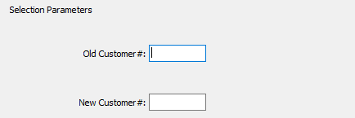

#### Old Customer #

The user may enter an old customer number that they wish to update in this field.

#### New Customer #

The user may enter a new customer number that they wish to update the old vendor number to in this field.

## Update FG Item Code [NQ3]

### Overview

This program will update an old Finished Good Item Code to a new Finished Good Item Code according to the user-selected parameters. In order to run this program, the user must first back up their database for data security.

### Selection Parameters

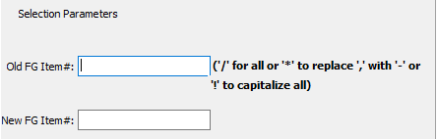

#### Old FG Item #

The user may enter an old Finished Good Item number that they wish to update in this field.

#### New FG Item #

The user may enter a new Finished Good Item number that they wish to update the old vendor number to in this field.

## Fix A/R Invoice Date [NQ4]

This program will allow a user to fix accounts receivable invoice dates for a specific, user-defined invoice.

### Selection Parameters

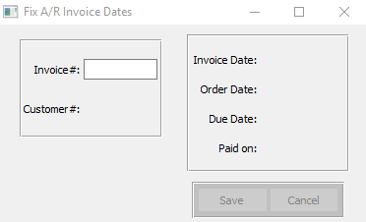

#### Invoice #

Enter the invoice number you wish to update. Alternatively, press the ***“F1”*** key to choose an invoice number form a list of available invoices.

## Fix Cash Receipt Date [NQ5]

This program will all a user to fix a receipt date within the user-selected parameters.

### Selection Parameters

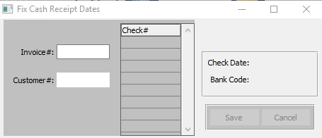

#### Invoice #

Enter an invoice number to search for.

#### Customer #

Enter a customer number to search for.

## Set Salesman Commission [NQ6]

This program will allow the user to set a new commission percentage for a specific salesman defined by the user.

### Selection Parameters

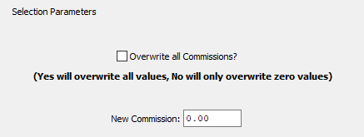

#### Overwrite All Commissions? – Toggle Box

To overwrite all commissions, make sure that this toggle box is checked. To only overwrite commission percentages that are currently set to zero, do not check this toggle box.

#### New Commission

Enter the new commission percentage to set the salesman’s commission to.

## Update RM Code [NQ7]

### Overview

This program will update an old raw material number to a new raw material number according to the user-selected parameters. In order to run this program, the user must first back up their database for data security.

### Selection Parameters

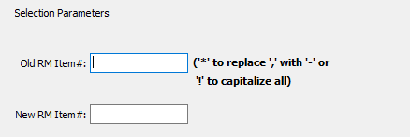

#### Old RM Item #

The user may enter an old raw material number that they wish to update in this field.

#### New RM Item #

The user may enter a new raw material number that they wish to update the old vendor number to in this field.

## Update AP Invoice [NQ8]

### Overview

This screen allows the user to quickly update a specific invoice’s due date and prices.

Please Note: Updating the invoice amounts through this screen will *not* update this invoice in the general ledger.

### Selection Parameters

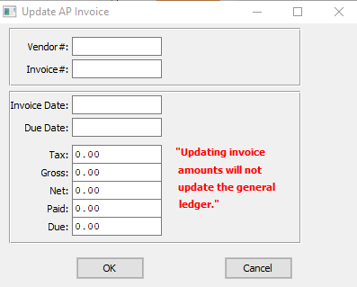

#### Vendor #

Enter the vendor number.

#### Invoice #

Enter the invoice number.

#### Invoice Date

Enter the invoice date.

#### Due Date

Enter the due date.

#### Tax

Enter the new tax percentage for this invoice.

#### Gross

Enter the new gross percentage for this invoice.

#### Net

Enter the new net percentage for this invoice.

#### Paid

Enter the new paid amount for this invoice.

#### Due

Enter the new sue amount for this invoice.

## Create FG Receipts from BOL’s [NQ9]

### Overview

This program will allow the user to create a Finished Good receipt from a bill of lading within the user-selected parameters. In order to run this program, the user must first back up their database for data security.

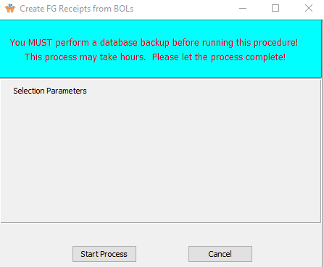

## Update AR / OE Invoice Cost & Commission [NQ)]

### Overview

This program will allow the user to update an accounts receivable or order entry cost and commission numbers within the user-selected parameters. In order to run this program, the user must first back up their database for data security.

### Selection Parameters

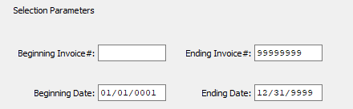

#### Beginning Invoice # / Ending Invoice #

Enter the beginning and ending Invoice Number to update Accounts Receivable or Order Entry cost and commission for.

#### Beginning Date / Ending Date

Enter the beginning and ending Date to update Accounts Receivable or Order Entry cost and commission for.

## Set Taxable FG Default [NQ!]

### Overview

This program will allow the user to select a default tax option in order to make future processing quicker. In order to run this program, the user must first back up their database for data security.

### Selection Parameters

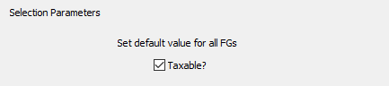

#### Taxable? – Toggle Box

To make the system default all new finished good items to taxable, and thus allow users to skip this step when entering new finished good items into the system, make sure that the Taxable toggle box is checked.

## Fix Invoice Cost [NQ@]

### Overview

Logic will update a posted invoice cost by importing the cost from the finished goods bin file for the job number shipped on the bill of lading.

This will run against any range of invoices. This utility could be run again and again without duplicating the records. This utility will also transfer the cost from the FG bin record on the bill of lading to the invoice history file.

The Utility N-Y-12 should be run before running this utility if the costs were zero or ? in the finished goods bin file. Hence if the purchased cost was zero or the job cost was zero, ? or simply wrong, the user may update the job file cost or purchase line cost then run the N-Y-12 utility and the system will correct the finished goods receipt history cost and the finished goods bin file cost. Once the costs are accurate in the finished goods bin file, the quick fit utility N-Q-12 and / or N-Q-10 may be run.

### Selection Parameters

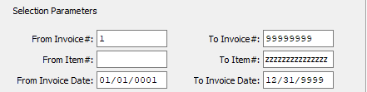

#### From Invoice # / To Invoice #

Enter the beginning and ending Invoice Number to fix an invoice cost for.

#### From Item # / To Item #

Enter the beginning and ending Item Number to fix an invoice cost for.

#### From Invoice Date / To Invoice Date

Enter the beginning and ending Invoice Date to fix an invoice cost for.

## Build FG Warehouse / Bin [NQ#]

### Overview

This program will build a finished good warehouse based upon the user-selected parameters. In order to run this program, the user must first back up their database for data security.

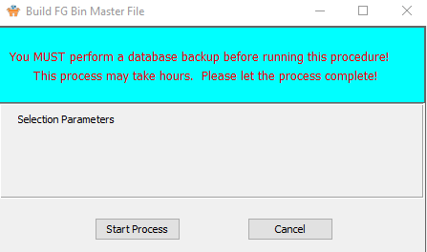

## Set FG Item Warehouse / Bin [NQ$]

### Overview

This program will allow the user to set up a finished good item warehouse bins within the user-selected parameters. In order to run this program, the user must first back up their database for data security.

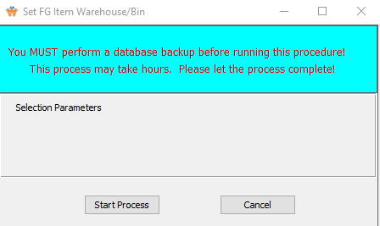

## Set FG Blank Warehouse / Bin [NQ%]

### Overview

This program will allow the user to set up and alter blank warehouse bins within the user-selected parameters. In order to run this program, the user must first back up their database for data security.

### Selection Parameters

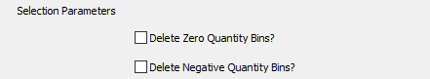

#### Delete Zero Quantity Bins? – Toggle Box

To delete all zero quantity bins throughout the warehouse system, make sure that the Delete Zero Quantity Bins toggle box is checked.

#### Delete Negative Quantity Bins? – Toggle Box

To delete all negative quantity bins throughout the warehouse system, make sure that the Delete Negative Quantity Bins toggle box is checked.

## FG Item Ship Method Update [NQ^]

### Overview

This program will allow the user to select a default shipping method of case or pallet in order to make future processing quicker. In order to run this program, the user must first back up their database for data security.

### Selection Parameters

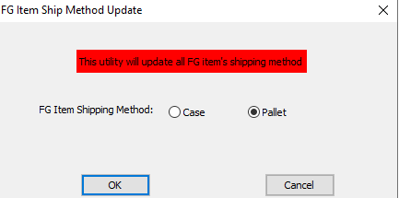

#### FG Item Shipping Method (Choice)

To choose the preferred default shipping method of Case vs. Pallet, please make sure the desired option choice bubble is toggled.

# **Z System Reference Files [NZ]**

## System Reference Files [NZ1]

**DO NOT MODIFY WITHOUT AUTHORIZATION FROM ASI!!**

This screen provides the ability to add or delete File Maintenance options from different modules. The program name should NOT be changed! The menu description could be changed to make the menu more friendly to understand. For Example, the Raw Material Item File may be accessed via CE & RM (Cost Estimating and Raw Materials).

### Browse File

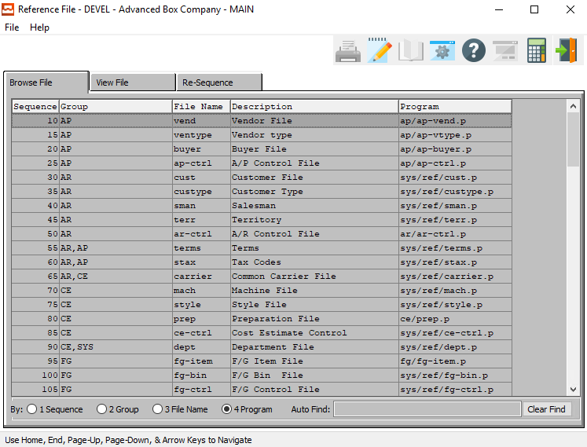

### View File

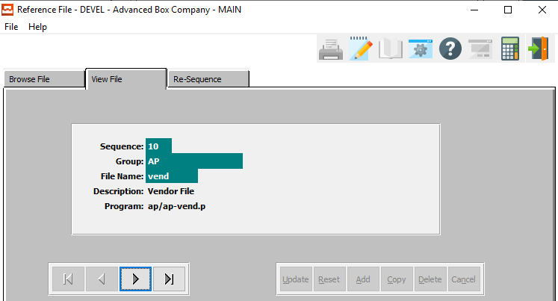

#### NEXT

Press ***"N"*** (Next) to find next Reference File to view or modify. Alternatively, press the ***“Right Arrow”*** on the screen.

#### PREVIOUS

Press ***"P"*** (Previous) to find previous Reference File to view or modify. Alternatively, press the ***“Left Arrow”*** on the screen.

### Re-Sequence

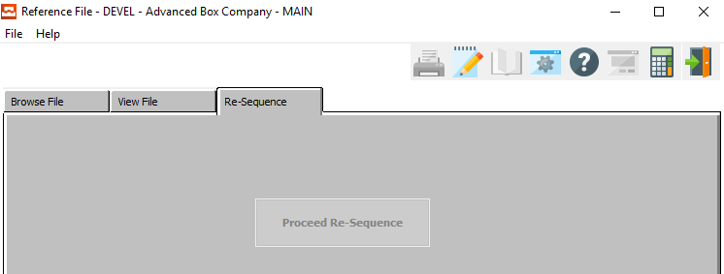

## Job Categories [NZ2]

**DO NOT MODIFY.** Valid codes are MR, RUN, DT and NC.@@

### Browse Category

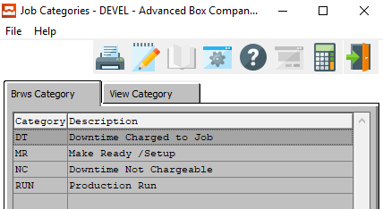

### View Category

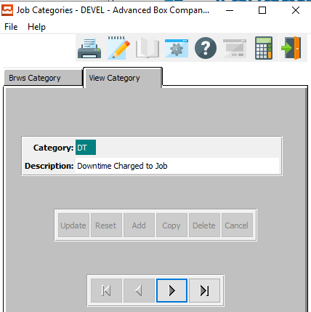

#### NEXT

Press ***"N"*** (Next) to find next Job Category to view or modify. Alternatively, press the ***“Right Arrow”*** on the screen.

#### PREVIOUS

Press ***"P"*** (Previous) to find previous Job Category to view or modify. Alternatively, press the ***“Left Arrow”*** on the screen.

## Material Types [NZ3]

**DO NOT UPDATE CODE.** Description may be modified to make system friendlier.

### Browse Types

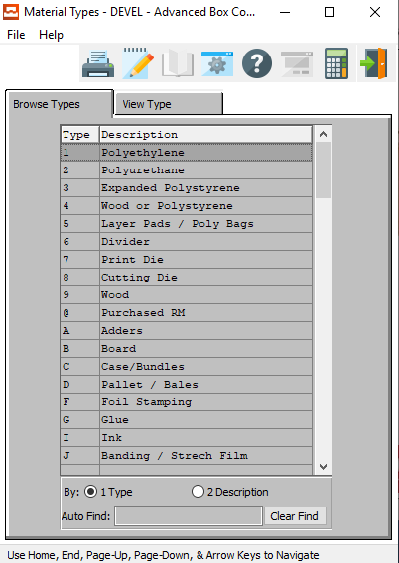

### View Type

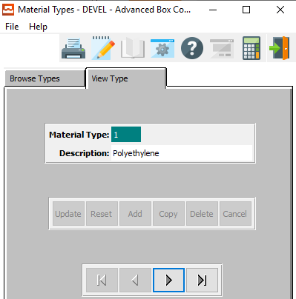

#### NEXT

Press ***"N"*** (Next) to find next Material Type to view or modify. Alternatively, press the ***“Right Arrow”*** on the screen.

#### PREVIOUS

Press ***"P"*** (Previous) to find previous Material Type to view or modify. Alternatively, press the ***“Left Arrow”*** on the screen.

## Departments [NZ4]

This screen lists the department codes and their descriptions.

### Browse Departments

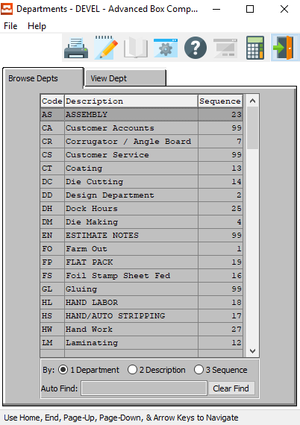

### View Department

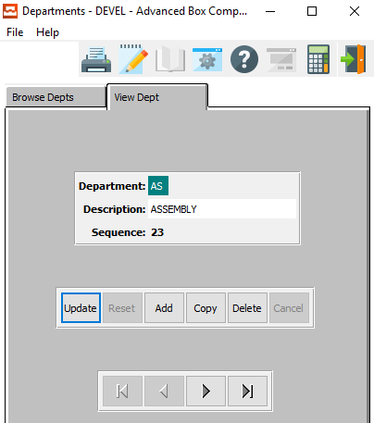

#### UPDATE

To change the currently selected Department, simply click the ***“Update***” button at the bottom of the screen.

#### ADD

Click the ***“Add”*** button at the bottom of the screen to add a new Department.

#### COPY

Click the ***“Copy”*** button to copy information from the currently selected Department.

#### DELETE

To delete the currently selected Department, simply press the ***"D"*** key. Alternatively, click the ***“Delete”*** button at the bottom of the screen.

#### NEXT

Press ***"N"*** (Next) to find next Department to view or modify. Alternatively, press the ***“Right Arrow”*** on the screen.

#### PREVIOUS

Press ***"P"*** (Previous) to find previous Department to view or modify. Alternatively, press the ***“Left Arrow”*** on the screen.

### Add/Update Department

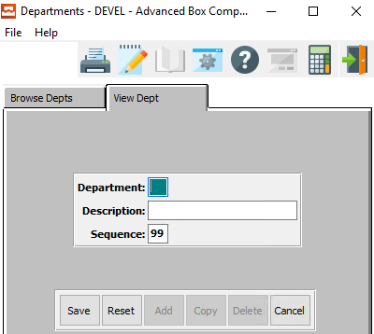

#### SAVE

Click the ***“Save”*** button to save all changes to the current Department.

#### RESET

Click the ***“Reset”*** button to reset all fields to their original state.

#### CANCEL

Click the ***“Cancel”*** button to cancel all changes to the Department without saving.

### Add/Update Department Field Definitions

#### Department

This is the code for the material. This option can only be modified by ASI.

#### Description

Enter a description of what is included in that department.

#### Sequence

This is the sequence of departments.

## Preparation Material Types [NZ5]

This screen lists the valid material codes and their types.

### Browse Types

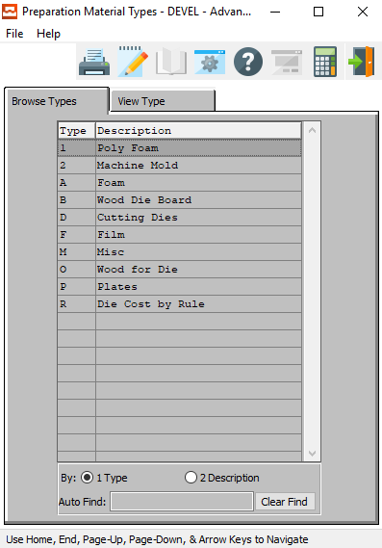

### View Type

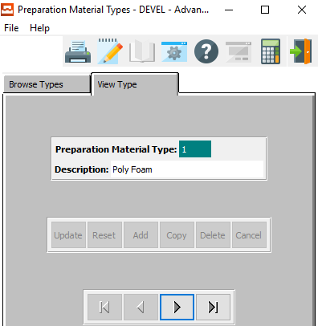

#### NEXT

Press ***"N"*** (Next) to find next Preparation Material Type to view or modify. Alternatively, press the ***“Right Arrow”*** on the screen.

#### PREVIOUS

Press ***"P"*** (Previous) to find previous Preparation Material Type to view or modify. Alternatively, press the ***“Left Arrow”*** on the screen.

## RM / FG Specifications [NZ6]

### Browse Spec

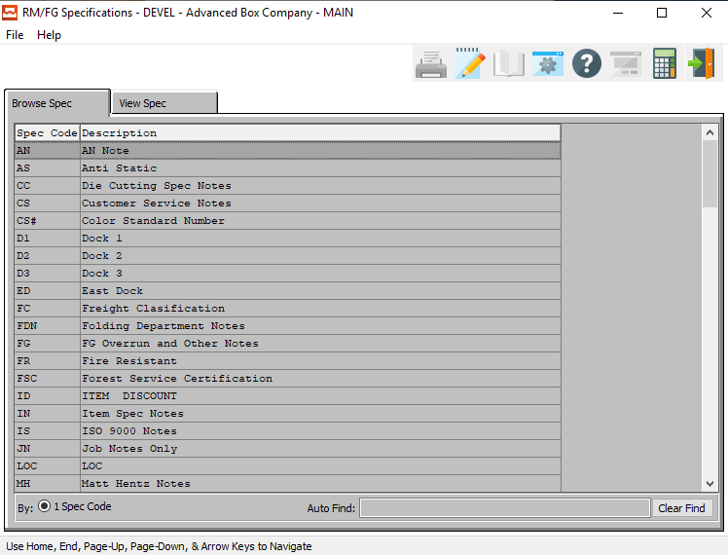

### View Spec

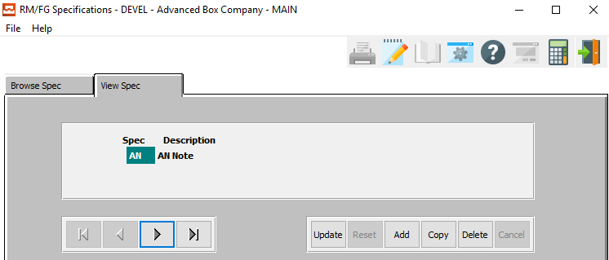

#### UPDATE

To change the currently selected Specification, simply click the ***“Update***” button at the bottom of the screen.

#### ADD

Click the ***“Add”*** button at the bottom of the screen to add a new Specification.

#### COPY

Click the ***“Copy”*** button to copy information from the currently selected Specification.

#### DELETE

To delete the currently selected Specification, simply press the ***"D"*** key. Alternatively, click the ***“Delete”*** button at the bottom of the screen.

#### NEXT

Press ***"N"*** (Next) to find next Specification to view or modify. Alternatively, press the ***“Right Arrow”*** on the screen.

#### PREVIOUS

Press ***"P"*** (Previous) to find previous Specification to view or modify. Alternatively, press the ***“Left Arrow”*** on the screen.

### Add/Update Spec

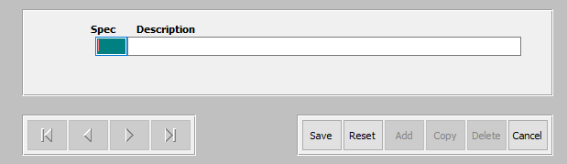

#### SAVE

Click the ***“Save”*** button to save all changes to the current Specification.

#### RESET

Click the ***“Reset”*** button to reset all fields to their original state.

#### CANCEL

Click the ***“Cancel”*** button to cancel all changes to the Specification without saving.

### Add/Update Spec Field Definitions

#### Spec

Enter the specification code.

#### Description

Enter a short description of this specification.

## Standards Matrix [NZ7]

This screen defines the codes, files, and fields for the machine standards.

### Browse Matrix

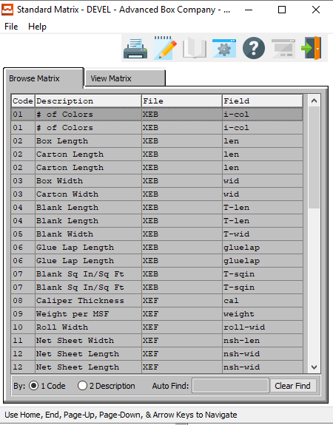

### View Matrix

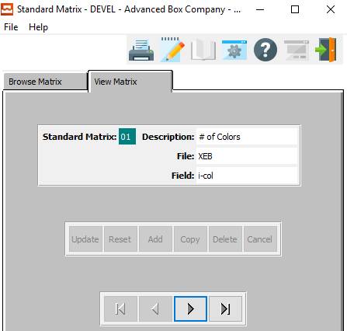

#### NEXT

Press ***"N"*** (Next) to find next Standard Matrix to view or modify. Alternatively, press the ***“Right Arrow”*** on the screen.

#### PREVIOUS

Press ***"P"*** (Previous) to find previous Standard Matrix to view or modify. Alternatively, press the ***“Left Arrow”*** on the screen.

## Units of Measure [NZ8]

This screen is where the system gets all of the valid Units of Measure and their multipliers, abbreviations, and Base Units of Measure.

### Browse UOM

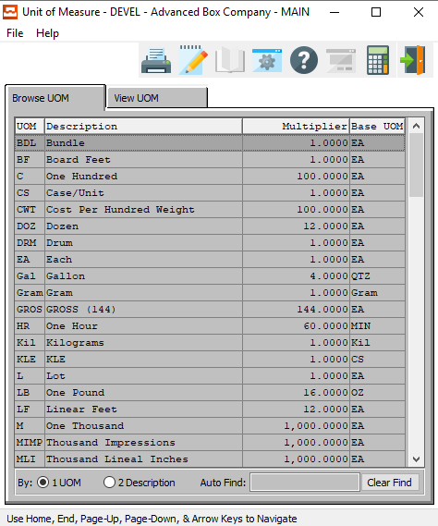

### View UOM

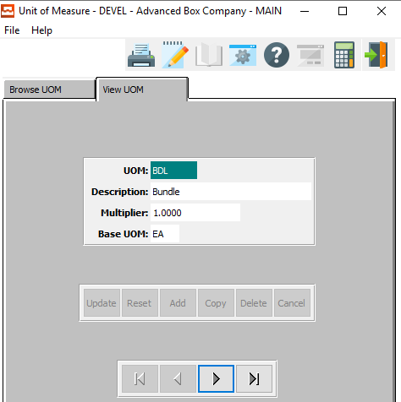

#### NEXT

Press ***"N"*** (Next) to find next Unit of Measure to view or modify. Alternatively, press the ***“Right Arrow”*** on the screen.

#### PREVIOUS

Press ***"P"*** (Previous) to find previous Unit of Measure to view or modify. Alternatively, press the ***“Left Arrow”*** on the screen.

## State and Province Abbreviations [NZ9]

### Browse States

This selection shows all valid state and province abbreviation listed in the system. The browser shows the state abbreviation, description, and FIPS code. To view a state, you may double click on the selected state or click the View State tab. The icons at the top of the browser provide additional capabilities. The icon with the fountain pen allows you to view the notes for each state.

Each note records the users initials, date, description of the note and a full-page of text for each note. Unlimited notes may be defined for each state. The browse icon will provide immediate access to the browser by state. The icon with the corner of a page folded over allows you to print a list of the state and province abbreviations.

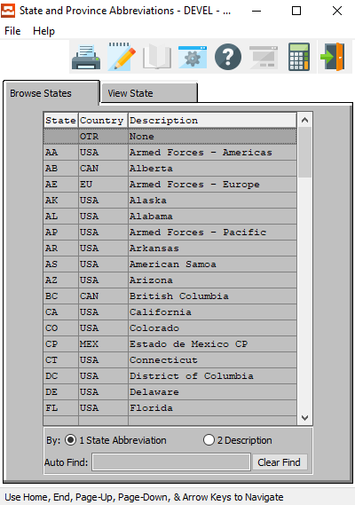

### View State

The view state screen allows you to view the information of each listing. You may copy, change, add or delete any information from this screen. Use the arrow keys at the bottom of the screen to view the next or previous state. The icons at the top of the screen provide additional capabilities.

The browse icon will provide immediate access to the browser by state. The icon with the fountain pen allows you to view any notes for the state record selected. The icon with the corner of a page folded over allows you to print a list of the state and province abbreviations.

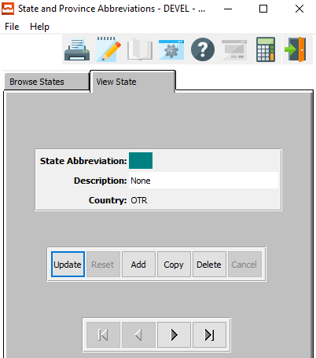

#### UPDATE

To change the currently selected State/Province Abbreviation, simply click the ***“Update***” button at the bottom of the screen.

#### ADD

Click the ***“Add”*** button at the bottom of the screen to add a new State/Province Abbreviation.

#### COPY

Click the ***“Copy”*** button to copy information from the currently selected State/Province Abbreviation.

#### DELETE

To delete the currently selected State/Province Abbreviation, simply press the ***"D"*** key. Alternatively, click the ***“Delete”*** button at the bottom of the screen.

#### NEXT

Press ***"N"*** (Next) to find next State/Province Abbreviation to view or modify. Alternatively, press the ***“Right Arrow”*** on the screen.

#### PREVIOUS

Press ***"P"*** (Previous) to find previous State/Province Abbreviation to view or modify. Alternatively, press the ***“Left Arrow”*** on the screen.

### Add/Update State

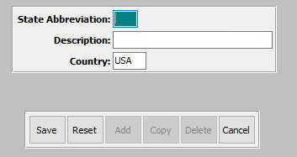

#### SAVE

Click the ***“Save”*** button to save all changes to the current State/Province Abbreviation.

#### RESET

Click the ***“Reset”*** button to reset all fields to their original state.

#### CANCEL

Click the ***“Cancel”*** button to cancel all changes to the State/Province Abbreviation without saving.

### Add/Update State Field Definitions

#### State Abbreviation

Enter the State/Province Abbreviation.

#### Description

Enter a short name or description for this state or province.

#### Country

Enter the country code for where this state or province is located.

## Holidays [NZ)]

### Browse Holidays

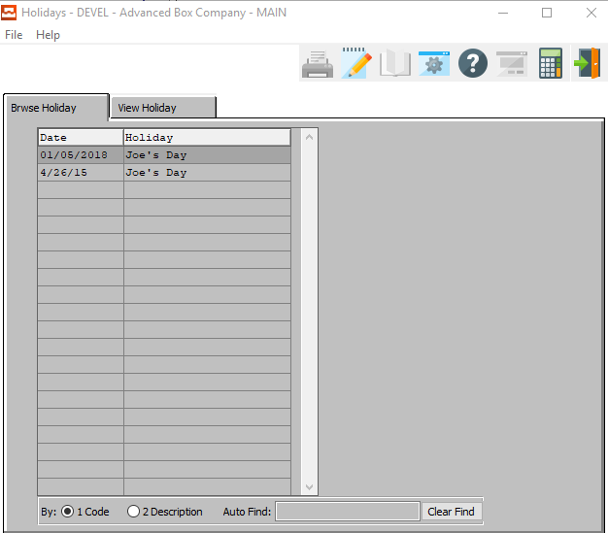

### View Holiday

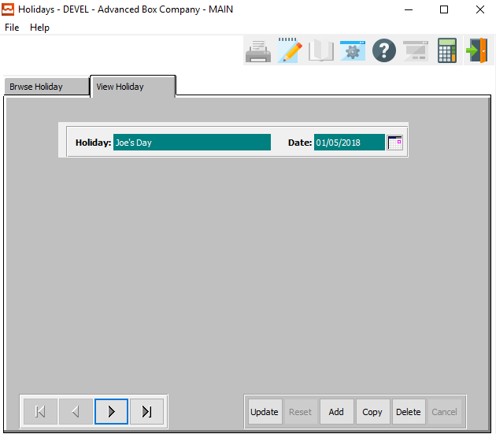

#### UPDATE

To change the currently selected Holiday, simply click the ***“Update***” button at the bottom of the screen.

#### ADD

Click the ***“Add”*** button at the bottom of the screen to add a new Holiday.

#### COPY

Click the ***“Copy”*** button to copy information from the currently selected Holiday.

#### DELETE

To delete the currently selected Holiday, simply press the ***"D"*** key. Alternatively, click the ***“Delete”*** button at the bottom of the screen.

#### NEXT

Press ***"N"*** (Next) to find next Holiday to view or modify. Alternatively, press the ***“Right Arrow”*** on the screen.

#### PREVIOUS

Press ***"P"*** (Previous) to find previous Holiday to view or modify. Alternatively, press the ***“Left Arrow”*** on the screen.

### Add/Update Holiday

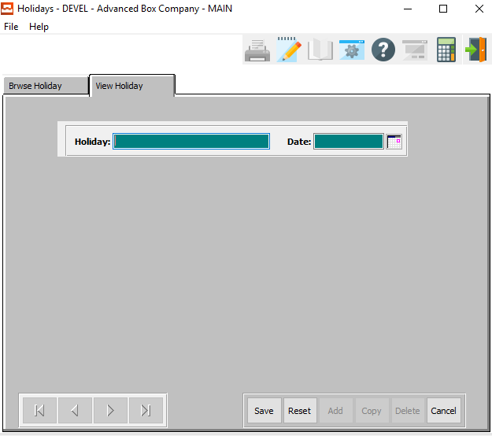

#### SAVE

Click the ***“Save”*** button to save all changes to the current Holiday.

#### RESET

Click the ***“Reset”*** button to reset all fields to their original state.

#### CANCEL

Click the ***“Cancel”*** button to cancel all changes to the Holiday without saving.

### Add/Update Holiday Field Definitions

#### Holiday Name

Enter the name of the holiday.

#### Date

Enter the date of this holiday.

## Cross References [NZ!]

### Browse XRef

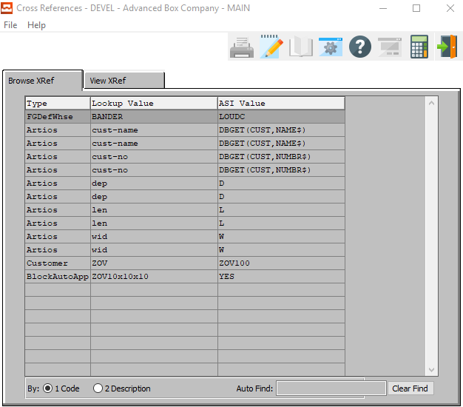

### View XRef

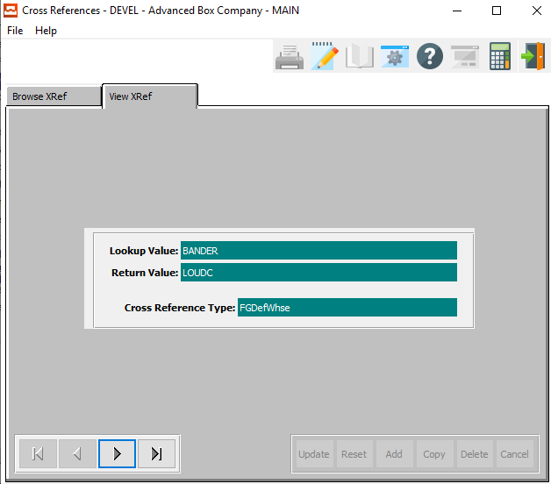

#### NEXT

Press ***"N"*** (Next) to find next Cross Reference to view or modify. Alternatively, press the ***“Right Arrow”*** on the screen.

#### PREVIOUS

Press ***"P"*** (Previous) to find previous Cross Reference to view or modify. Alternatively, press the ***“Left Arrow”*** on the screen.

## Message Maintenance [NZ@]

### Browse Message

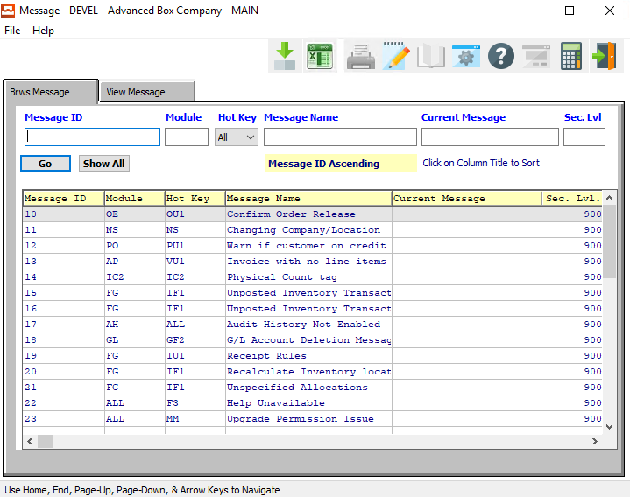

#### Message ID

Enter a message ID number to search for.

#### Module

Enter a Module code to search for.

#### Hot Key

The user may search for a hot key combination to search for.

#### Message Name

Enter a message name to search for.

#### Sec. Level

Enter a security level to search for.

### View Message

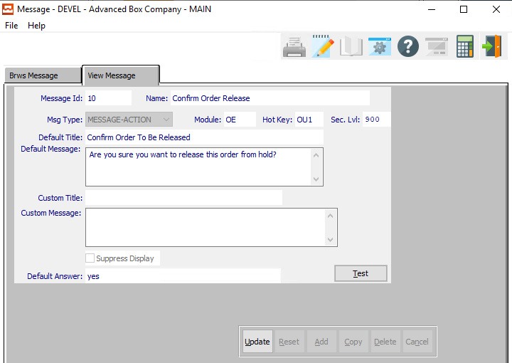

#### UPDATE

To change the currently selected Message, simply click the ***“Update***” button at the bottom of the screen.

#### TEST

Click the ***“Test”*** button to test the current message output.

### Update Message

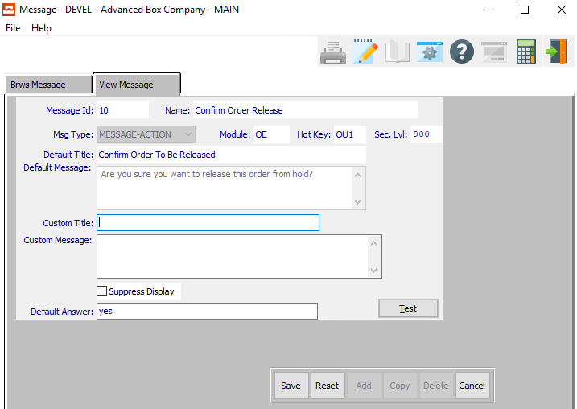

#### SAVE

Click the ***“Save”*** button to save all changes to the current Message.

#### RESET

Click the ***“Reset”*** button to reset all fields to their original state.

#### CANCEL

Click the ***“Cancel”*** button to cancel all changes to the Message without saving.

### Update Message Field Definitions

#### Custom Title

Enter a short custom title or description for this system message.

#### Custom Message

Enter a custom message to display for this system message screen rather than the default.

#### Suppress Display – Toggle Box

To suppress displaying the currently selected message, make sure that the Suppress Display toggle box is checked.

#### Default Answer

Choose the default answer to be highlighted in the message box. The highlighted (default) answer makes it easy to quickly press the ***“Enter”*** key when this message pops up, thus making operations quicker.

# **Reports for Admins [NR]**

## Batch Procedure Maintenance [NR1]

### Overview

Reports and Utilities can be configured to run automatically any time of the day and as often as desired.

The Batch Procedure Maintenance file stores the print parameter selections that will print. The batch report can be copied and then changed for another sales representative. Likewise, the data can be updated of that the reports print parameters can be modified each day, week or month. For example, the sales report below will need to be updated at the beginning of each month to the 1st day of the month.

### Browse Batch

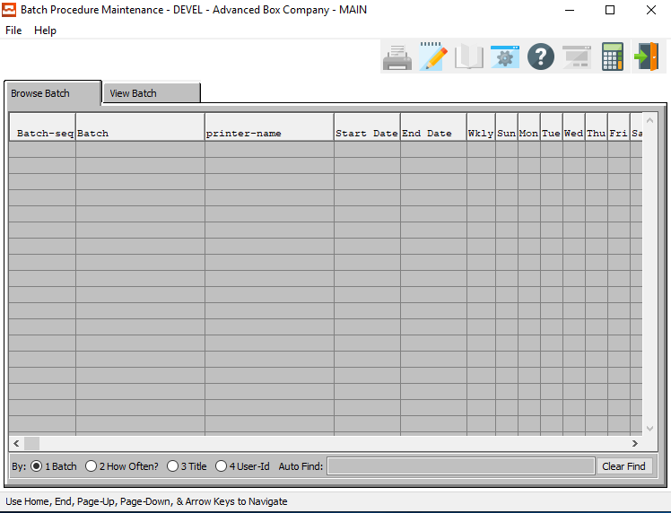

### View Batch

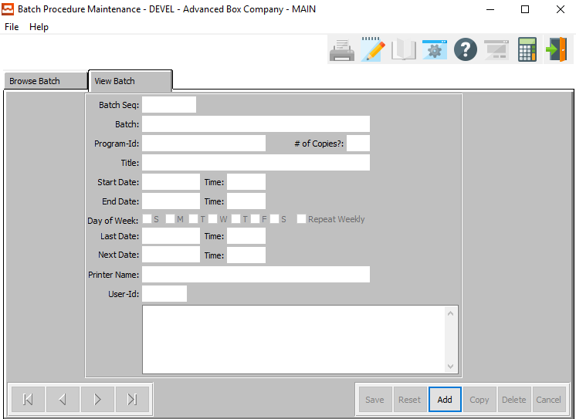

#### ADD

Click the ***“Add”*** button at the bottom of the screen to add a new Batch Procedure.

### Add Batch

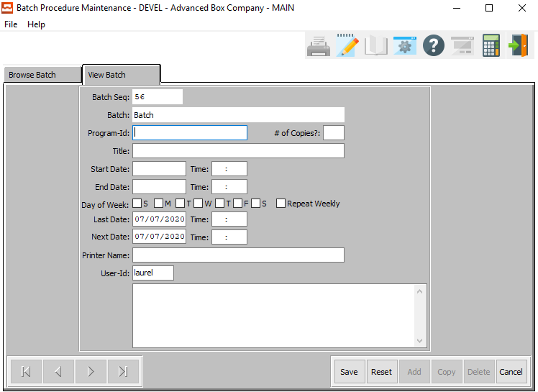

#### SAVE

Click the ***“Save”*** button to save all changes to the current Batch Procedure.

#### RESET

Click the ***“Reset”*** button to reset all fields to their original state.

#### CANCEL

Click the ***“Cancel”*** button to cancel all changes to the Batch Procedure without saving.

### Add Batch Field Definitions

#### Program ID

Enter a valid program ID for this batch. Alternatively, press the ***“F1”*** key to choose a valid Program ID from a list of available account information.

#### # of Copies?

Enter a number of copies for this batch.

#### Title

The Title field will automatically be filled in by the system as soon as the user enters or chooses a valid Program ID.

#### Start Date / End Date

Enter the beginning and ending Date to run batches for.

#### Start Time / End Time

Enter the beginning and ending Time to run batches for.

#### Day of Week – Toggle Boxes

To run this batch system multiple days a week, make sure that the desired daily toggle boxes are checked.

#### Repeat Weekly – Toggle Box

To repeat this batch weekly, make sure that the Repeat Weekly toggle box is checked.

#### Last Date / Time

This field shows the last date and time that this batch was run

#### Next Date / Time

The field shows the next scheduled date and time that this batch will be run.

#### Printer Name

Enter the print name for this batch’s default printer.

#### User ID

This field is the username of the user that created or updated this batch. It defaults to the current username, but can be modified.

#### Notes

Enter any desired notes about this batch.

## Batch Running Procedure [NR2]

This program will run all batches within the user-selected parameters.

### Selection Parameters

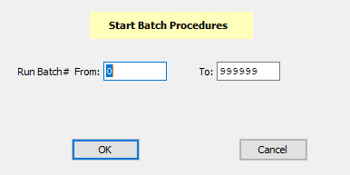

#### Run Batch # From / To

Enter the beginning and ending Batch Number to run a batch procedure for.

## EDI Release Create / BOL Load [NR3]

### Overview

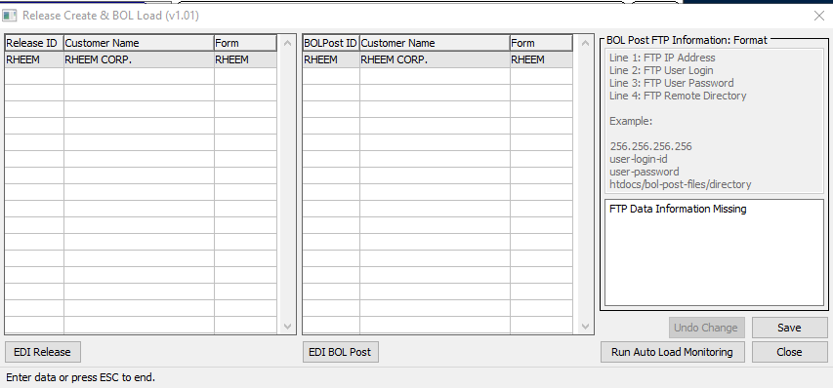

#### RUN AUTO LOAD MONITORING

Clicking the ***“Run Auto Load Monitoring”*** to automatically run this program at a user-defined interval.

#### SAVE

Click the ***“Save”*** button to save all changes to the current Bill of Lading.

#### CLOSE

Click the ***“Close”*** button to close the Release and Create BOL Load screen.

### Release Information

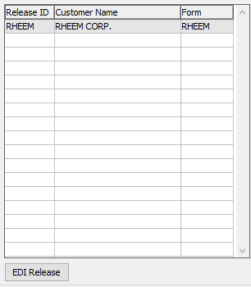

#### EDI RELEASE

The user may click on any item within the Release column section. Then, click the ***“EDI Release”*** button to release the selected Electronic Data Interchange.

### BOL Information

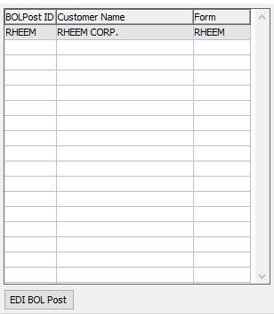

#### EDI BOL POST

The user may click on any item within the BOL column section. Then, click the ***“EDI BOL Post”*** button to post the selected bill of lading’s Electronic Data Interchange.

## Query Builder [NR8]

The user may use the Query Builder system to build their own system inquiries for printing reports necessary to their company or customers.

The user may enter their own name for the new report, and use the drop-down menus to shape the inquiry to their needs.

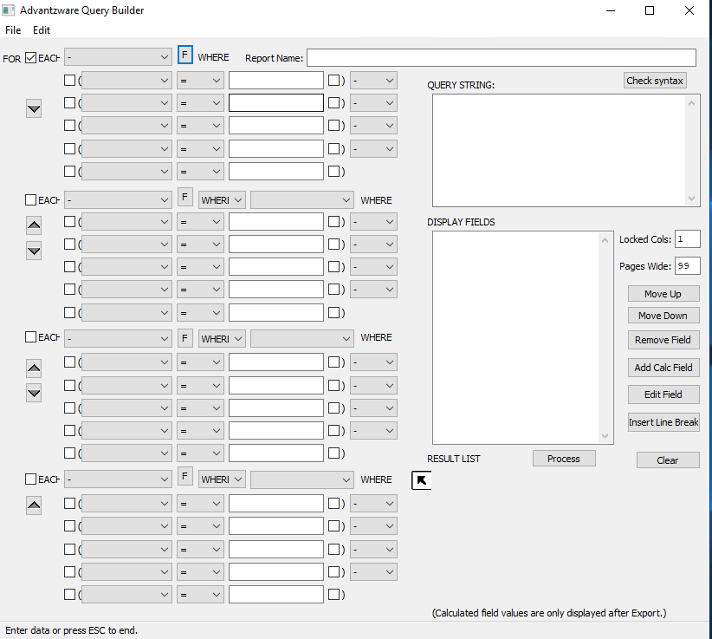

# **System [NS]**

## Batch Spool Requests [NS1]

### Overview

This selection shows you any print jobs set to print at a later time. When you print from any module in this system, you can choose to print the report at a later time. When you select printer from the output device and place a check in the spool check box, a date and time will appear. The user will than enter the date and time they would like the report to print.

Once the report is sent to the spool request, it will print at that time. You may process the report at any time, simply by clicking the process button at the bottom of the screen. You may also choose to delete this print job, by clicking the delete button at the bottom of the screen. You may not, however, modify this print job in any way.

### Batch Spool Request Screen

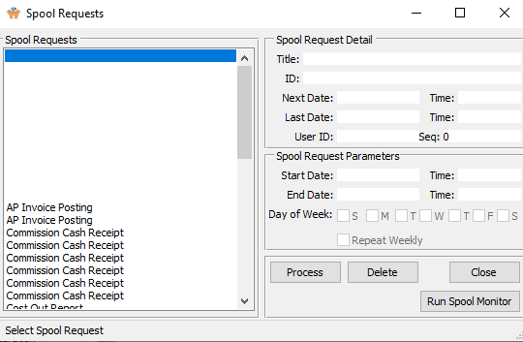

#### PROCESS

Click the ***“Process”*** button to process the currently selected spool request.

#### DELETE

To delete the currently selected Spool Request, simply press the ***"D"*** key. Alternatively, click the ***“Delete”*** button at the bottom of the screen.

#### CLOSE

Click the ***“Close”*** button close the Spool Request screen.

#### RUN SPOOL MONITOR

Click the ***“Run Spool Monitor”*** button to run the spool monitoring system at a user-defined interval.

### Spool Requests

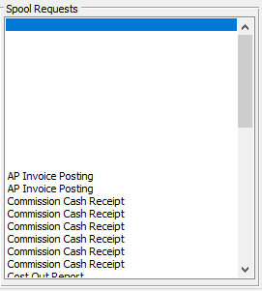

#### Spool Requests

The user may click on their desired spool request selection in order to highlight it. Only highlighted spool request will be processed when the user clicks the ***“Process”*** button.

## Shutdown Spool Request Monitor [NS2]

This selection disables the spool request option. If you choose to disable the spool request monitor, users may still spool print jobs. They will not print until you restart the spool request monitor. Once the spool request is running, it will check the spooled jobs and process any job prior to the current date and time.

Please Note: This program can only be run if the system detects that a Spool Request Monitor is currently running. If a monitor is not running, the user will be notified of this, and the program will not run.

## Configurations [NS3]

### Overview

This selection allows you to select your personal directories. To make any changes click on the update button. When selecting a directory, the user must type in a fully qualified path. The user may change the audit, log, or spool directory.

### Selection Parameters

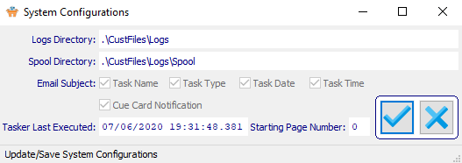

#### UPDATE

Click the ***“Blue Check Mark Icon”*** button to update the system configurations.

#### CANCEL

Click the ***“Blue X Icon”*** button to cancel updating the system configurations.

### Update System Configurations

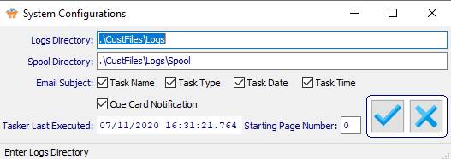

#### Logs Directory

Enter the location of the Log Directory for the system to use. Alternatively, press the ***“F1”*** key to use the Windows Explorer window to choose the proper file path.

#### Spool Directory

Enter the location of the Spool Directory for the system to use. Alternatively, press the ***“F1”*** key to use the Windows Explorer window to choose the proper file path.

#### Email Subject: Task Name – Toggle Box

To include the task name in the system emails, make sure that the Task Name toggle box is checked.

#### Email Subject: Task Type – Toggle Box

To include the task type in the system emails, make sure that the Task Type toggle box is checked.

#### Email Subject: Task Date – Toggle Box

To include the task date in the system emails, make sure that the Task Date toggle box is checked.

#### Email Subject: Task Time – Toggle Box

To include the task time in the system emails, make sure that the Task Time toggle box is checked.

#### Email Subject: Cue Card Notification – Toggle Box

To include the cue card information in the system emails, make sure that the Cue Card Notification toggle box is checked.

#### Task Last Executed

This field shows the user the date and time that the system configuration was last updated. It defaults to the system date and time, and cannot be modified by the user.

#### Starting Page Number

Enter the page number on which to start the system.

## Select Tables to Audit [NS4]

This selection allows the user to selection tables, or menu, they would like to audit. By selecting a table name from the list, the system will track the user, date and time any changes were made. To print this report, the user must go to the Audit Trail List, found in the System Listing option in the System menu. By using this selection, you may audit the users going into different areas of the system.

The user may choose their desired audit items by making sure that the desired toggle box next to each is checked.

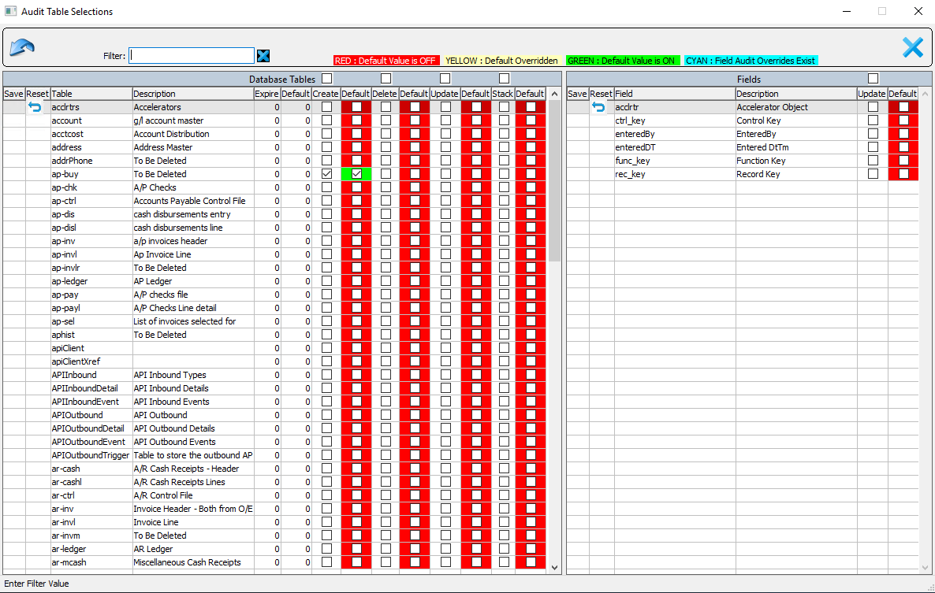

## Audit History [NS5]

### Audit History

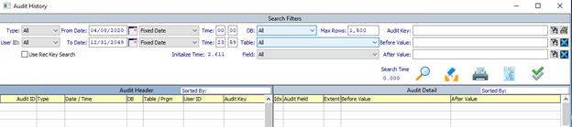

#### Type

The user may choose an audit type from the drop-down list of options.

Valid Types are as Follows:

|  |  |  |  |
| --- | --- | --- | --- |
| ALL | DELETE | LOG | TRACK |
| CREATE | UPDATE | TASK | RESTORE |

#### User ID

The user may choose a user ID from the drop-down list of user options.

#### From Date / To Date

The user may enter a starting and ending date to search between.

#### From Date Type / To Date Type

The user may choose a date type from the drop-down list of date options.

#### From Time / To Time

The user may enter a starting and ending time to search between.

#### Use Rec Key Search – Toggle Box

To use a rec key search, make sure that this toggle box is checked.

#### DB

The user may choose a database from the drop-down list of user options.

#### Table

The user may choose a table from the drop-down list of user options.

#### Field

The user may choose a field from the drop-down list of user options.

#### Max Rows

The user may enter the maximum number of rows that their search may fill in the audit header list.

#### Audit Key

The user may enter an audit key to search for.

#### Before Value / After Value

The user may enter a before and after value to search for.

## Build Security by Menu [NS6]

### Overview

This security program allows the administrator to define which users or groups may have access to specific programs. If the user id or group name is not defined for the programs selected, then the user will be not be able to run, update, create, or delete that program. **An * gives rights to all users so this code is not recommended.**

To secure a program, simply highlight the program from the menu structure list. To highlight each program, simply click each program or press the SELECT ALL button to highlight all programs. Once the programs are highlighted, press the SELECT DEFAULT PROGRAM to display current users with access rights. I would recommend the SELECT ALL followed by the SELECT DEFAULT PROGRAM to set the security rights for the president, owner and individuals with complete access rights to the entire system.

You must choose the indented most program name rather than the heading. For example, the File Maintenance Menu option cannot be secured, but rather each program indented under file maintenance should be highlighted. After highlighting the desired programs by clicking each program name, you MUST click the button called Select Default Program. Thereafter, on the right side of the window, previously secured user and group names for each program will be displayed.

Please Note: The Select Default Program button must be clicked, otherwise modifications to the user and group names entered will not be saved. After selecting the programs, click on the security option Can Run, Can Update, Can Create or Can Delete, then enter the usernames or user groups.

Enter an (*) to allow all users access to the highlighted program. You must click the save button to save the settings. The Select All button will highlight every program; therefore, this should be run first to add security to system administration and giving access to every program. Next, individual programs should be updated to individual access rights.

PLEASE NOTE: There are two ways to set security in the Advantzware software: Access Security by Menu as well as the Program Master. The Access security by menu allows selecting a range of programs.

The Program Master allows selecting individual program for applying security. We recommend the SELECT ALL button followed by the SELECT DEFAULT PROGRAM to set the security rights for the president, owner and individuals with complete access rights to the entire system by typing their user ID on the Can Run, Can Update, Can Delete and Can Create blocks. Next, access the program master to set individual access rights by menu selection.

### Security Access Screen

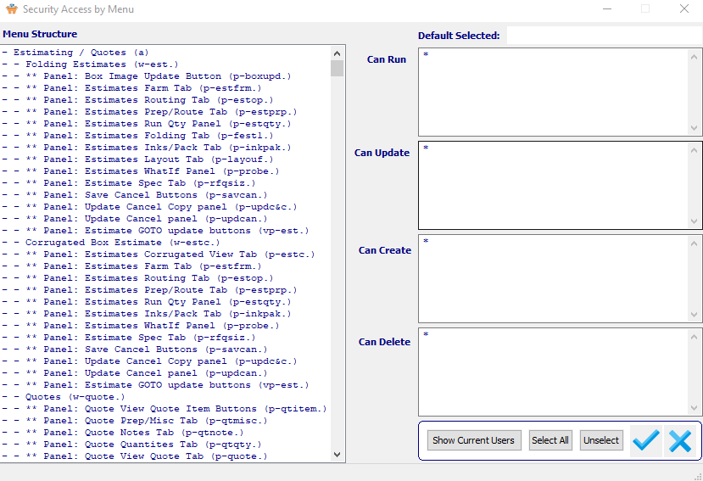

#### SHOW CURRENT USERS

Click the ***“Show Current Users”*** button to have the program show any current users within the Default Selected field.

#### SELECT ALL

Click the ***“Select All”*** button to select all items in the Menu Structure section.

#### UNSELECT

Click the ***“Unselect”*** button to unselect all items that have been highlighted in the Menu Structure section.

#### OK

Click the ***“Blue Check Mark Icon”*** button to confirm all security access changes.

#### CANCEL

Click the ***“Blue X Icon”*** button to cancel all changes to the Security Access parameters and exit the screen.

## User Defined Fields Builder [NS7]

The Field Builder system allows the user to create and define their own field system for multiple item types. The user may click on any tab within this system in order to choose which field will pertain to each item they wish within the system.

Valid Item Type Screens are as Follows:

|  |  |  |  |  |
| --- | --- | --- | --- | --- |
| Slitter | Rite-Size | Curioni | 60’ Press | Rotary |
| MIEHLE | Mini | Up Down | Cut Score | Band Saw |
| Bag Machine | Gluer | Bundler | Hand Labor | Other Types |

### Slitter Screen

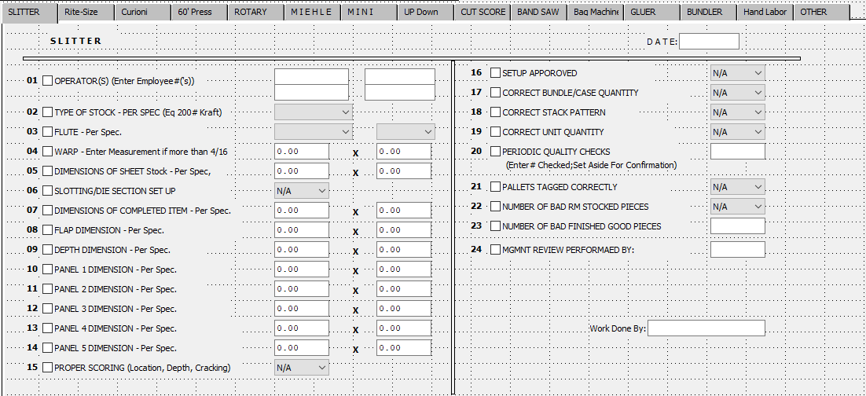

### Rite-Size Screen

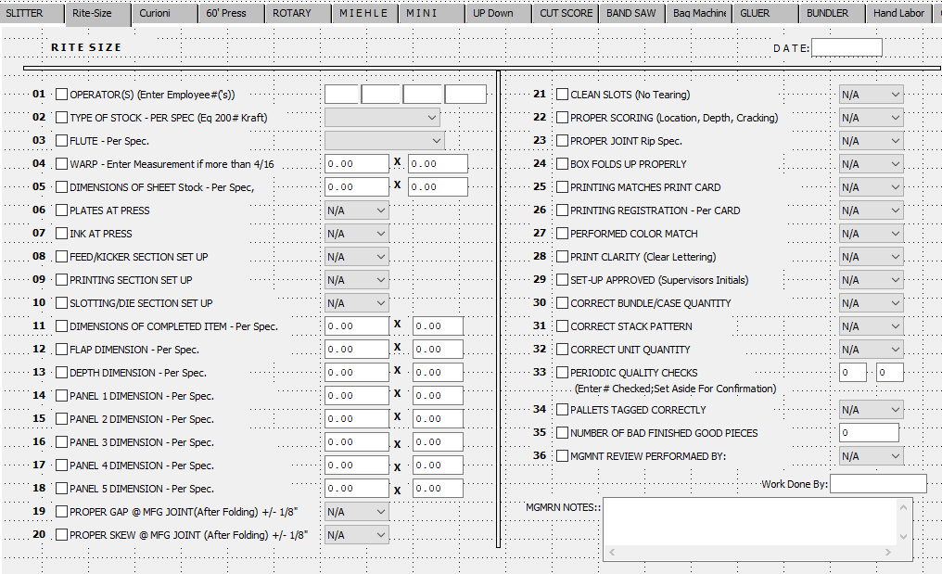

### Curioni Screen

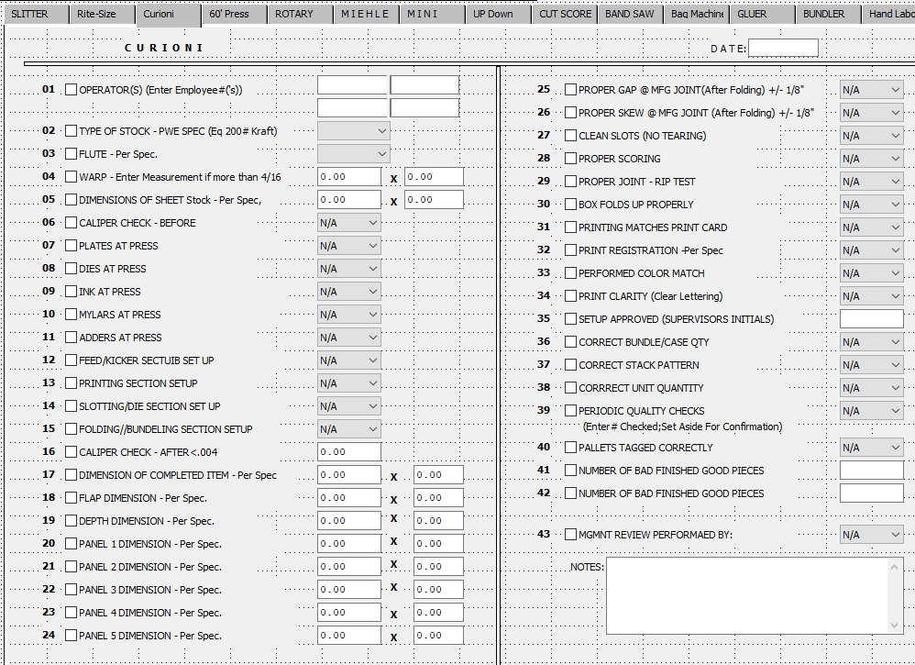

### 60’ Press Screen

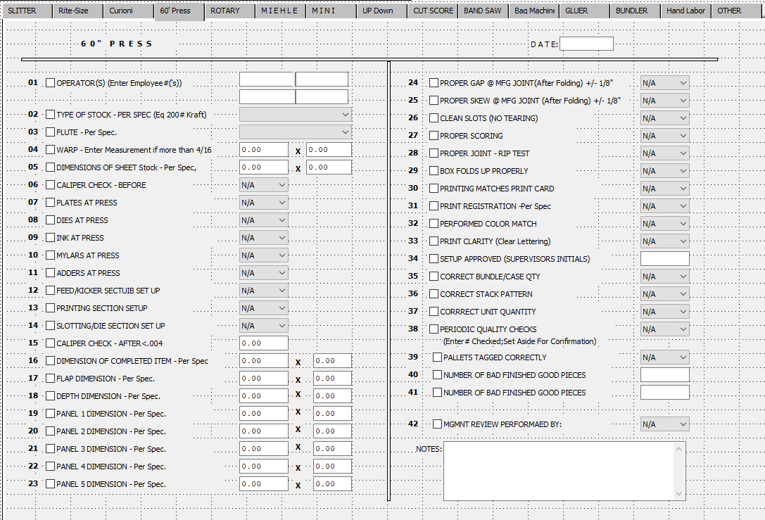

### Rotary Screen

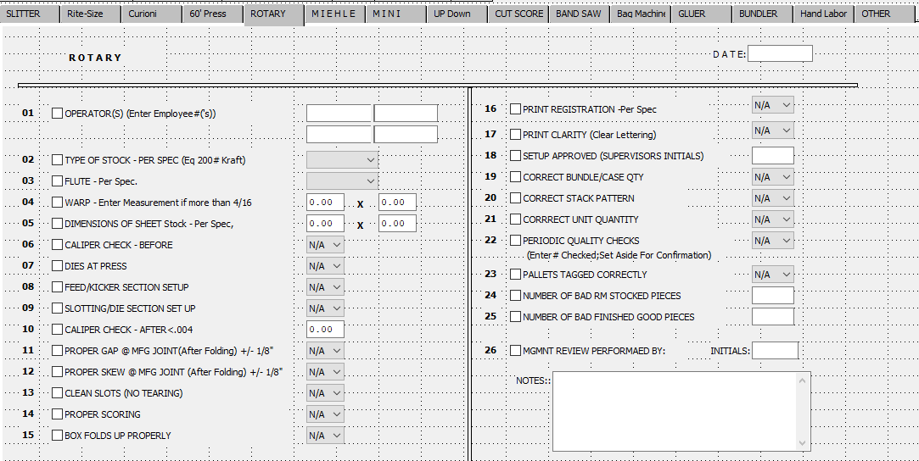

### MIEHLE Screen

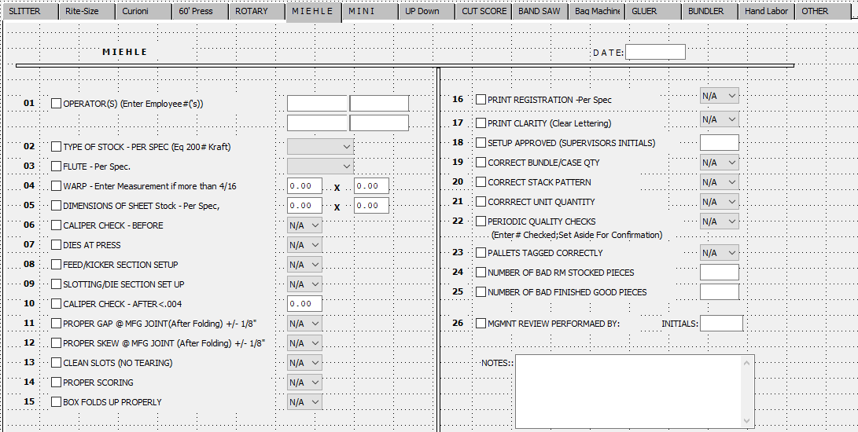

### Mini Screen

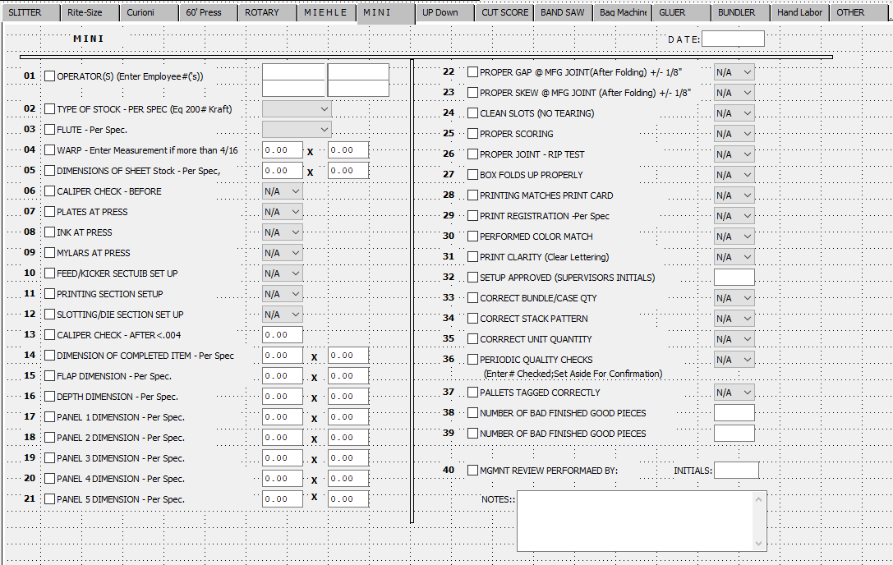

### Up Down Screen

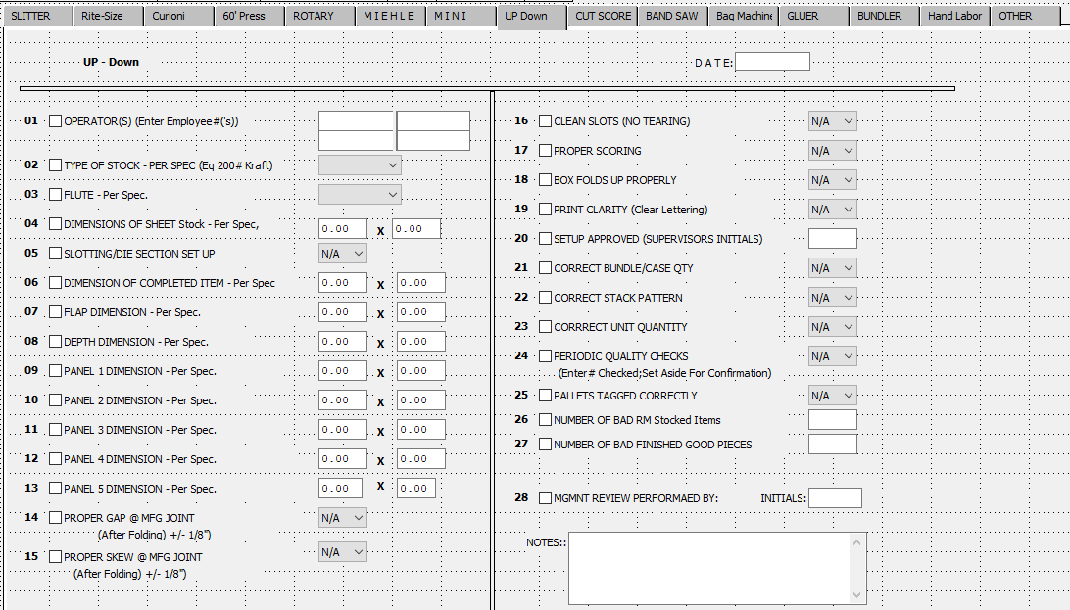

### Cut Score Screen

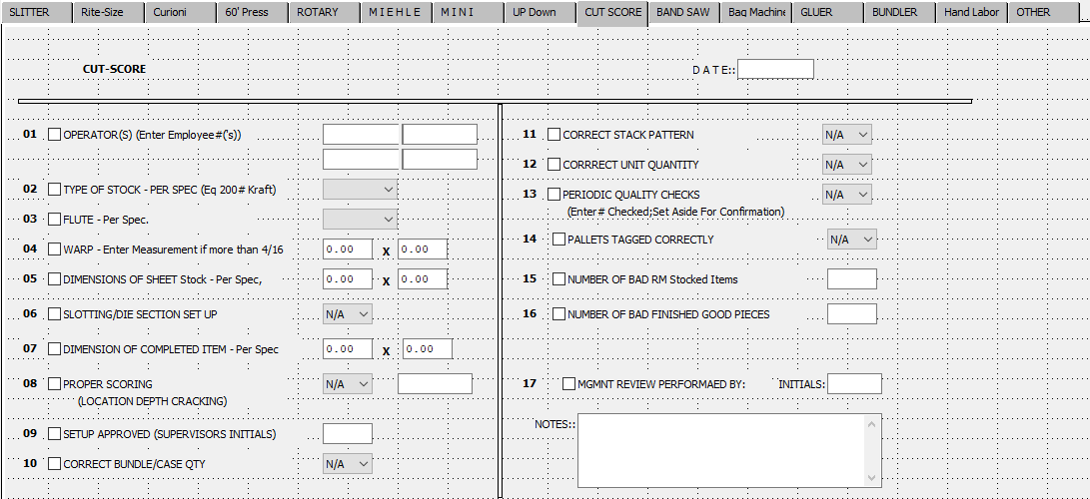

### Band Saw Screen

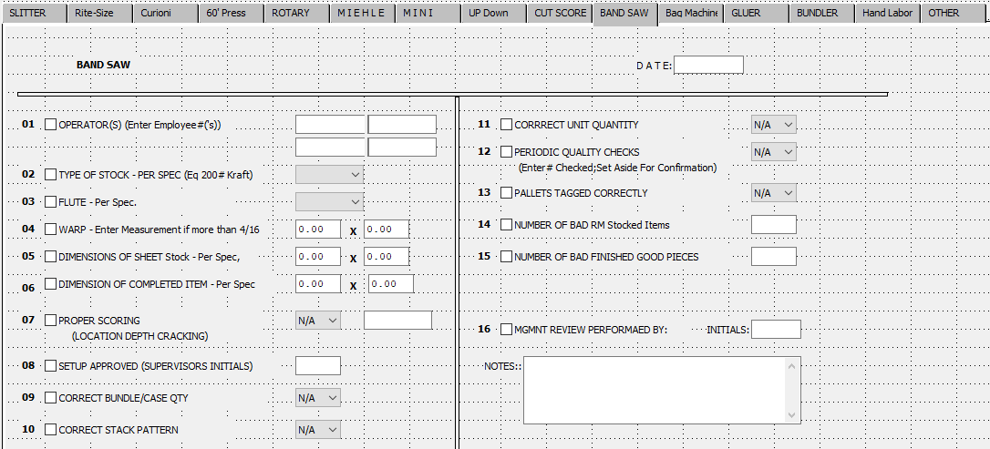

### Bag Machine Screen

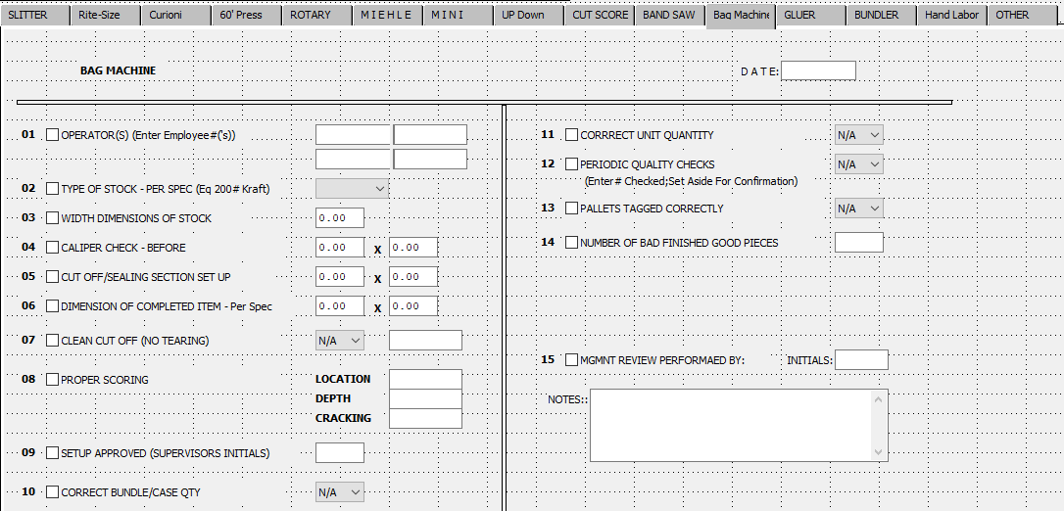

### Gluer Screen

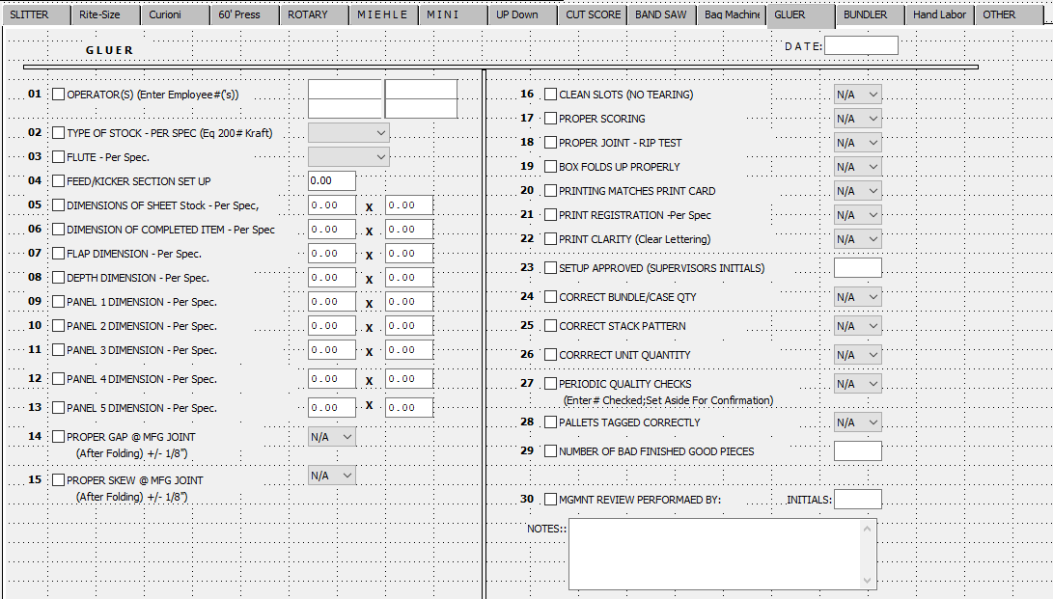

### Bundler Screen

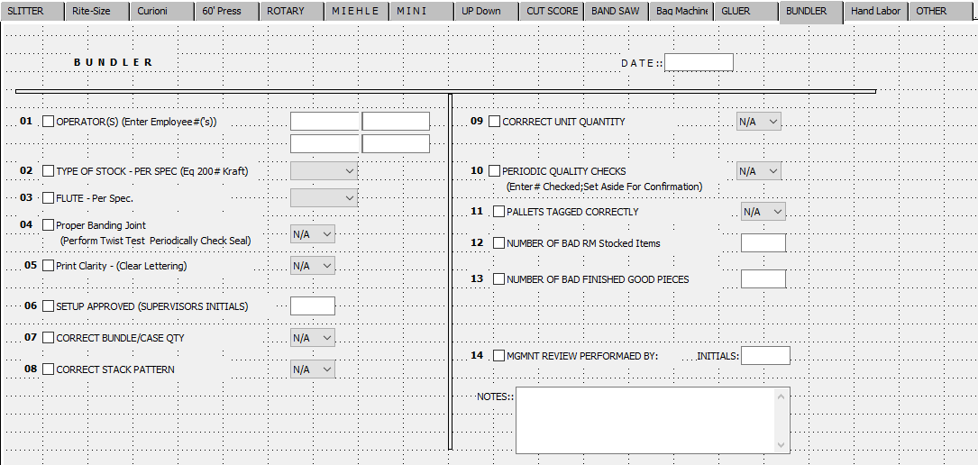

### Hand Labor Screen

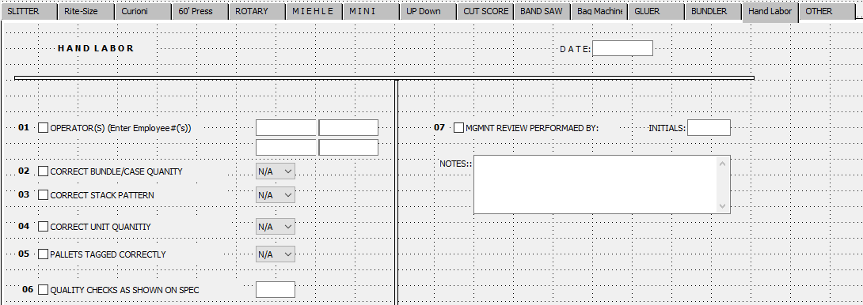

### Other Screen

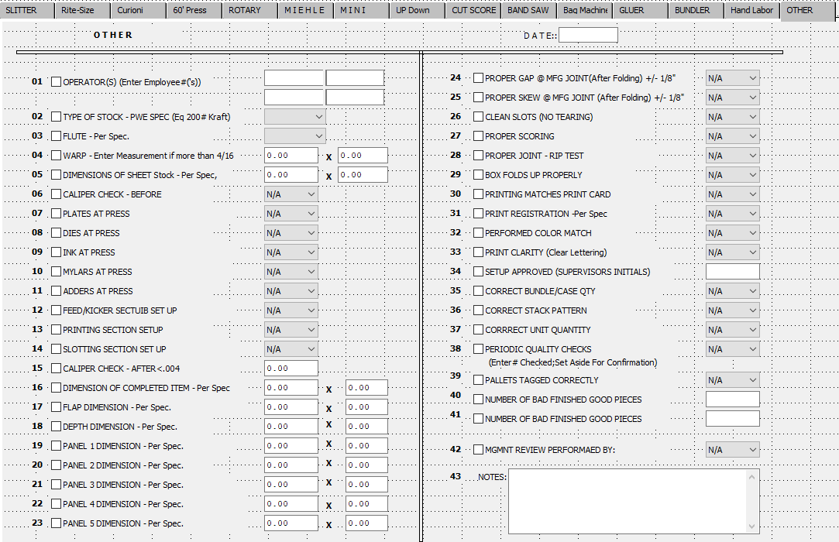

## Program Master [NS8]

### Browse Programs

This selection shows all the program names for each menu option. The browser shows the program name, menu title, directory, and version. This also shows if the selection appears on a menu, if it’s tracked for usage, and if it’s a pop-up screen.

The best way to find a menu is to click the TITLE radio button on the bottom then type the menu name that appears on the Advantzware menu in the AUTOFIND box. Simply type and the box will begin searching for the menu. If you click inside the box and start typing, then you must press the ENTER key to begin the search. Alternatively, the program name is listed by pressing the F3 key while running a program. Write down the program name, then access the program master and type the program name.

To view a program, you may double click on the selected file or click the View Program tab. The icons at the top of the browser provide additional capabilities. The icon with the fountain pen allows you to view the notes for each program.

Each note records the users initials, date, description of the note and a full-page of text for each note. Unlimited notes may be defined for each program. The browse icon will provide immediate access to the browser by program name. The icon with the corner of a page folded over allows you to print a list of the program files. The icon of the man will provide immediate access to the security by menu screen. The icon of the letters will provide immediate access to the set font and colors screen. The icon of the drop-down menu will provide immediate access to the users menu structure screen.

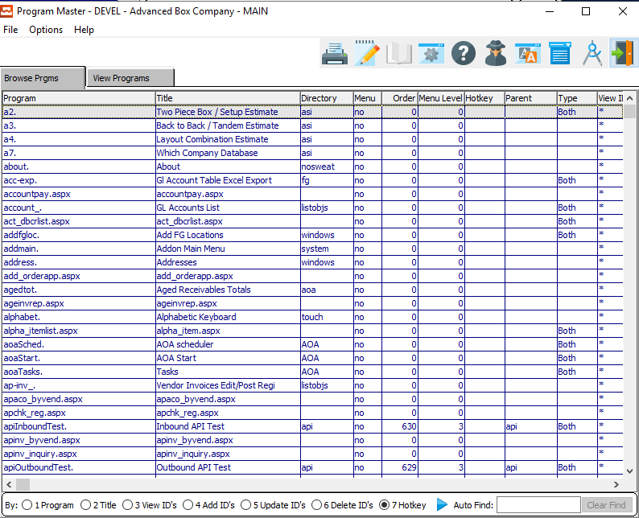

### View Program

The view Program screen allows you to view the information of each program. You may copy, change, add or delete any program from this screen, but ASI does not recommend this. You may also change the security for each program through this screen. Use the arrow keys at the bottom of the screen to view the next or previous program file. The icons at the top of the screen provide additional capabilities.

To change the security for each program through this screen, press the UPDATE button and simply add the user ID’s and / or group names to each block called Can Run, Can Create, Can Update and Can Delete, then press SAVE. Use the arrow keys at the bottom of the screen to view the next or previous program file. **You should not copy, change, add or delete any program from this screen.**

The icons at the top of the screen provide additional capabilities. The browse icon will provide immediate access to the browser by program name. The icon with the fountain pen allows you to view any notes for the program selected. The icon with the corner of a page folded over allows you to print a list of the program files. The icon of the man will provide immediate access to the security by menu screen.

The icon of the letters will provide immediate access to the set font and colors screen. The icon of the drop-down menu will provide immediate access to the users menu structure screen.

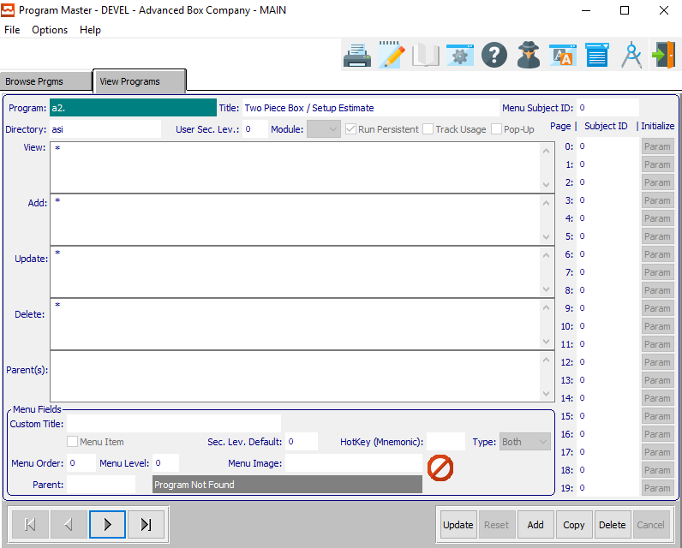

#### UPDATE

To change the currently selected Program, simply click the ***“Update***” button at the bottom of the screen.

#### ADD

Click the ***“Add”*** button at the bottom of the screen to add a new Program.

#### COPY

Click the ***“Copy”*** button to copy information from the currently selected Program.

#### DELETE

To delete the currently selected Program, simply press the ***"D"*** key. Alternatively, click the ***“Delete”*** button at the bottom of the screen.

#### NEXT

Press ***"N"*** (Next) to find next Program to view or modify. Alternatively, press the ***“Right Arrow”*** on the screen.

#### PREVIOUS

Press ***"P"*** (Previous) to find previous Program to view or modify. Alternatively, press the ***“Left Arrow”*** on the screen.

### Add/Update Program

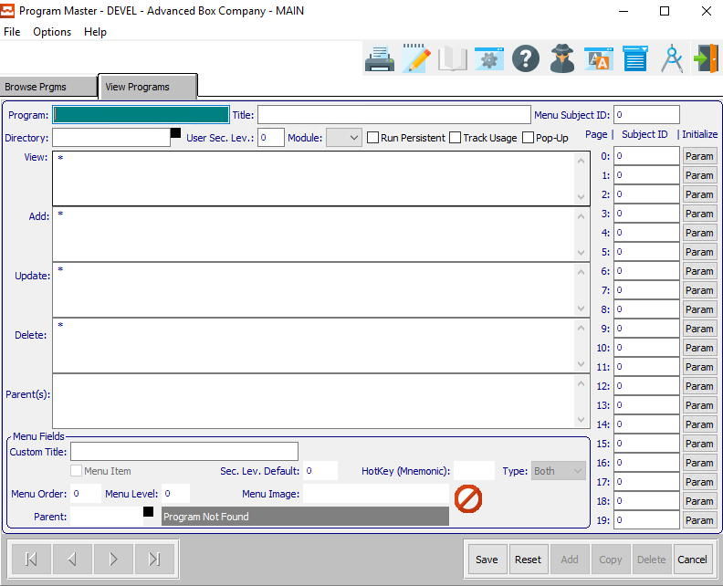

#### SAVE

Click the ***“Save”*** button to save all changes to the current Program.

#### RESET

Click the ***“Reset”*** button to reset all fields to their original state.

#### CANCEL

Click the ***“Cancel”*** button to cancel all changes to the Program without saving.

### Add/Update Program Field Definitions

#### Program

Enter a name for this program.

#### Program Title

Enter a short title for this program.

#### Menu Subject ID

Enter a menu subject ID for this program. Alternatively, press the ***“F1”*** key to choose a valid ID from a list of available Subjects.

#### Directory

Enter a directory for this program. Alternatively, press the ***“F1”*** key to choose a valid directory from a list of available directories.

#### User Sec. Level

Enter the minimum-security level that a user must have in order to run this program.

#### Module

The user may choose the module that this program belongs to from the drop-down list.

#### Run Persistent – Toggle Box

To run this as a persistent program, make sure that the Run Persistent toggle box is checked.

#### Track Usage – Toggle Box

To have the system track the usage of this program, make sure that the Track Usage toggle box is checked.

#### Pop-Up – Toggle Box

To run this program as a popup screen, make sure that the Pop-Up toggle box is checked.

#### Subject IDs

The user may enter as many subject IDs as they wish here. Pressing the ***“F1”*** key will allow the user to select a valid subject ID from a list of available subjects.

#### Initialize

After choosing a valid subject ID, the user may the ***“Param”*** button in order to open the parameters menu.

#### Custom Title

Enter the custom title for the menu field for this program.

### Initialize Parameters

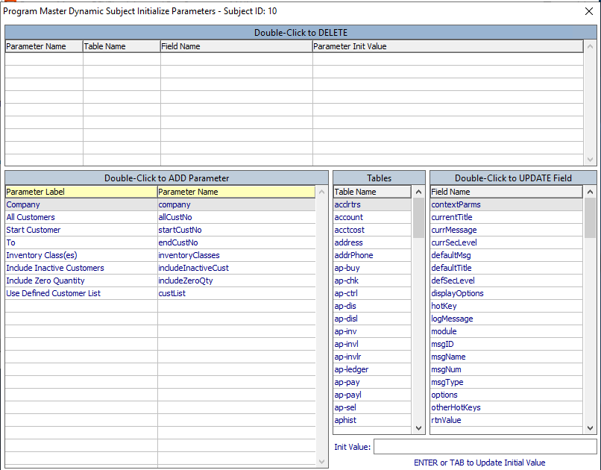

The user may double-click on any available parameters within the parameters list in order to add them to the new program.

## Email Configuration [NS!]

### Browse Email Configuration

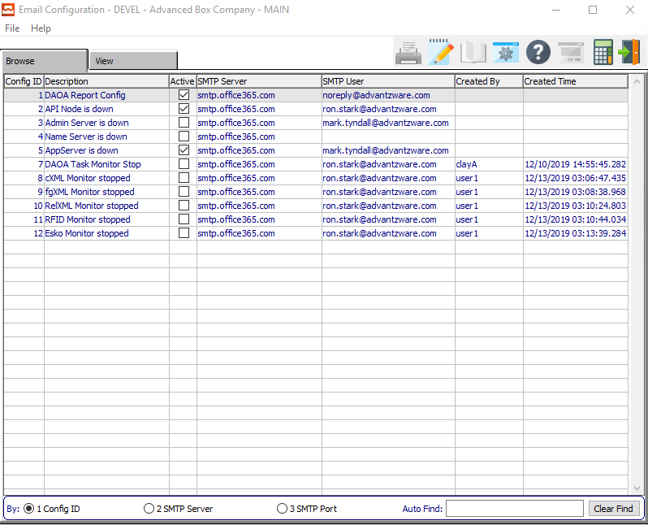

#### Active – Toggle Boxes

To mark a specific email configuration as active, make sure that the Active toggle box next to it is checked.

### View Email Configuration

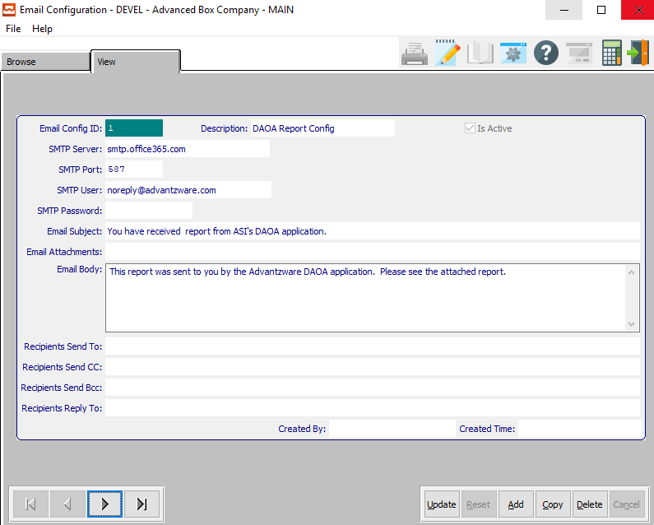

#### UPDATE

To change the currently selected Email Configuration, simply click the ***“Update***” button at the bottom of the screen.

#### ADD

Click the ***“Add”*** button at the bottom of the screen to add a new Email Configuration.

#### COPY

Click the ***“Copy”*** button to copy information from the currently selected Email Configuration.

#### DELETE

To delete the currently selected Email Configuration, simply press the ***"D"*** key. Alternatively, click the ***“Delete”*** button at the bottom of the screen.

#### NEXT

Press ***"N"*** (Next) to find next Email Configuration to view or modify. Alternatively, press the ***“Right Arrow”*** on the screen.

#### PREVIOUS

Press ***"P"*** (Previous) to find previous Email Configuration to view or modify. Alternatively, press the ***“Left Arrow”*** on the screen.

### Add/Update Email Configuration

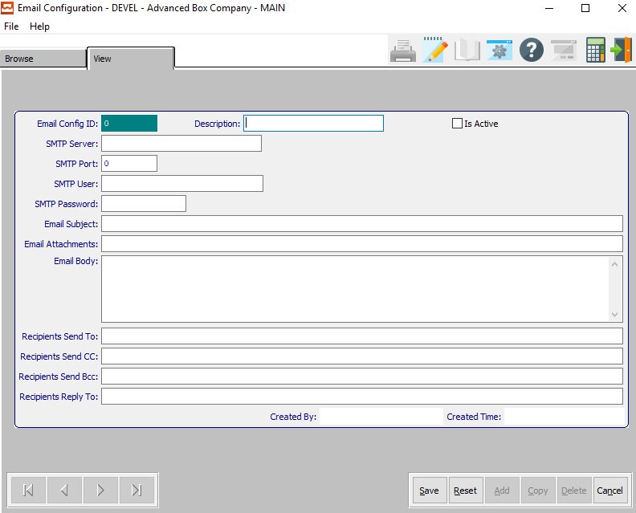

#### SAVE

Click the ***“Save”*** button to save all changes to the current Email Configuration.

#### RESET

Click the ***“Reset”*** button to reset all fields to their original state.

#### CANCEL

Click the ***“Cancel”*** button to cancel all changes to the Email Configuration without saving.

### Add/Update Email Configuration Field Definitions

#### Description

Enter a short description for this email configuration.

#### Is Active – Toggle Box

To mark this configuration as active, make sure that the Is Active toggle box is checked.

#### SMTP Server

Enter the address of the SMTP server. For Example: smtp.office365.com

#### SMTP Port

Enter the default port number for the outgoing SMPT server.

#### SMTP User

Enter the username that is used to login to the defined SMTP server.

#### SMTP Password

Enter the password for the username that is used to login to the defined SMTP server.

Please Note: This entry is not encrypted.

#### Email Subject

Enter the subject for this email configuration.

#### Email Attachments

Enter any email attachments in this field.

#### Email Body

Enter the text that is to populate the body of the emails generated for this configuration.

#### Recipients Send To

Enter the email addresses for the recipients of the emails generated for this configuration. Each address is to be separated by a comma (,).

#### Recipients Send CC

Enter the email addresses for the recipients who are to be 'copied' on the emails generated for this configuration. Each address is to be separated by a comma (,).

#### Recipients Send Bcc

Enter the email addresses for the recipients who are to be 'blind copied ' on the emails generated for this configuration. Each address is to be separated by a comma (,).

#### Recipients Reply To

Enter the email addresses which will receive replies to emails generated for this configuration. Each address is to be separated by a comma (,).

## Cue Cards [NS$]

The cue card system will show the user any cue cards that are currently displayed to users throughout the software system.

### Cue Card Display Example

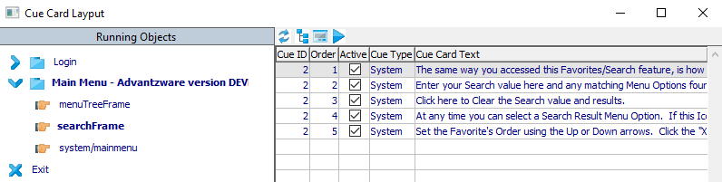

#### Active – Toggle Boxes

To mark any available cue cards as currently active, make sure that the Active toggle box next to it is checked.

## Date Rules [NS%]

### Browse Rules

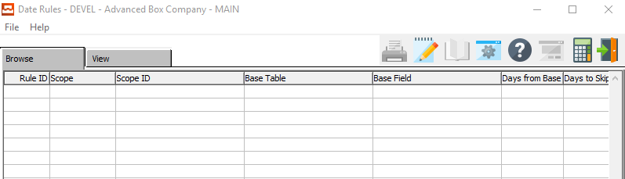

### View Rule

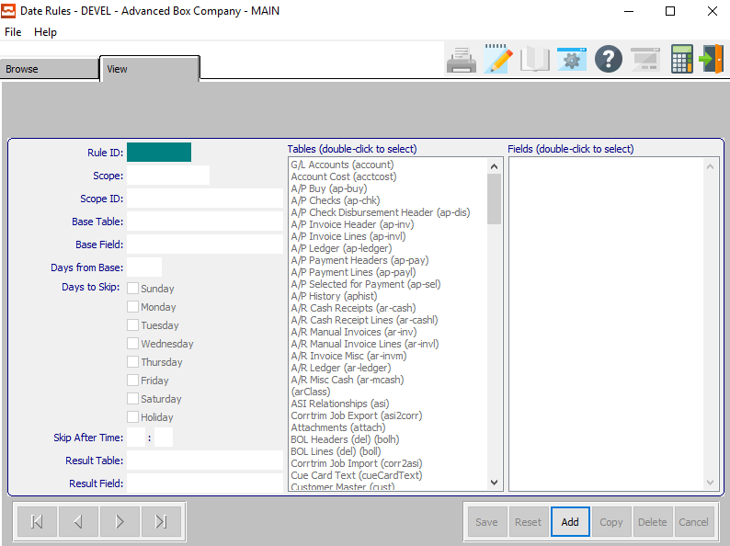

#### ADD

Click the ***“Add”*** button at the bottom of the screen to add a new Date Rule.

### Add Rule

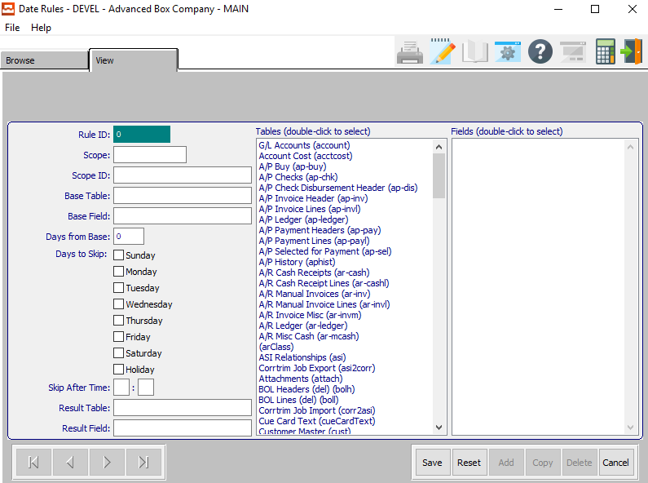

#### SAVE

Click the ***“Save”*** button to save all changes to the current Date Rule.

#### RESET

Click the ***“Reset”*** button to reset all fields to their original state.

#### CANCEL

Click the ***“Cancel”*** button to cancel all changes to the Date Rule without saving.

### Add Rule Field Definitions

#### Scope

Enter a name for the date rule.

#### Scope ID

Enter an ID number/code for this date rule.

#### Base Table

Enter the base table for this date rule. This field will automatically be filled by the system as soon as the user chooses a valid table from the list of available tables.

Please Note: In order to fill this table from the list, the user must first click the field with their cursor.

#### Base Field

Enter the base field for this date rule. This field will automatically be filled by the system as soon as the user chooses a valid field from the list of available fields.

Please Note: In order to fill this field from the list, the user must first click the field with their cursor.

#### Days From Base

Enter the number of days from base that this date rule will expire.

#### Days to Skip – Toggle Boxes

To slip certain days of the week while running this date rule, make sure that the toggle box next to the desired day of the week is checked.

The user may also choose to skip any day that the system has marked as a holiday by making sure that the Holiday toggle box Is checked.

#### Skip After Time

Enter a specific time after which to skip this date rule.

#### Result Table

Enter the result table for this date rule. This field will automatically be filled by the system as soon as the user chooses a valid table from the list of available tables.

Please Note: In order to fill this table from the list, the user must first click the field with their cursor.

#### Result Field

Enter the base table for this date rule. This field will automatically be filled by the system as soon as the user chooses a valid table from the list of available tables.

Please Note: In order to fill this field from the list, the user must first click the field with their cursor.

#### Tables

Click on a desired table to select the fields within that table.

#### Fields

Click on the desired field.

# **Dynamics [ND]**

## Task Monitor [ND1]

### Overview

The task monitor shows which system tasks are currently running for all users on the system.

### Tasks

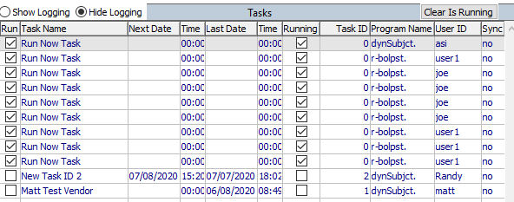

#### Run – Toggle Boxes

The Run toggle box will start a selected program.

#### Running – Toggle Boxes

The Running toggle box tells the user that a system is currently running.

### Pending Emails

The Pending emails section shows a user all emails that are currently pending being sent by the system, and who they are intended for.

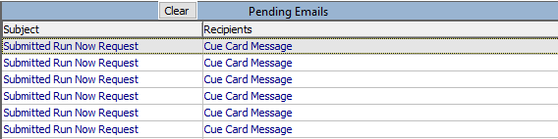

## Dynamic Subject Builder [ND2]

The Subject Builder allows a system administrator set up new subjects that all users on their system can use.

### Subject Screen

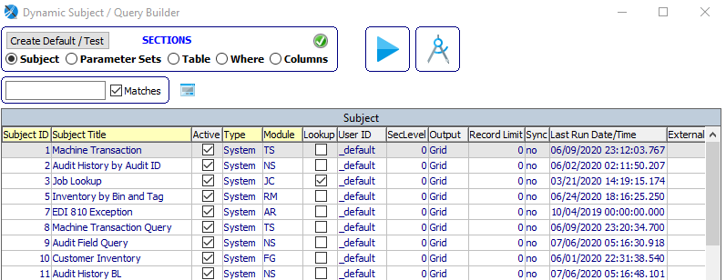

#### RUN SUBJECT

Click the ***“Blue Play Button”*** to run the current subject program.

#### VIEW

Click the ***“Small Program Screen Icon”*** button to view detailed information about the currently selected subject.

#### Sections (Choice)

To choose the preferred section for the desired subject, please make sure the desired option choice bubble is toggled.

#### Active – Toggle Boxes

To mark a subject within the list as active, make sure that the Active toggle box next to the selected subject is checked.

#### Lookup – Toggle Boxes

To mark a subject within the list as available for lookup, make sure that the Lookup toggle box next to the selected subject is checked.

### View Subject

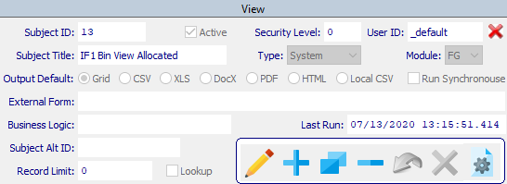

#### UPDATE/SAVE

To change the currently selected Subject, simply click the ***“Pencil Icon***” button at the bottom of the screen.

#### ADD

Click the ***“Blue + Icon”*** to add a new Subject.

#### COPY

Click the ***“Two Pages Icon”*** button to copy information from the currently selected Subject.

#### DELETE

To delete the currently selected Subject, simply press the ***"D"*** key. Alternatively, click the ***“Blue - Icon”*** button at the bottom of the screen.

### Add/Update Subject

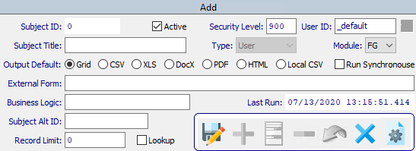

#### SAVE

Click the ***“Floppy Disc Icon”*** to save all changes to the Subject screen.

#### CANCEL

Click the ***“Blue X Icon”*** button to cancel all changes to the Subject without saving.

### Add/Update Subject Field Definitions

#### Active – Toggle Box

To mark this subject as active, make sure that the Active toggle box is checked.

#### Security Level

Enter the minimum-security level for this subject.

#### User ID

Enter a specific user ID for this subject.

#### Subject Title

Enter a short title for this subject.

#### Module

The user may choose a module for this subject from the drop-down list of options.

#### Output Default (Choice)

To choose the preferred default output document type, please make sure the desired option choice bubble is toggled.

#### Run Synchronouse – Toggle Box

To allow this subject to run Synchronouse, make sure that this toggle box is checked.

#### External Form

Enter the location of the External Form for this Subject. Alternatively, press the ***“F1”*** key to use the Windows Explorer window to choose the proper file path.

#### Business Logic

Enter the location of the Business Logic for this Subject. Alternatively, press the ***“F1”*** key to use the Windows Explorer window to choose the proper file path.

#### Last Run

This is the last date and time that this subject was run. This defaults to the system date and time and cannot be modified by the user.

#### Subject Alt ID

Enter the alternate ID for this subject.

#### Record Limit

Enter a number of records that this subject may have at one time.

#### Lookup – Toggle Box

To allow this subject to be looked up, make sure that the Lookup toggle box is checked.

## Dynamic Parameter Builder [ND3]

The Parameter Builder allows a system administrator set up new parameters that all users on their system can use.

### Sets

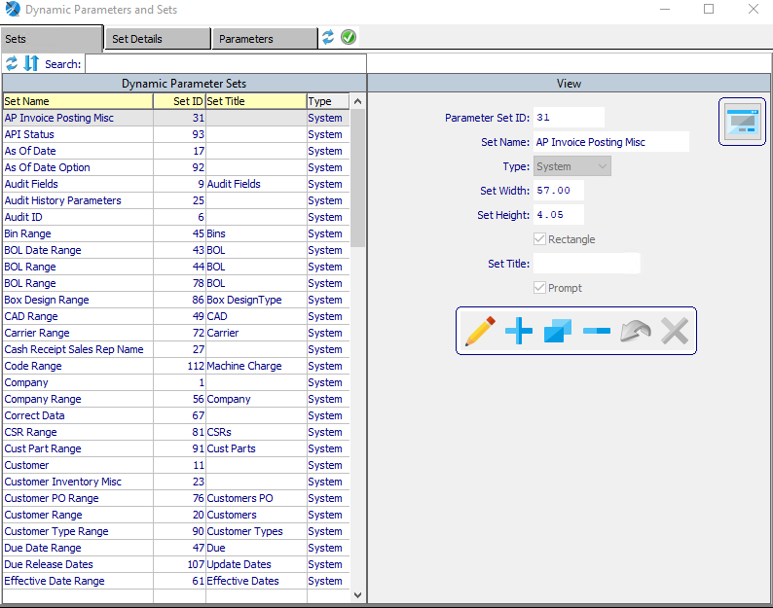

#### UPDATE/SAVE

To change the currently selected Parameter, simply click the ***“Pencil Icon***” button at the bottom of the screen.

#### ADD

Click the ***“Blue + Icon”*** to add a new Parameter.

#### COPY

Click the ***“Two Pages Icon”*** button to copy information from the currently selected Parameter.

#### DELETE

To delete the currently selected Parameter, simply press the ***"D"*** key. Alternatively, click the ***“Blue - Icon”*** button at the bottom of the screen.

### Add Set

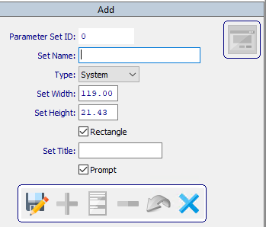

#### SAVE

Click the ***“Floppy Disc Icon”*** to save all changes to the Set screen.

#### CANCEL

Click the ***“Blue X Icon”*** button to cancel all changes to the Set without saving.

#### Set Name

Enter a short Set name for this parameter.

#### Type

The user may choose the type for this parameter from the drop-down list of options.

#### Set Width

Enter the set width for this parameter.

#### Set Height

Enter the set height for this parameter.

#### Rectangle – Toggle Box

To mark this set as a rectangle, make sure that the Rectangle toggle box is checked.

#### Set Title

Enter the set title for this parameter.

#### Prompt – Toggle Box

To prompt the user when using this parameter, make sure that the Prompt toggle box is checked.

### Set Details

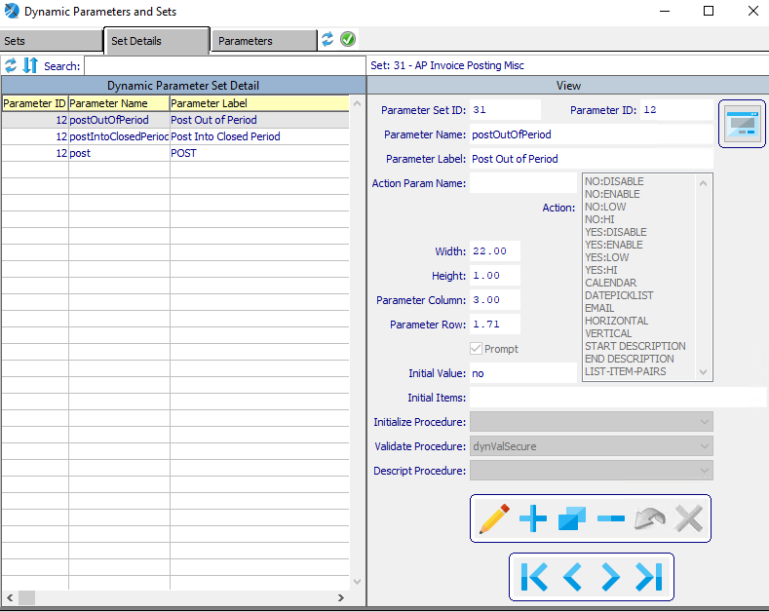

#### UPDATE/SAVE

To change the currently selected Set Detail, simply click the ***“Pencil Icon***” button at the bottom of the screen.

#### ADD

Click the ***“Blue + Icon”*** to add a new Set Detail.

#### COPY

Click the ***“Two Pages Icon”*** button to copy information from the currently selected Set Detail.

#### DELETE

To delete the currently selected Set Detail, simply press the ***"D"*** key. Alternatively, click the ***“Blue - Icon”*** button at the bottom of the screen.

#### NEXT

Press ***"N"*** (Next) to find next Set Detail to view or modify. Alternatively, press the ***“Right Arrow”*** on the screen.

#### PREVIOUS

Press ***"P"*** (Previous) to find previous Set Detail to view or modify. Alternatively, press the ***“Left Arrow”*** on the screen.

### Add Set Details

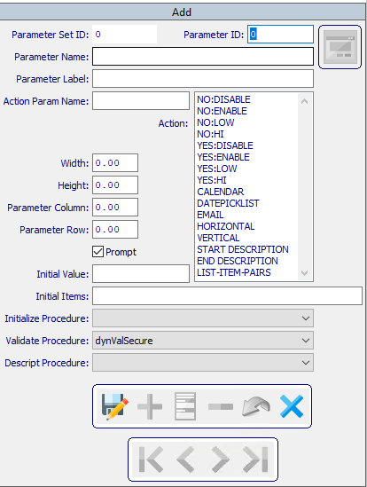

#### SAVE

Click the ***“Floppy Disc Icon”*** to save all changes to the Set Detail screen.

#### CANCEL

Click the ***“Blue X Icon”*** button to cancel all changes to the Set Detail without saving.

### Add Set Details Field Definitions

#### Parameter ID

Enter a valid parameter ID for this Set Detail. Alternatively, press the ***“F1”*** key to choose an ID from a list of valid Parameters.

#### Parameter Name

The Parameter Name will automatically transfer from the Parameter file as soon as the user enters or chooses a valid Parameter ID. However, the user may modify this field if they wish.

#### Parameter Label

The Parameter Label will automatically transfer from the Parameter file as soon as the user enters or chooses a valid Parameter ID. However, the user may modify this field if they wish.

#### Action Parameter Name

Enter the action parameter name for this Set Detail.

#### Action

The user may choose which action this set detail will perform by clicking on their desired action within the list. Only highlighted actions will be performed by this set detail. To choose multiple actions, the user may use the ***“Control-Click”*** method to highlight as many actions as they wish.

#### Width

The Width will automatically transfer from the Parameter file as soon as the user enters or chooses a valid Parameter ID. However, the user may modify this field if they wish.

#### Height

The Height will automatically transfer from the Parameter file as soon as the user enters or chooses a valid Parameter ID. However, the user may modify this field if they wish.

#### Parameter Column

The Parameter Column will automatically transfer from the Parameter file as soon as the user enters or chooses a valid Parameter ID. However, the user may modify this field if they wish.

#### Parameter Row

The Parameter Row will automatically transfer from the Parameter file as soon as the user enters or chooses a valid Parameter ID. However, the user may modify this field if they wish.

#### Prompt – Toggle Box

To prompt the user when using this parameter, make sure that the Prompt toggle box is checked.

#### Initial Value

The Initial Value will automatically transfer from the Parameter file as soon as the user enters or chooses a valid Parameter ID. However, the user may modify this field if they wish.

#### Initial Items

Enter any initial items for this parameter set.

#### Initialize Procedure

The user may choose which procedure this parameter will begin from the drop-down menu.

#### Validate Procedure

The user may choose which procedure this parameter will validate from the drop-down menu.

#### Descript Procedure

The user may choose which procedure this parameter will describe from the drop-down menu.

### Parameters

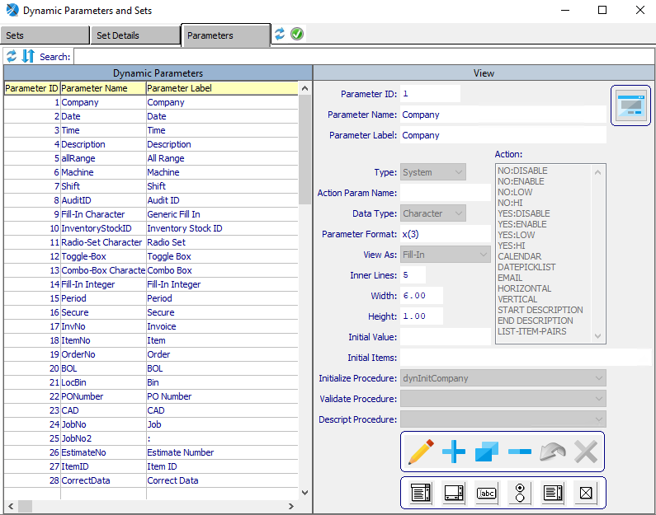

### Add Parameters

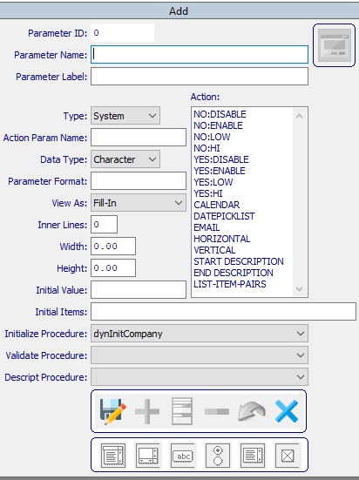

#### SAVE

Click the ***“Floppy Disc Icon”*** to save all changes to the parameter screen.

#### CANCEL

Click the ***“Blue X Icon”*** button to cancel all changes to the parameter without saving.

### Add Parameters Field Definitions

#### Parameter Name

Enter a name for this parameter.

#### Parameter Label

Enter a short description for this parameter.

#### Type

The user may choose the parameter type from the drop-down menu. Valid types are as follows:

|  |  |
| --- | --- |
| System | User |

#### Data Type

The user may choose the data type from the drop-down menu. Valid data types are as follows:

|  |  |  |
| --- | --- | --- |
| Character | Date | Date/Time |
| Decimal | Integer | Logical |

#### Parameter Format

Enter the format for this parameter.

#### View As

The user may choose the view type from the drop-down menu. Valid view types are as follows:

|  |  |  |
| --- | --- | --- |
| Combo-Box | Editor | Fill-In |
| Radio-Set | Selection-List | Toggle-Box |

#### Inner Lines

Enter the number of inner lines for this parameter.

#### Width / Height

Enter the width and height for this parameter.

#### Initial Value

Enter an initial value for this parameter.

#### Initial Items

Enter the initials items for this parameter.

#### Initialize Procedure

The user may choose which procedure this parameter will begin from the drop-down menu.

#### Validate Procedure

The user may choose which procedure this parameter will validate from the drop-down menu.

#### Descript Procedure

The user may choose which procedure this parameter will describe from the drop-down menu.

#### Action

The user may choose which action this parameter will perform by clicking on their desired action within the list. Only highlighted actions will be performed by this parameter. To choose multiple actions, the user may use the ***“Control-Click”*** method to highlight as many actions as they wish.

## Dynamic Subject Sync [ND4]

### Subject Sync

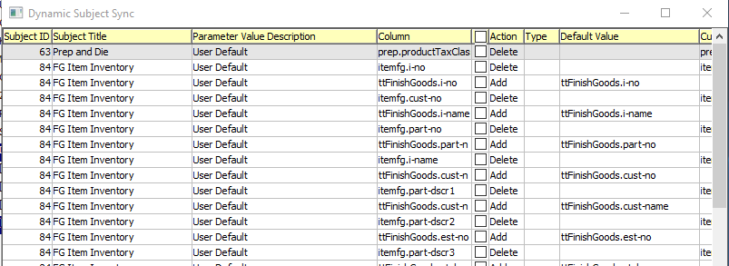

#### Add – Toggle Boxes

The user may add any subject within this list by checking the Add toggle box next to the desired Subject.

#### Delete – Toggle Boxes

The user may delete any subject within this list by checking the Delete toggle box next to the desired Subject.